HBF TRAFFIC MANAGEMENT WORKING GROUP 2017

Purpose: The purpose of the Traffic Management Working Group is to
- Review existing develop traffic management (vehicle movements, pedestrian segregation and associated topics)
- Develop guidance around a base line standard of HBF expectations for site traffic and pedestrian management arrangements
INTRODUCTION

Accidents caused by inadequate traffic management arrangements can occur throughout the construction process from the start of ground works through to site completion. Each year construction vehicle related accidents account for an average of 10 deaths and hundreds of serious injuries. Construction Managers, operatives, site visitors and members of the public can all be at risk if construction vehicle activities are not properly managed and controlled. This document aims to set standards which if adopted will help to identify and control hazards and reduce the risks that arise from the use of vehicles in the construction industry.
Much of the occupational health and safety law relating to construction transport operations is qualified by the term “so far as is reasonably practicable”. The control measures required in a specific situation will be in direct relation to the extent and nature of the particular risks involved.
The majority of construction transport accidents result from inadequate segregation of pedestrians and vehicles. This can usually be avoided by careful planning and by controlling vehicle operations during construction work. Successful management of construction vehicle activities is based on the provision and maintenance of safe work places, safe vehicles, safe drivers and safe work practices. Risk assessment is an essential part of effective health and safety management.
Planning for traffic management must begin prior to the start of the construction phase; the CDM Regulations place specific duties on all CDM duty holders including the Client, Principal Designers, Designers and Contractors to manage construction work in a safe manner, this includes the need to provide and manage safe traffic and pedestrian routes throughout the construction phase and during the client handover period.
2. RELEVANT LEGISLATION & GUIDANCE.

1. Health and Safety at Work etc Act 1974
2. Management of Health and Safety at Work Regulations 1999
3. Construction (Design and Management) Regulations 2015
4. Supply of Machinery (Safety) Regulations 2008
5. Provision and Use of Work Equipment 1998
6. The Work at Height Regulations 2005

Guidance
1. HSG 144 The Safe Use of Vehicles on Construction Sites (UNDER REVIEW 2017)
2. Safety at Street Works and Road Works – A Code of Practice.

Key Duty Holders Responsibilities

Designers
Designers need to examine, assess and reduce the risks associated with their designs. Consideration of the following measures at the design stage can assist safe site vehicle operations:
a) allowing space around structures and site boundaries for safe traffic movement (Examples below)
b) designing one way systems and drive through areas to reduce the need for reversing
c) removing hazardous gradients and embankments
d) specifying suitable profiles, surfaces and traffic management for site roads, and the early installation of permanent roads with safe site access to and from the public highway
e) consider how site traffic routes can avoid hazards such as overhead and buried services, railway lines etc and how routes need to change as work progresses on site
f) indicating the maximum loading limits of floors used by vehicles, particularly during construction, demolition and refurbishment
g) relocating or protecting vulnerable services such as gas pipes and electricity cables
h) passing information on features of the design presenting significant transport risks to the Principal Designer for inclusion in the project information pack

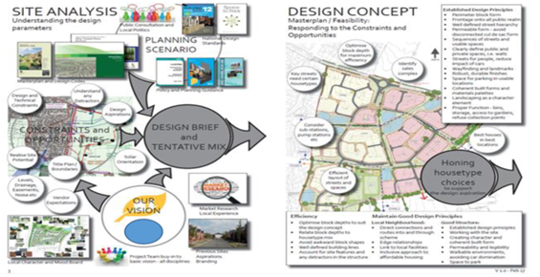

Principal Designer
Principal Designer’s should ensure that project designs take account of the issues previously mentioned, and that the project information pack contains information on specific transport risks. The Construction Phase Plan will need to provide information on factors such as:
a) phasing works to minimise risk to the public and allow a safe occupation strategy (Examples bellow)
b) local or statutory restrictions eg. In relation to access on and off the public highway.
c) a constraints plan is needed for each site to establish potential delays that could affect a build programme.

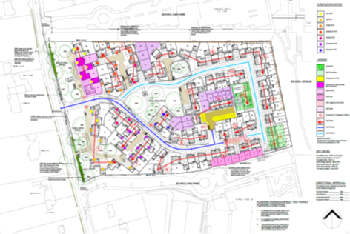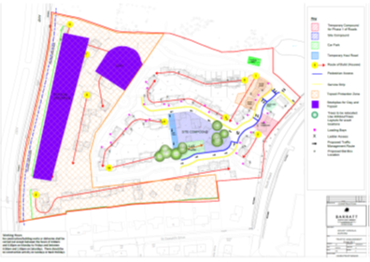

Principal Contractors
Principal Contractors should ensure the safe management of pedestrian and vehicle movements on and off site. Key tasks for principal contractors include:
a) planning work, preparing method statements and detailing safe systems of work to workers
b) implementing systems of work which ensure that pedestrians and vehicles are kept apart as far as possible
c) ensuring subcontractors make adequate provision for the selection and supervision of drivers and general vehicle safety
d) making specific reference to vehicle safety in the construction phase health and safety plan, including emergency procedures, vehicle access and site rules
e) setting standards for driver competence, vehicle safety and maintenance, and maintaining a site register of authorised drivers
f) ensuring co-ordination and co-operation between contractors
g) co-ordinating the views of safety representatives and site operatives
h) ensuring all workers receive site induction training and toolbox talks covering safe traffic routes and site rules for operating vehicles
i) establishing safety monitoring procedures for the use of vehicles on site eg. Checking vehicle maintenance, key custody and permit to work systems , driver’s work practices and the use of high visibility clothing
j) reviewing the health and safety performance of everyone on site.

Compliance with the site rules needs to be monitored and positive action taken when they are breached. Appropriate disciplinary action may be necessary against contractors and individuals who ignore site rules.

Contractors
Contractors should assess and minimise the transport risks associated with their work, institute safe systems of work, and follow the site rules and guidance applicable to them.
Remember, construction vehicles can kill! construction vehicle accidents are preventable by effective management!
To prevent death and injury ensure that you have:
a) a safe workplace
b) safe vehicles
c) safe drivers, driving and work practices.
Further information and advice on Traffic Management on Construction Sites can be found in the HSE document HSG 144 (second edition published in 2009) which is available from the HSE web site.(under review 2017)
CONSTRUCTION
TRAFFIC MANAGEMENT hierarchy of controls

Heading/Element | Principal Considerations | Further Considerations and good practice images
Pedestrian and Vehicle separation | a) Pedestrian only areas from which vehicles are excluded  b) Safe designated pedestrian routes to work locations and emergency assembly points  c) Vehicle only areas, especially where space is limited or traffic heavy  d) Safe vehicle routes on and around the site  e) Safe designated signed site entry and crossing points  f) designated parking areas | 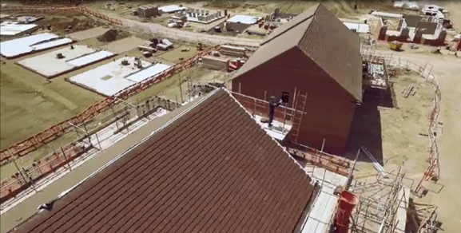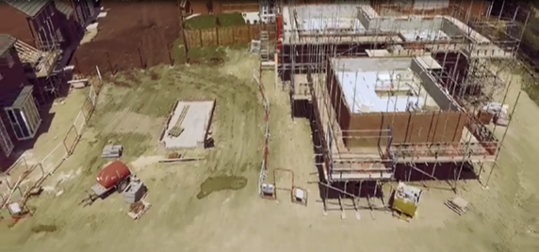
Pedestrian Routes | a) must be clearly separated from vehicle routes by substantial barriers and/or kerbs, or other suitable means  b) be wide enough to safely accommodate the number of people likely to use them at peak times  c) allow safe access routes to work and emergency assembly areas  d) be kept clear of obstructions and trip hazards  e) be clearly signed  f) ensure pedestrian safety where they cross main traffic routes by providing designated crossing points with adequate signage | 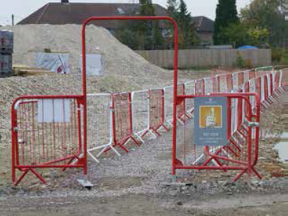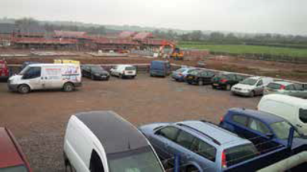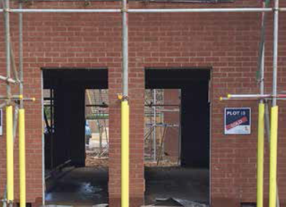

SITE PUBLIC PROTECTION & SECURITY REQUIREMENT ASSESSMENT
Operating Business: |  |  | Site Name:
Assessed by: |  |  | Position:
Signed: |  |  | Date:
Reason for the Assessment (new site, ongoing review, change to existing build etc):

This assessment is mainly concerned with preventing accidents and ill health to the public, but it may also help reduce related nuisance issues.
It identifies the hazards and risks which most commonly affect the public and visitors to sites who may not be fully aware of hazards created in construction and housebuilding.

This assessment does not cover illegal trespass or forced entry on to sites by those intent on criminal activity; however, the measures identified here may act as a deterrent and reducing the risk of illegal activity.
Remember - The planning for security of a site should be proportionate to the risk
The Traffic Management Assessment must also be consulted to ensure controls are in place for access / egress into site

Hazard Rating: H = High M = Medium L = Low

Hazard = potential to cause harm Risk = probability of that harm occurring

The Risk Rating Criteria is detailed below:
HIGH: A hazard, which has the potential to cause a fatal/major injury or health damage.
MEDIUM: A hazard resulting in loss time injury or significant material or environmental damage.
LOW: A hazard resulting in minor injury but not lost time, or some material damage.

The following hazards and means of control must be assessed prior to the commencement of the site.
For further guidance please consult the Group H & S Policy Documentation and HSE Guidance HSG151

Hazard Identified | Y/N | H | M | L | Controls Required

Vehicle Access and Egress – Site Entrance/Exit
Site boundary security
Incomplete roads and footpaths or uneven surfaces

Raised Iron Works

Terrain (Muddy Roadways)

Hazard Identified | Y/N | H |  | M | L | Controls Required

Occupied Plots

Local School(s) in vicinity of site

Play areas in vicinity

Open Water Area ( eg SUDS Pond)
Off site works ( excavations etc)
Road side parking at occupied areas
The following should be considered when completing the “Control Measures” column:
- Access Road/Off-Site & On-Site Signage  - Speed limits on site and approach roads  - Creation of familiar crossing points for public  - Use of Banksman or Gate Wardens  - Use of security or permanent fencing  - Use of security personnel  - Early installation of roads and footpaths  - Regular inspection or road conditions  - Levelling iron works until top coat complete  - Haunching and paint highlighting of ironworks  - Regular inspection of iron works condition |  |  | - Regular road cleaning regime  - Use of “on site” road cleaning attachments  - Use of wheel wash equipment  - Strict working hours for noise levels Letters of general advice to clients  - Advising clients of irregular off site works  - Restricted supplier delivery times  - Site vehicle and plant exclusion zones  - Additional fencing and signs at open water  - Use of permit to access / work  - Compound/Sales Location  - Contractor/Visitor Parking
The list is not exhaustive.
Note: All items identified shall be brought to the attention of all concerned and displayed (along with this document) on all relevant notice boards.

