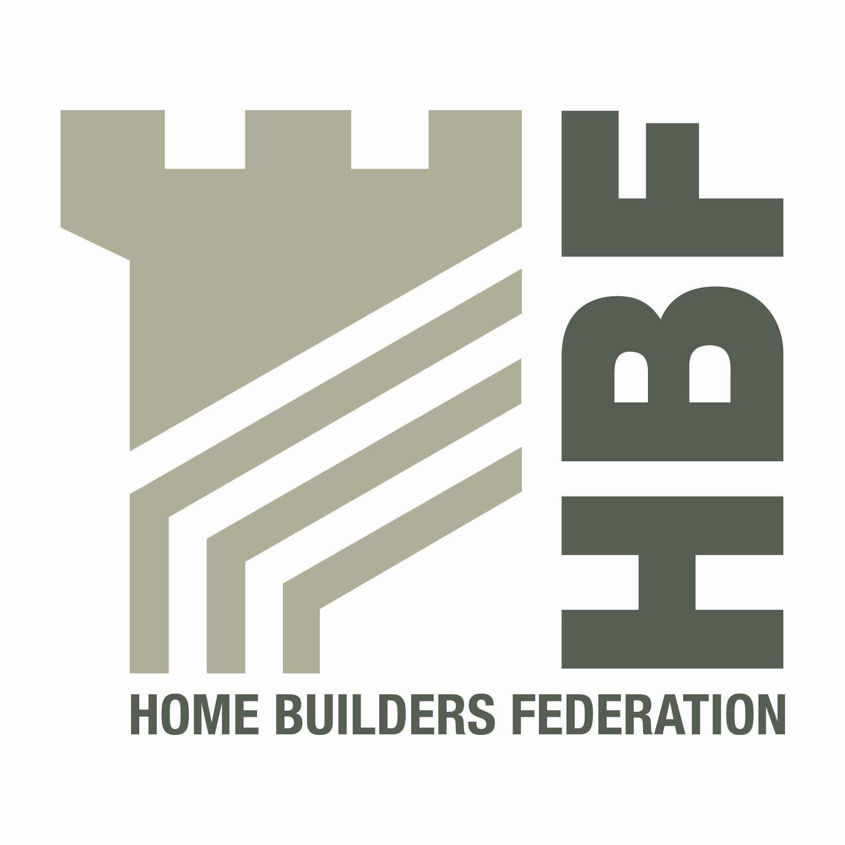

THE HOME BUILDERS FEDERATION
HBF HEALTH AND SAFETY FORUM

Thursday 13th July 2017
8.30 for 9.00am Start

LEA MARSTON HOTEL,
Haunch Lane, Lea Marton, SUTTON COLDFIELD, B76 0BY

AGENDA

- Welcome and Introductions

- Notes of previous meeting

- STA Update - 16 Steps and Fire Mitigation Works

- HBF H&S working groups Update from existing Groups
- Dust Dave Hickman
- Roof trusses Craig Donelan
- 2017 HBF H&S working groups present update:

- Occupational Health Michelle Shani
- Sharing best practice/ lessons learnt Matthew Stubblefield
- Traffic Management Rhodri Stephens
- Contractors Supervision Greg Johnson
- Lobbying and engagement Steve Acaster

- HBF H&S Statistics

- Industry Updates
- HSE
- CONIAC
- Emerging issues

- Brick and Block Loads – Edward Woods

- Last Meeting date 2017 - Thursday 26 October

- AOB

