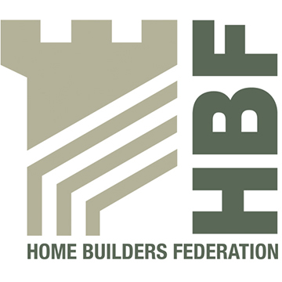

HBF HEALTH AND SAFETY COMMITTEE

HEALTH & SAFETY committee

TERMS OF REFERENCE

- The Health and Safety Committee is the principal policy making body considering all aspects of health and safety relating to housebuilding.

- The Health and Safety Committee previews proposed legislation, approved codes of practice and guidance with a view to providing comments on behalf of the industry.

- The health and safety committee reports to the HBF Board.

- The Health and Safety Committee maintains close links with HSE, and direct contact on all industry related health and safety matters.

- The Health and Safety Committee is responsible for the Health and Safety Charter and for reviewing the agreed action plan annually.

- Members of the committee may be asked to attend external meetings on behalf of HBF and report back to the committee.

- Health and safety matters raised by members of HBF and brought to the committee will be discussed and addressed in the appropriate manner.

- The Health and Safety Committee meets with members of the Housebuilders’ Health and Safety Forum in order to share information and promote Health and Safety best practice across the housebuilding sector. However it should be clear that the two groups are separate and where it appears that there may be a conflict of interest the chairman of the committee should discuss this with the Director of Technical Services or his representative.

HBF HEALTH AND SAFETY COMMITTEE

HEALTH & SAFETY WORKING GROUPS

TERMS OF REFERENCE

- The Health and Safety Committee will require the formation of task and finish working groups to deliver specific actions in support of the Health and Safety Charter, legislative changes and other emergent issues relevant to Health and Safety within Homebuilding.

- The need for any Working Group (WG) will be agreed at Health and Safety Committee meetings.

- A WG will be chaired by a member of the HBF Health and Safety Committee for the duration of the working group activity. The chair will manage the activities of the WG in accordance with the agreed scope and programme.

- As part of the establishment of any WG a short clearly defined scope and objectives, programme of action and deliverables will be agreed with the H&S Committee Chair/ HBF Technical Director. This will include clarity over the nature and status of any documented outputs. For longer duration WGs it may be appropriate to provide an annual programme.

- The WG will seek to deliver regular & consistent progress between Health and Safety Committee meetings and is expected to meet at least once/ quarter. Telephone conference call, Video conferences and other technological solutions are deemed as acceptable as appropriate.

- The chair of each WG is expected to provide a single A4 page summary of progress. This is to be forwarded to HBF such that it can be included in the Health & Safety Committee meeting pack

