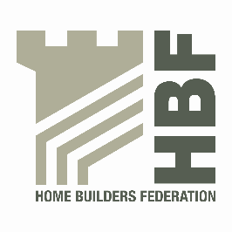

HBF HEALTH AND SAFETY FORUM
THURSDAY 19th JANUARY 2016.
MEETING STARTS @ 9AM

LEA MARSTON HOTEL, HAUNCH LANE, LEA MARSTON, SUTTON COLDFIELD, B76 0BY

AGENDA

- Review of 2016 / where do we go – Statistics/annual report update

- Breakout session

- Actions arising from previous meeting

- Timber Construction Concerns and Barriers &16 steps update
Martin Milner – STA

- Sentencing guidelines update

- A O B

