

Health and Safety Statistical Analysis Report for
2015/2016

Issue: Draft 002 Date: 29th November 2016

CONTENTS:
1. Introduction
2. General Data
3. Reportable Injuries
4. Annual Injury Incidence Rate (AIIR)
5. Causes of Injury – HBF Member Organisations
6. Data on Slips and Trips
7. Dangerous Occurrences
8. Fires on Construction Sites
9. Enforcement Action
10. Causes of Injury – HSE Figures for the Construction Industry
11. Members of the public

1. Introduction
This report deals with data provided by those Member Organisations* that have volunteered to provide information on injuries and dangerous occurrences reported by them to the Health and Safety Executive (HSE) in accordance with the Reporting of Injuries, Diseases and Dangerous Occurrences Regulations 2013 (RIDDOR). The data was collected in the period 01 April 2015 to 31 March 2016.
*A Member Organisation is defined as a home building company that is represented on the Home Builders Federation (HBF) Health and Safety Committee.

These data have been analysed in various ways and a written summary is contained in this report. The scope of the reporting covers all locations under the control of each Member Organisation with the exception of locations operated by main contractors employed by a Member Organisation as a ‘Principal Contractor’ under the Construction (Design and Management) Regulations 2015.

2. General Data
- 23 Member Organisations contributed their data during the year (20 contributed last year).
- The 23 Member Organisations reported and average number employed of 117,912 people resulting in a 13% increase on last year as the 20 member organisations employed an average of 102,052 in 2014/2015).

Table 2.1: Member Organisations and Average Number Employed
 | 2015/  2016 | 2014/  2015 | 2013/  2014 | 2012/  2013 | 2011/  2012 | 2010/  2011 | 2009/  2010 | 2008/  2009 | 2008/ 2007
Number of Member Organisations | 23 | 20 | 20 | 22 | 17 | 17 | 17 | 16 | 19
Average Number Employed¹ | 117,912 | 102,052 | 86,519 | 81,470 | 74,887 | 66,879 | 55,880 | 61,695 | 100,317

3. Reportable Injuries
Directly employed
- There were no fatal injuries during the year - for the 8th consecutive year
- There were 21 ‘major injuries’ (down 13 % on last year’s 24).
- There were 72 ‘over 7 day injuries’ (up 38% on last year’s 52)

Subcontractors
- There was one fatal injury during the year, (1 occurred last year).
- There were 120 ‘major injuries’ (<up 4%> on last year’s 115).
- There were 181 ‘over 7 day injuries’ (<up 3%> on last year’s 176).

All reported injuries
The total number of injuries reported to the HSE during the year was 395 (up 7% on last year’s 368). The relevant data are given in Table 3.1 and Figure 3.1a below.

Table 3.1: All Reported Injuries (employed and subcontractors)

 | 2015/  2016 | 2014/  2015 | 2013/  2014 | 2012/  2013 | 2011/  2012 | 2010/  2011 | 2009/  2010 | 2008/  2009
Fatalities | 1 | 1 | 1 | 1 | 0 | 2 | 0 | 0
Major Injuries | 141 | 139 | 134 | 113 | 108 | 108 | 90 | 94
Over 3 Day Injuries | -- | -- | -- | -- | 261 | 259 | 205 | 252
Over 7 Day Injuries | 253 | 228 | 169 | 155 | -- | -- | -- | --
Total | 395 | 368 | 304 | 269 | 369 | 369 | 295 | 346

Figure 3.1a: All Reported Injuries (employed and subcontractors) by RIDDOR Category
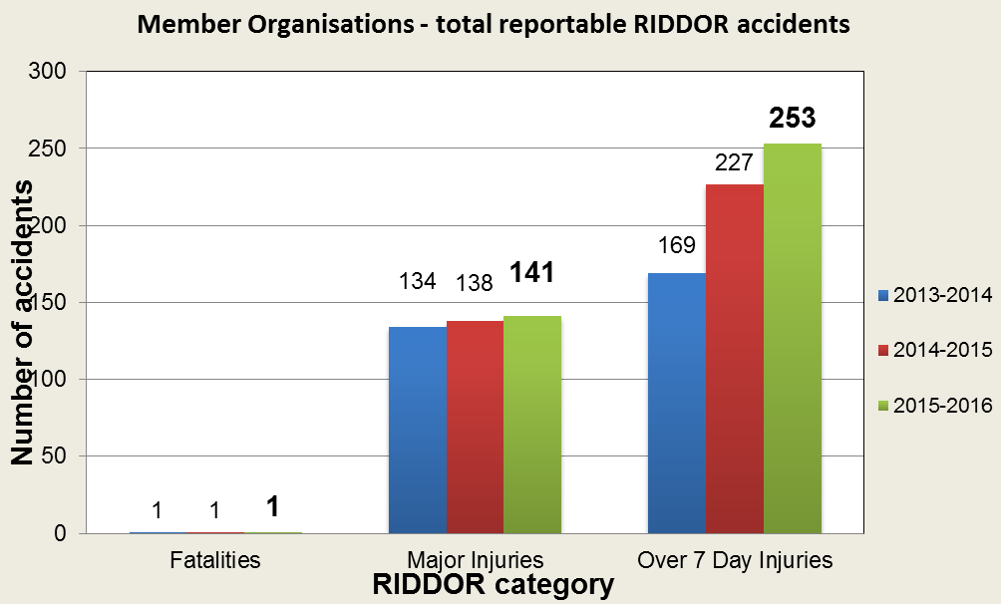
4. Annual Injury Incidence Rate (AIIR)
The ‘Home Builder’ AIIR for 2014/2015 was 335*, the previous year and it was 361.
*395 incidents divided by an average number employed of 117,912 multiplied by 100,000 = 335

The Construction Industry AIIR for the same period has yet to be published by the Health and Safety Executive; this should happen in November 2016.

Figure 4.1a compares the Home Builder Federation’s AIIR with the HSE’s Construction Industry’s AIIR between 2012 and 2016.

Figure 4.1a: AIIR for the periods 2012/13 to 2015/2016
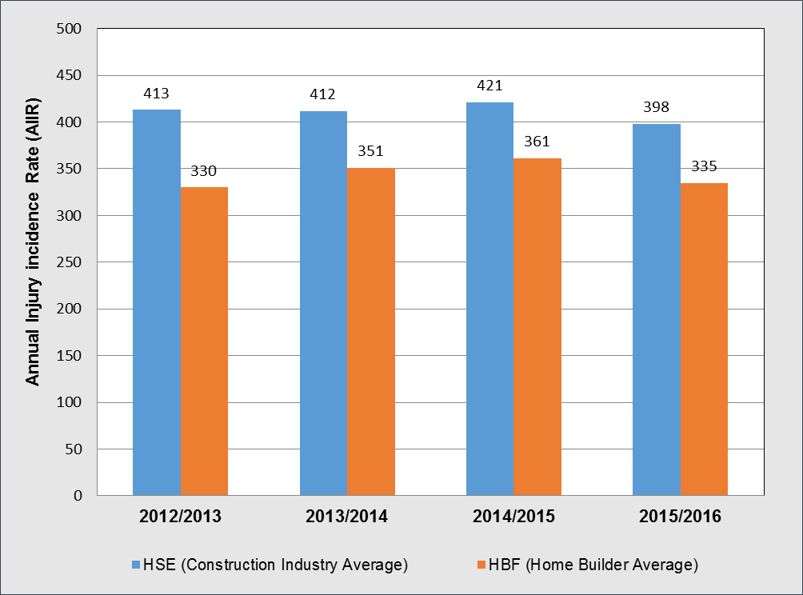

Note: the Annual Injury Incidence Rate (AIIR) 2006/2007 to 2011/2012 which includes Fatal injury, Major injury and Over 3 day injury data can be found in Figure 4.1 of the annual report dated 22nd November 2012, Issue 002.

5. Causes of Injury
Falling at the same level accounted for 36% of all incidents (directly employed and contractors) reported to the HSE in accordance with RIDDOR, Figure 5.1a below details the top five causes of injury by number reported:

Figure 5.1a: Top Five Causes of Injury (employed and subcontractors)
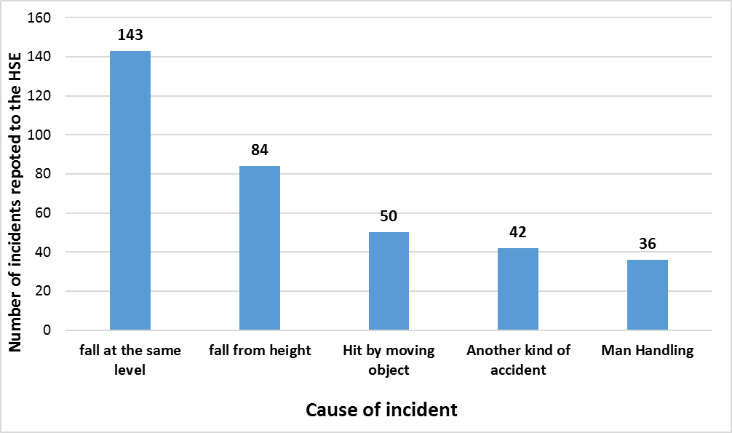

Fatal Injuries
There was one fatal injury which involved being hit by moving, flying or falling object, which is currently being investigated and no information was available at the time this report was published.

Major Injuries
Table 5.1 below provides information on the top six causes of major injuries to employed staff and subcontractors by reporting year.

Table 5.1: Major Injuries (employed and subcontractors)
 | 2015/  2016 | 2014/  2015 | 2013/  2014 | 2012/  2013 | 2011/  2012 | 2010/  2011 | 2009/  2010 | 2008/  2009
Fall – same level | 53 | 56 | 54 | 50 | 33 | 42 | 37 | 42
Fall – height | 44 | 41 | 23 | 21 | 38 | 26 | 29 | 23
Hit by moving object | 18 | 18 | 21 | 15 | 15 | 11 | 5 | 7
Manual handling | 7 | 5 | 11 | - | 4 | - | 4 | 8
Contact - machinery | 6 | 5 | 8 | 6 | 3 | 7 | 3 | 3
Hit by moving vehicle | 5 | 4 | 3 | - | - | 5 | - | -
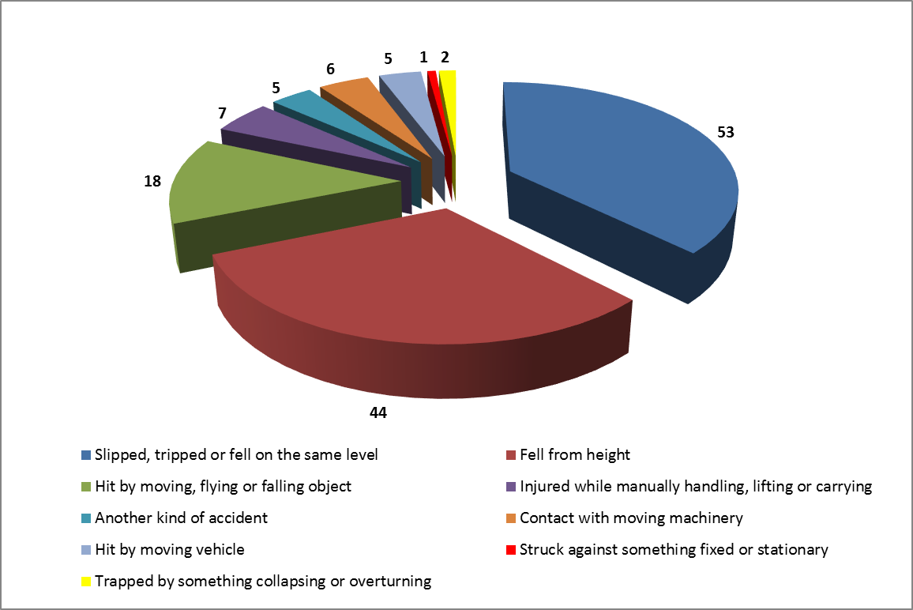

Over 7 Day Injuries
Table 5.2 below provides information on the top six causes of ‘over 7 day injuries’ to employed staff and subcontractors by reporting year.
Table 5.2: Over 7 Day Injuries (employed and subcontractors)
 | 2015/2016 | 2014/2015 | 2013/2014 | 2012/2013
Fall – same level | 90 | 79 | 61 | 53
Hit by moving object | 31 | 39 | 23 | 30
Manual handling | 29 | 22 | 16 | 23
Fall - height | 40 | 31 | 16 | 18
Contact - machinery | 11 | 25 | 7 | 6
Another kind of incident | 37 | 15 | 18 | -
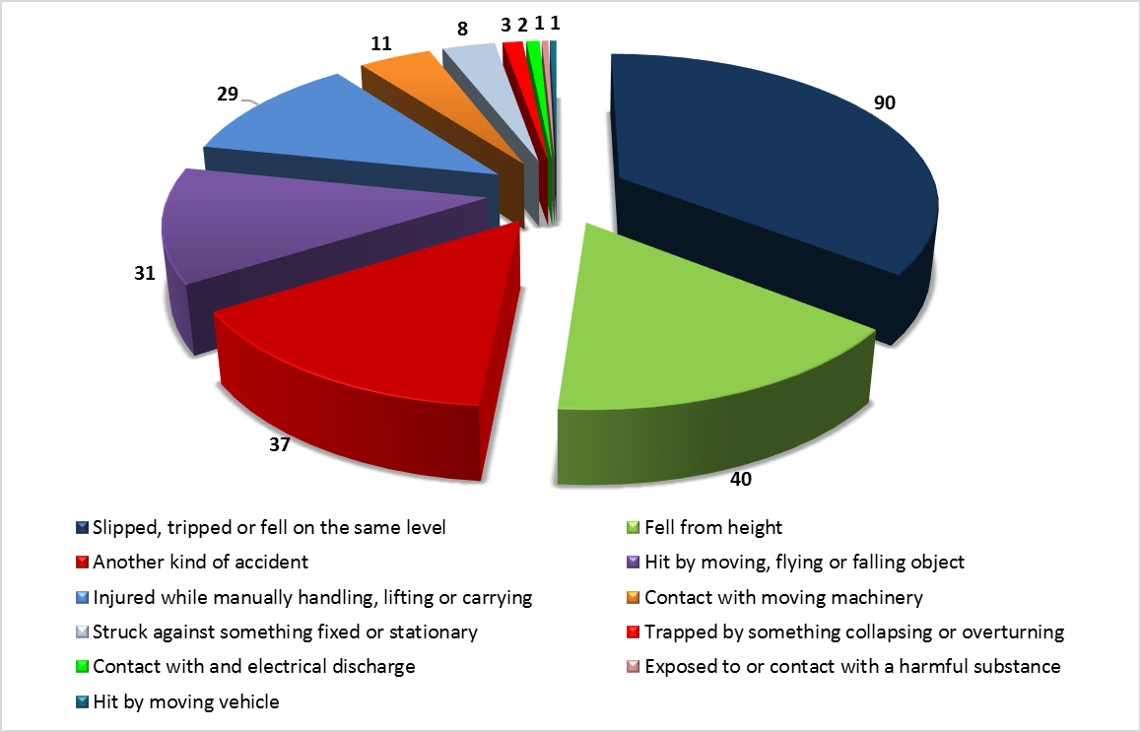

6. Data on Slips, Trips and Falls on the Same Level
Of the 395 incidents reported to the HSE (see table 3.1) 145 were attributable to slips, trips and falls on the same level. Member Organisations were asked to submit data on these incidents and 145 reports were received. Table 6.1 summarises the analysis carried out.

Table 6.1: Summary of Causes

 | (5A) | (5B) | (5C) | (5D) | (5E)
 | Slip, no fall | Slip, fall | Trip, no fall | Trip, fall | Fall | Total
Ditches / Trenches | 0 | 1 | 1 | 1 | 0 | 3
Doorways / Exits | 1 | 3 | 1 | 4 | 1 | 10
Flora | 0 | 0 | 0 | 0 | 0 | 0
Footwear | 0 | 0 | 0 | 0 | 0 | 0
Holes | 0 | 1 | 0 | 1 | 1 | 3
Ice / Snow | 1 | 2 | 0 | 1 | 0 | 4
Ladder use | 1 | 1 | 1 | 0 | 0 | 3
Materials | 1 | 5 | 3 | 14 | 0 | 23
Roof work | 0 | 0 | 1 | 0 | 1 | 2
Rough/Uneven Ground | 2 | 5 | 2 | 7 | 1 | 17
Scaffold use | 2 | 5 | 5 | 9 | 0 | 21
Stepladders | 0 | 0 | 0 | 1 | 0 | 1
Steps / Stairways | 3 | 5 | 1 | 6 | 1 | 16
Tools | 0 | 0 | 0 | 1 | 0 | 1
Unknown | 1 | 3 | 0 | 1 | 0 | 5
Vehicles | 2 | 3 | 0 | 0 | 0 | 5
Waste | 2 | 1 | 0 | 1 | 0 | 4
Wet Floor | 0 | 4 | 0 | 0 | 0 | 4
Wet Ground | 0 | 5 | 0 | 0 | 1 | 6
Other | 3 | 4 | 4 | 4 | 2 | 17
Totals | 19 | 48 | 19 | 51 | 8 | 145

It can be seen from Table 6.1 that the main four causes (contributing to 53% of the total) from falls at same level are:
- materials,
- rough and uneven ground
- scaffold use
- steps and stairways

Further details are given in figures 6.1a and 6.1b

Figure 6.1a: Bar chart of slip, trip and fall contributory causes
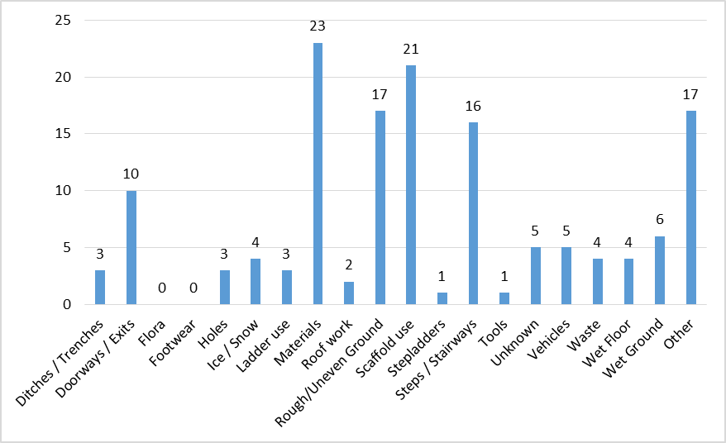

Figure 6.1b: Pie Chart for the number of key slip, trip and fall categories
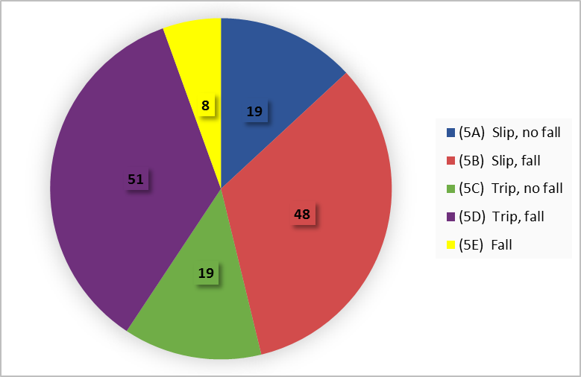
7. Dangerous Occurrences
During the year 25 dangerous occurrences were reported to the HSE (40 were reported last year). Figure 7.1a below details the kinds of dangerous occurrences reported.

Figure 7.1a: Dangerous Occurrences by Kind

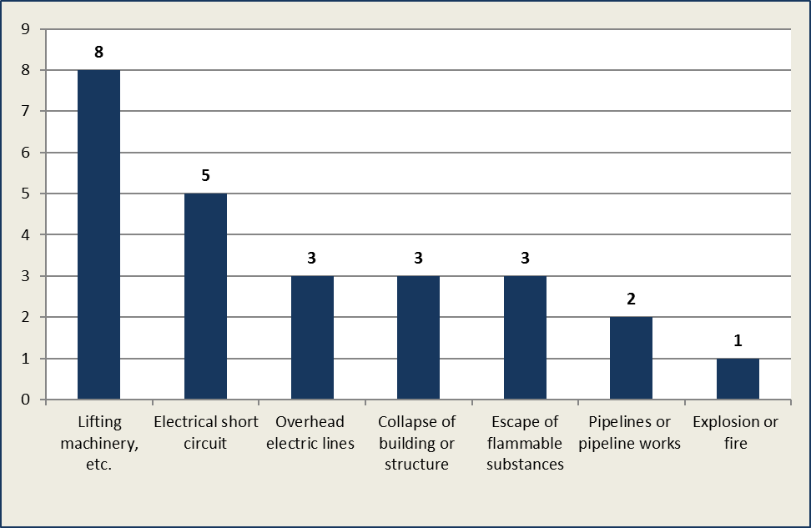

8. Fires on Construction Sites
During the year 5 fires were reported (3 last year).
- 1 brick and block apartment
- 1 timber frame apartment block
- 1 concrete frame apartment block
- 1 timber frame unused site accommodation
- 1 construction vehicle
The causes of the fires by property are detailed in the figure 8.1a.

Figure 8.1a: Causes of Fire by Property
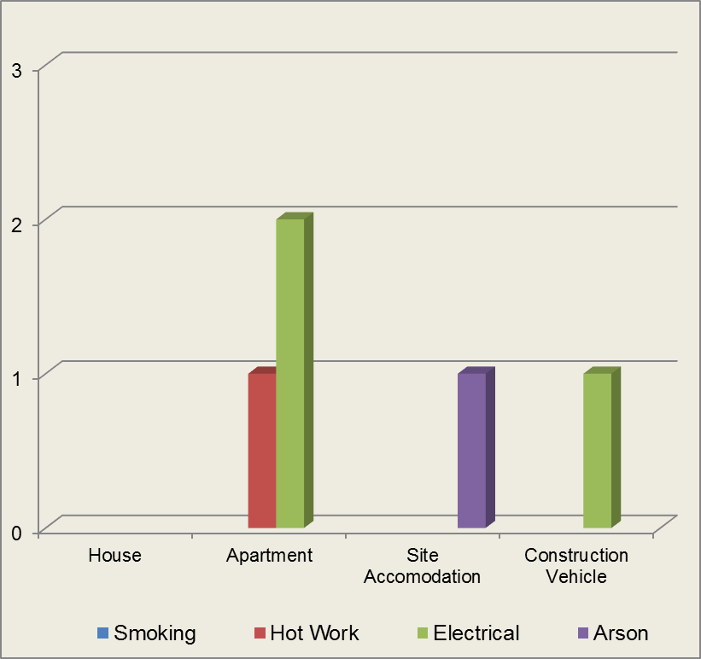

9. Enforcement Action
During the year the Health and Safety Executive (HSE) served a total of 15 Notifications of Contravention* upon Member Organisations (25 last year). Figure 9.1a gives the reasons for the HSE issuing the Notices. Of the 15 Notifications:
- 12 were invoiced, resulting in a total of £9,182.80 being paid to the HSE (giving an average of £765.23 per Notification of Contravention)
- 3 were awaiting an invoice at the time this report was published
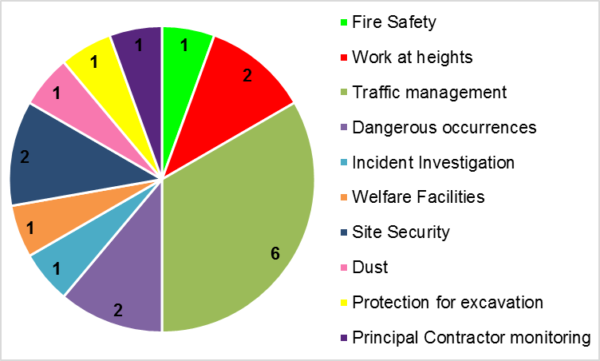
Figure 9.1a: Notifications of Contravention by Reason

* Health and Safety (Fees) Regulations 2012, whereby the HSE can recover their costs when they discover ‘material breaches’ and issue a Notification of Contravention.

10. Causes of Injury – HSE Figures for the Construction Industry
The HSE statistical report ‘ridkind’ that details the causes of both ‘major injuries’ and ‘over seven day injuries’ for the construction industry detailed the following top five by highest number reported through RIDDOR 2015/2016;

 | Major injuries |  | Over seven day injuries
1. | Fall from height | 1. | Injured whilst, lifting, moving or carrying
2. | Fall at same level | 2. | Fall at same level
3. | Struck by moving, falling, flying object | 3. | Fall from height
4. | Struck by moving machinery | 4. | Struck by moving, falling, flying object
5. | Contact with vehicle | 5. | Struck by moving machinery

11. Members of the public
- There were ZERO fatal injuries during the year
- There were 11 reportable injuries and the causes were attributed to:
- 1 Hit by moving, flying or falling object
- 1 Struck against something fixed or stationary
- 6 Slipped, tripped or fell on the same level
- 1 Contact with and electrical discharge
- 2 Another kind of accident

Table 10.1: Reported Injuries to Members of the Public
 | 2015/  2016 | 2014/  2015 | 2013/  2014 | 2012/  2013 | 2011/  2012 | 2010/  2011 | 2009/  2010 | 2008/  2009
Members of the public | 11 | 7 | 8 | 3 | 7 | 8 | 14 | 6

¹ Average number employed does not include the following; visitors to Member Organisation locations, Members of the public, Delivery Drivers, Main contractors employed as ‘Principal Contractor’ under the Construction (Design and Management) Regulations 2015. It does include directly employed staff and those carrying out work for Member Organisations (e.g. subcontractors).

