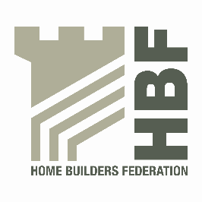 | HBF HEALTH AND SAFETY FORUM  THURSDAY 20th OCTOBER 2016.  MEETING STARTS @ 9AM  LEA MARSTON HOTEL, HAUNCH LANE, LEA MARSTON, SUTTON COLDFIELD, B76 0BY
AGENDA

- Welcome and Introductions

- Notes of previous meeting

- Sub Group updates

- Dust in Construction – Dave Hickman
Update of action plan & do it right materials (from 05/15)
Proposed actions from HSE Wood dust survey (from 05/16)
The case for an HBF Occupational Health video (from 01/15)

- Roof Trusses – Craig Donelan
- CDM – Steve Acaster

- Timber Construction Concerns and Barriers &16 steps update
Martin Milner - STA

- BIM4 Health & Safety – Gordon Crick - HSE

- Statistics update (Reportable Injuries and Dangerous Occurrences/Fire Incidents/Fee for Intervention) including annual report update and update on collection of data & injury comparison with other industries

- HSE update

- Update from CONIAC – Steve Acaster

- Sentencing Guidelines – Martyn Price

- Pokemon GO – Site problems

- All Party Parliamentary Carbon Monoxide Group/Forum

- Health and Safety Charter

- Charter Action Plan

- Contact list

- Meeting dates 2017

Thursday 19 January, Thursday 4 May, Thursday 13 July, Thursday 26 October
- Any Other Business

