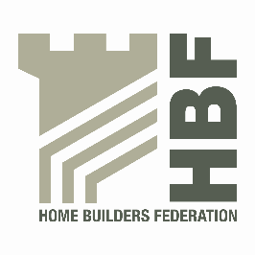 | HBF HEALTH AND SAFETY FORUM  THURSDAY 7th JULY 2016.  MEETING STARTS @ 9AM  LEA MARSTON HOTEL, HAUNCH LANE, LEA MARSTON, SUTTON COLDFIELD, B76 0BY

AGENDA

- Welcome and Introductions

- Notes of previous meeting

- Dust in Construction latest – Dave Hickman

- Occupational Health view from Construction Health Leadership Group - Lawrence Waterman

- Occupational Health & Wellbeing group update – Michelle Shani

- Statistics update (Reportable Injuries and Dangerous Occurrences/Fire Incidents/Fee for Intervention) including annual report update and update on collection of data & injury comparison with other industries

- Guidance/Sub Group Updates:

- Contact list
- Health and Safety Charter
- Charter Action Plan
- CDM sub-group

- Update from CONIAC

- CITB Forum – Steve Acaster

- All Party Parliamentary Carbon Monoxide Group/Forum

- Meeting dates 2016

- Thursday 20 October

- Any Other Business

