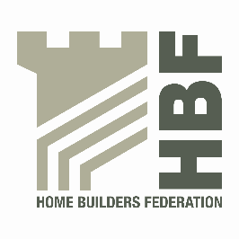 | HBF HEALTH AND SAFETY FORUM  THURSDAY 5TH MAY 2016.  MEETING STARTS @ 9AM  LEA MARSTON HOTEL, HAUNCH LANE, LEA MARSTON, SUTTON COLDFIELD, B76 0BY

AGENDA

- Welcome and Introductions

- Notes of previous meeting including Action Log update

- Sentencing Guidelines – Steffan Groch

- Dust in Construction latest – Dave Hickman

- Occupational Health & Wellbeing questionnaire results

- a) Statistics update (Reportable Injuries and Dangerous Occurrences/Fire Incidents/Fee for Intervention) including annual report update and update on collection of data & injury comparison with other industries

b) Data collection

- Guidance/Sub Group Updates:

- Contact list
- Health and Safety Charter
- Charter Action Plan
- CDM sub-group

- Falls from vehicles – David Ford

- Update from CONIAC

- Staircase installation review

- CITB Forum – Steve Acaster

- Meeting dates 2016

- Thursday 7 July
- Thursday 20 October (BE AWARE THIS IS A NEW DATE)

- Any Other Business

