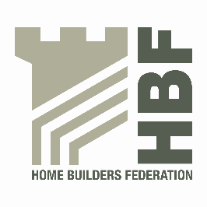 | HBF HEALTH AND SAFETY FORUM  THURSDAY 21st JANUARY 2016.  MEETING STARTS @ 9AM  LEA MARSTON HOTEL, HAUNCH LANE, LEA MARSTON, SUTTON COLDFIELD, B76 0BY

- Welcome and Introductions

- Notes of previous meeting including Action Log update

- Feedback from Health and Safety focus group meeting on 11th December

- Dust in Construction latest – Dave Hickman/Ed Woods

- Statistics update (Reportable Injuries and Dangerous Occurrences/Fire Incidents/Fee for Intervention) including annual report update and update on collection of data

- Guidance/Sub Group Updates:

- Contact list
- Health and Safety Charter
- Charter Action Plan
- Installation of Roof trusses/Work at Height sub-group
- CDM sub-group

- Update from CONIAC

- GE700 – Homebuilding chapter

- HSE – Beam and Block Floors – Review of musculoskeletal disorders

- Meeting dates 2016

- Thursday 5 May
- Thursday 7 July
- Thursday 6 October

- Any Other Business

