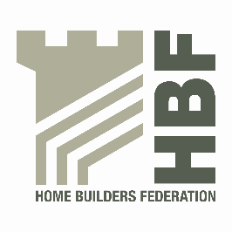 | HBF HEALTH AND SAFETY FORUM  1ST OCTOBER 2015. MEETING STARTS @ 9AM  LEA MARSTON HOTEL, HAUNCH LANE, LEA MARSTON, SUTTON COLDFIELD, B76 0BY

AGENDA

- Welcome and Introductions

- Notes of previous meeting including Action Log update

- Feedback from MSC discussions

- Dust in Construction update – Dave Hickman/Ed Woods

- Open Dust Seals - Openreach

- HSE/HBF review of working at height within homebuilding.

  - Guide to a Scaffold Specification
  - Soft Landing Systems
These are now approved & subject to meeting can go out

- Statistics update (Reportable Injuries and Dangerous Occurrences/Fire Incidents/
Fee for Intervention) including annual report update and update on collection of data

- Guidance/Sub Group Updates:

- Contact list
- Health and Safety Charter
- Charter Action Plan
- Installation of Roof trusses/Work at Height sub-group
- CDM sub-group

- Site Perimeter Protection

- Update from CONIAC

- GE700 – Homebuilding chapter

- HSE – Beam and Block Floors – Review of musculoskeletal disorders

- 2016 chair

- Meeting dates 2016

- Thursday 21 January
- Thursday 5 May
- Thursday 7 July
- Thursday 6 October

- Any Other Business

