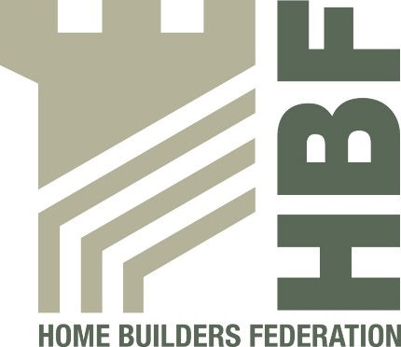
Health & Safety Statistics

April 2014 – September 2014

Q1 & Q2 2014-2015 report

MISSING TWO COMPANIES Q2 DATA

1 fatality from Charter Signatories April 2014 – September 2014

Injuries to Members of Public Q2 2014/15 (July 2014 – September 2014)

During the period Q2 2014/15 (July 2014 – September 2014) there have been 1 reported incidents involving a member of the public.

