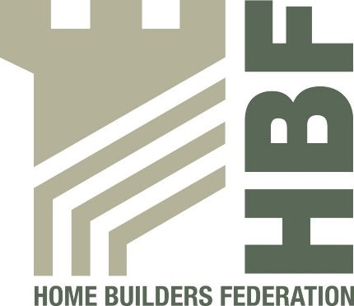
Health & Safety Statistics

April 2014 – June 2014
Q1 2014-2015 report

ISSUE 02

1 fatality from Charter Signatories April 2014 – June 2014

Injuries to Members of Public Q1 2014/15 (April 2014 – June 2014)

During the period Q1 2014/15 (April 2014 – June 2014) there has been 1 reported incidents involving a member of the public.

