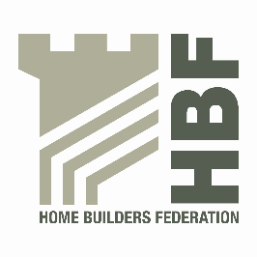 | HBF HEALTH AND SAFETY FORUM  THURSDAY 22 JANUARY @ 9.am  LEA MARSTON HOTEL  HAUNCH LANE  LEA MARSTON  SUTTON COLDFIELD  B76 0BY

AGENDA

- Welcome and Introductions

- Notes of previous meeting including Action Log update

- Dust in Construction – Dave Hickman

- HSE/HBF review of working at height within homebuilding.

  - Guide to a Scaffold Specification
  - Soft Landing Systems

- Statistics update (Reportable Injuries and Dangerous Occurrences/Fire
Incidents/ Fee for Intervention) including annual report update and update on collection of data.

- Guidance/Sub Group Updates:

- Contact list
- Health and Safety Charter
- Charter Action Plan
- Installation of Roof trusses/Work at Height sub-group
- Temporary Works sub-group
- CDM sub-group

- Update from CONIAC

- London Best Practice Guide – Control of Dust and Emissions

- Consumer Units – Potential Fire Risk

- Next meeting date

- Thursday 7 May 2015

