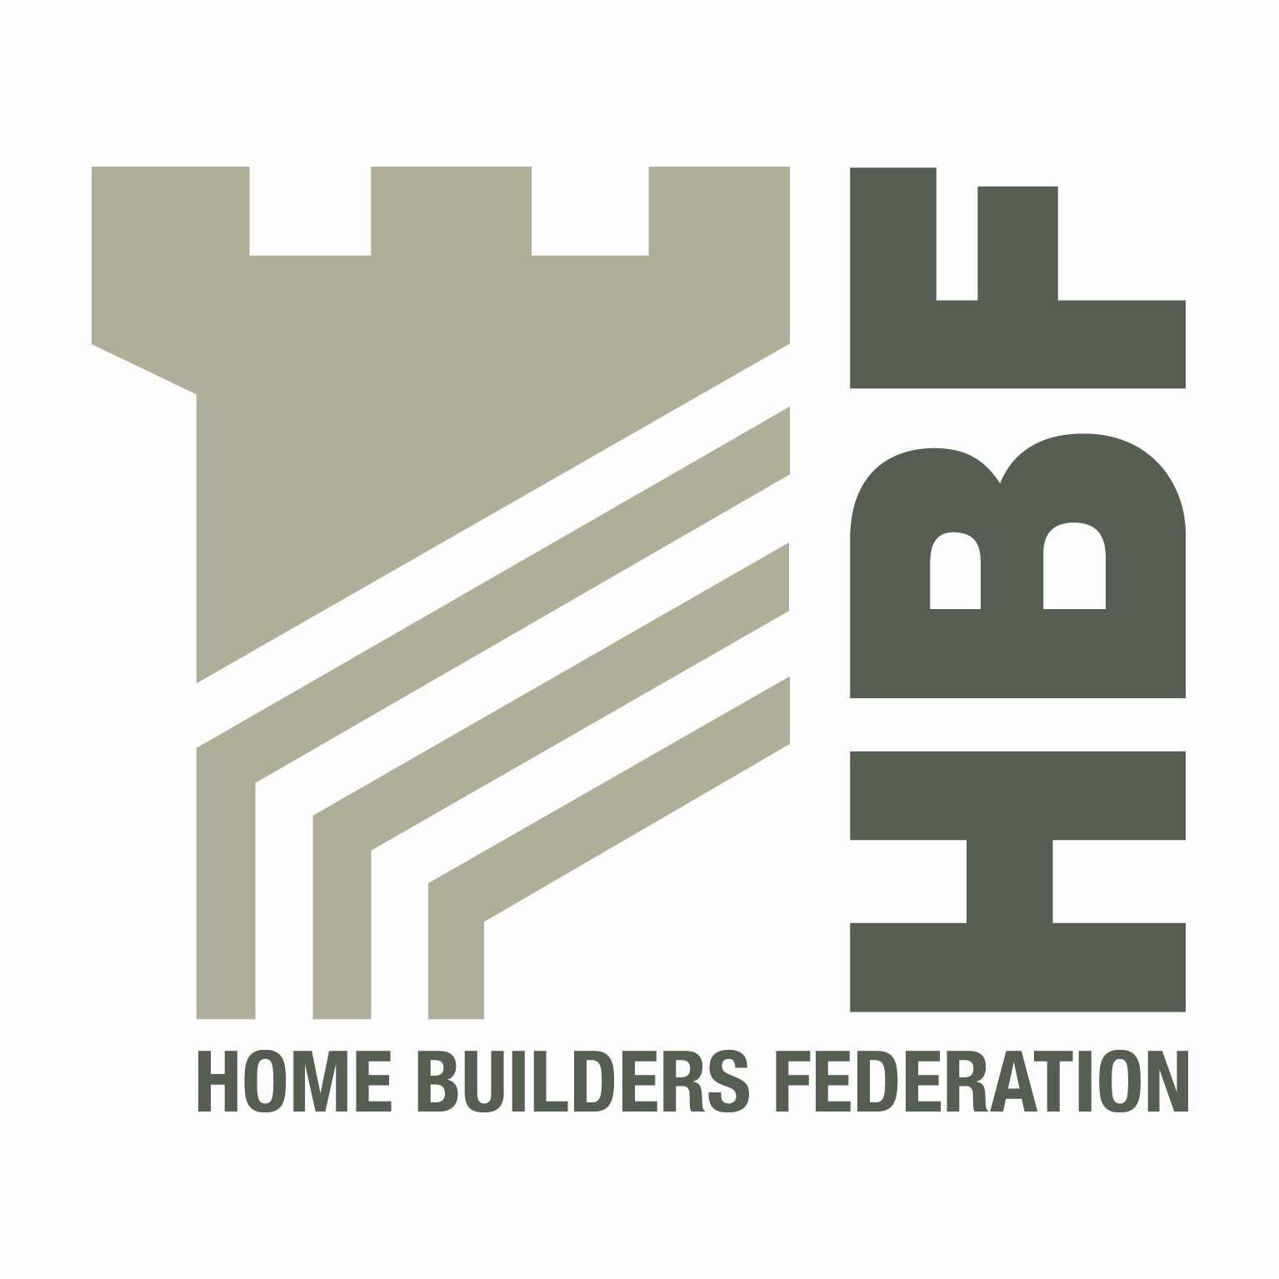 HBF HEALTH AND SAFETY FORUM
THURSDAY 3 OCTOBER 2013
WENTBRIDGE HOUSE HOTEL
WENTBRIDGE, PONTEFRACT
WEST YORKSHIRE, WF8 3JJ

NOTES OF MEETING
PRESENT
Peter Heenan | Bancon Group | Vince Coyle (Chair) | Barratt Homes
Tracey Murphy | Bellway Homes | Barry Oliver | Berkeley Group
Andrew Locker | Bloor Homes | Paul Haxell | Bovis Homes
Ken Millar | CALA Group | David Hudson | Countryside Properties
Martyn Price | Crest Nicholson | Eamonn McMenamin | Davidsons Developments
Joe Yardley | Larkfleet | Martin Lloyd | Lend Lease
Steve Langslow | Lovell | Dave Hickman | Miller Homes
David Bolton | Morris Homes Ltd | Christopher Epps | NHBC
Tony Haigh | Persimmon Homes | Mark Dyche | RFS Consultancy
John Rutter | RFS Consultancy | Lee Mills | Stewart Milne Group
David Sanderson | Story Homes | Vernon Cunningham | Strata Homes
Dave Carter | Taylor Wimpey | Steve Dudman | Westleigh Developments
Alex Winkler | Willmott Dixon Housing

IN ATTENDANCE
Dave Mitchell | HBF

APOLOGIES
Steve Foley | Avant Homes | David Ford | Barratt
Garry Rapson | Croudace | Matthew Stubblefield | Croudace
Steve Allix | Fairview New Homes | Paul Howarth | Galliford Try
Nigel Parsons | Larkfleet | Darryl Hammond | Lovell
John Nelson | McCarthy & Stone | Steve Acaster | Persimmon Homes
Silvio Petrasso | Stansted Environmental Services | Andrew Pegg | Yuill

- Welcome and Introductions
VC opened the meeting and welcomed everyone. Apologies were accepted from those listed above. New members were introduced to the forum.
- Notes of previous meeting
These were taken as read with the following comments;
SSIP – VC working on this and will report back.
Confirmation that the Gas Safe presentation from the last meeting had been sent out to members of the forum
- Business Case – Subscription fees for Membership of the Forum
VC talked about the current position re the business case and that we were still awaiting some subscriptions to come in.
DM explained that these fees would be ring fenced solely for Health and Safety meeting arrangements and any campaigns.
- Public Health Responsibility Deal – Construction Launch
Martin Coyd from Lend Lease gave a presentation surrounding the public health responsibility deal construction launch.
VC to prepare note for CEOs asking for support and forum members to take back to the organisations to also seek report. Providing there is a general consensus surrounding this from members, HBF could sign up although there is nothing to stop forum member companies signing up if they wished.

- Guidance Groups
- Contact List
Members asked to check that the correct details are shown on the contact lists.
- Health and Safety Charter
This will be re issued in the new year with additional signatories included.
- Charter Action Plan
The Action plan needs to be updated to clearly show the work that the group intends to undertake.
Suggested additional items to the existing list include Temporary works, Environmental Agency issues, Installation of roof trusses, Accident stats and how best to use them, Use of trestles, HSE inspection programmes, Plant and People, Occupational Health issues, CDM, Behavioural Strategies.
VC to draw up revised action plan list to bring back to the group.
- Sun Safe Campaign update
64,000 leaflets and 4,400 posters were requested by members and the forum considered this campaign was a big success although it is noted that it is very hard to measure how successful these kind of campaigns are.
- Installation of Roof Trusses
VC updated the group on this. The problem surrounding this is the top bracing and how this is fixed. One member had worked with a safety products company and they have come up with a ladder which fits between the trusses allowing safe access. This is to be reviewed further.

- Scaffolding
VC had previously asked the group for comments. SA had come back with some comments.
VC will take away and tidy up the document and move this forward.

- Telehandler Working Party
Next meeting for this working group is 25th October. Members attending will report back at next meeting.
- Incident Updates/Bulletins
VC provided a draft format for an alert which all agreed was acceptable. An alert on potential telehandler failure will be issued to members.
- Statistics update (Reportable Injuries and Dangerous Occurrences/Fire Incidents/Fee for Intervention)
MP explained to the group the need for getting the stats in by the deadline dates. This has proved problematical for some in the past.
Deadlines to be extended to 6 weeks in order to help.
DM reported back from the recent HBF board meeting. In order to benchmark the accident stats to get a more accurate comparison for members it was agreed that accidents were to be expressed as a percentage of dwellings built rather than sites.
The H & S forum are to consider how the accuracy of the stats might be challenged and improved. This is for the benefit of all companies submitting stats.
The H & S forum will look at and examine any trends that appear from the stats and lastly the production of rolling stats was considered by all to be a good move forward.
- Update from CONIAC
PH updated the group on the CONIAC meeting held back in July.
CPA have issued guidance on conc; pumps
There is also an update of medical standards.
PH draft CONIAC notes to be circulated to group.

- CDM Consultation
PH met with Anthony Lees surrounding this consultation. Latest information is to expect a consultation in late summer 2013. This date is however slipping and members will be kept informed.
They are progressing guidance for issue twelve months before enforcement of regulations.
Suggested that we should look at developing our own industry guidance which we should put into the groups work plan moving forward.
Post meeting note PH has suggested that SA (with his approval ) should head up this group.
- NHBC – Entry into Roof spaces
Paper re this issued with pack.
NHBC inspectors will not go into roof spaces to carry out inspections. They only view from roof hatch.
They are looking to now go into roof spaces in order to inspect ventilation, flues and fire stopping etc, but they need builders to provide safe access to the parts of the roof requiring inspection.
DM said he will discuss this issue further with NHBC and report back to the group.
- RIDDOR
This was an agenda item for information on changes to RIDDOR
- Use of Trestles
A query was raised regarding the use of handrails on trestles and when these are permitted. VC reported that he written to HSE as it was understood there was a working party on the issue. No response from HSE as yet.
There is a need to establish if there is a standard for this. If not what is the industries view.
Members of the forum were asked to e mail VC on their current practice surrounding this.
- HSE matters – working well together
Aims in the remainder of 2013 and 2014 are to hold further training sessions in Occupational health, Silica and fragile roofs.
- Manual Handling – Drop-box presentation
A supplier provide a presentation on their ‘Drop box’ system for lifting materials.
Copies of presentation to be circulated to the forum.
- Drugs and Alcohol Testing
DH to pass policy through to VC for sharing with the group.
DH said this has big implications so it needs to be looked at very carefully.
Agenda item for next meeting.
- CSCS Scheme Changes
Paper in forum members pack re scheme changes.
Labour green card will be become a NVQ 1 qualification and additional professional qualified routes of entry have been opened.
- Dates for 2014
- Thursday 23rd January - Lea Marston Hotel
- Thursday 1st May - Venue to be organised
- Thursday 3rd July - Birmingham – note date change
- Thursday 9th October - Venue to be organised

