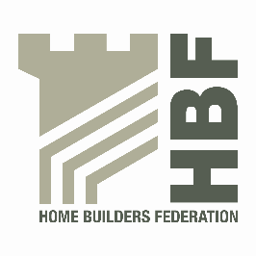 | HBF HEALTH AND SAFETY FORUM  09.00HRS – THURSDAY 23rd JANUARY 2014  (Tea and Coffee available from 8.30am)  LEA MARSTON HOTEL,  HAUNCH LANE, LEA MARSTON,  SUTTON COLDFIELD,  B76 0BY

AGENDA

- Welcome and Introductions

- Notes of previous meeting

- Priorities for House Building from 2014 – Simon Longbottom - HSE

- Guidance/Sub Group Updates:

- Contact list
- Health and Safety Charter
- Charter Action Plan
- Installation of Roof trusses
- Scaffolding
- Telehandler Working Party
- Hot Topics (Incident Updates/Bulletins)
- Boilers
- Fireplaces

- Statistics update (Reportable Injuries and Dangerous Occurrences/Fire
Incidents/ Fee for Intervention)

- Engaging with the Workforce – DH

- Insurance Claims – Review - AL

- Update from CONIAC - PH

- Temporary Works - SA

- TG20:13 – Presentation by Simon Hughes

- CDM Consultation - PH/SA

- Use of Trestles - EW

- Dates for 2014

- Thursday 1 May
- Thursday 3 July - Hilton, Brindley Place, Birmingham
- Thursday 9 October

