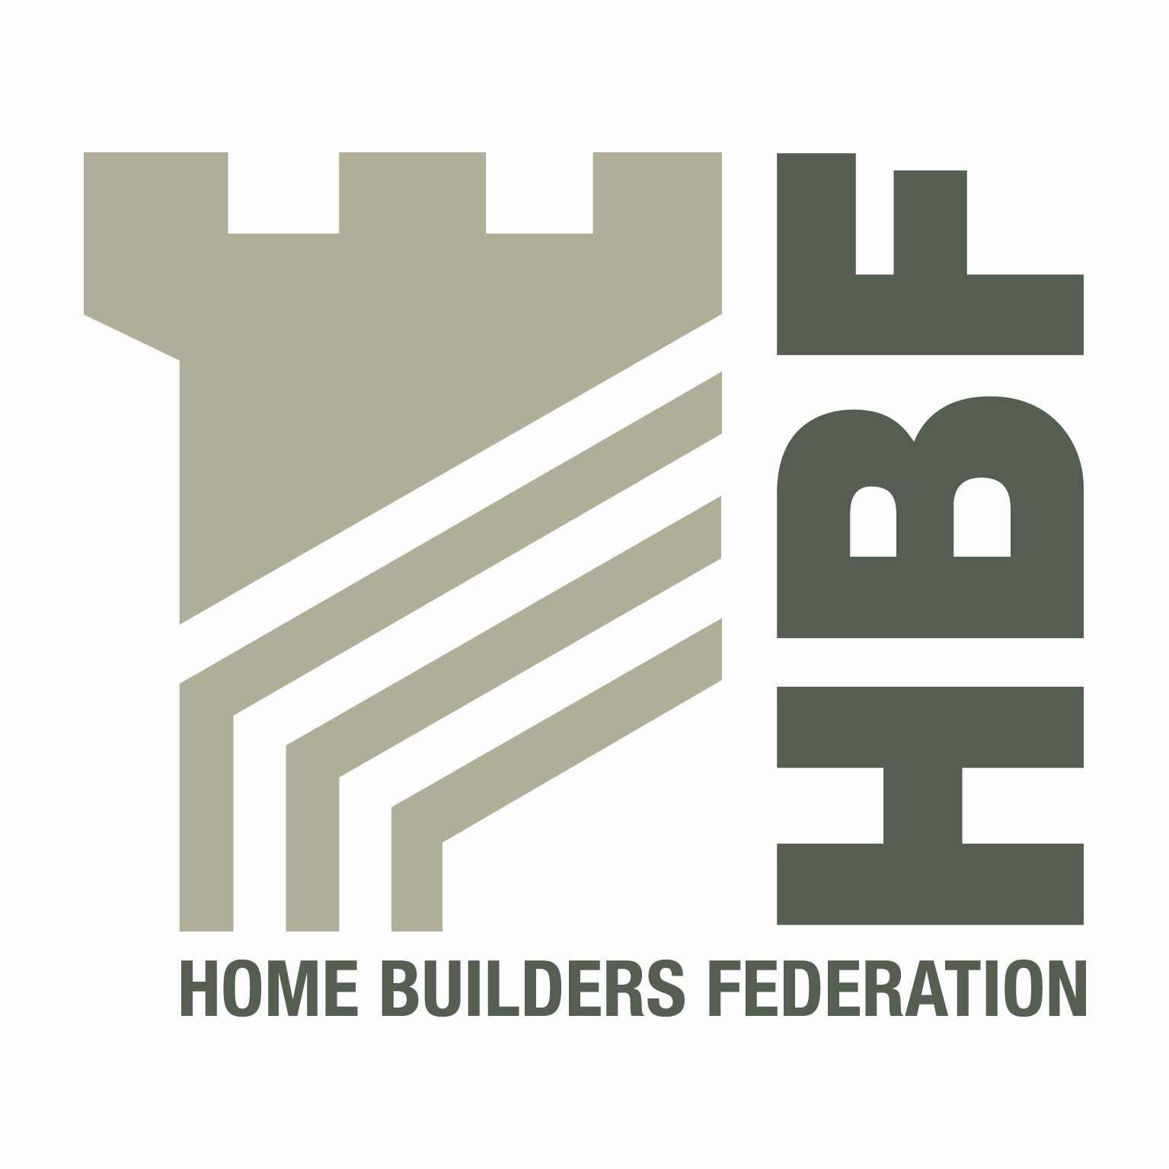 | HBF HEALTH AND SAFETY FORUM  09.30HRS – THURSDAY 3 OCTOBER 2013  (Tea and Coffee available from 9.00am)  WENTBRIDGE HOUSE HOTEL  WENTBRIDGE, PONTEFRACT  WEST YORKSHIRE WF8 3JJ

AGENDA

- Welcome and Introductions

- Notes of previous meeting

- Business Case – Subscription Fees for Membership of the Forum

- Public Health Responsibility Deal – Construction Launch

- Mark Coyd – Lend Lease, Regional Head of Environment, Health and Safety – Europe, Middle East & Africa

- Guidance/Sub Group Updates:

- Contact list
- Health and Safety Charter
- Charter Action Plan
- Sun Safe Campaign update
- Installation of Roof trusses
- Scaffolding
- Telehandler Working Party
- Incident Updates/Bulletins

- Statistics update (Reportable Injuries and Dangerous Occurrences/Fire Incidents/
Fee for Intervention)

- Update from CONIAC

- CDM Consultation

- NHBC – Entry into Roofspaces

- RIDDOR

- Use of Trestles

- HSE Matters – Working Well Together

- Manual Handling – Drop-box Presentation

- Drugs and Alcohol Testing

- CSCS Scheme Changes

- Dates for 2014

- Thursday 23 January
- Thursday 1 May
- Thursday 17 July
- Thursday 9 October

- Any Other Business

