
Health & Safety Statistics
Draft Report:
Data from two companies is outstanding

Data from 3 companies
January 2013 – March 2013
Q4 2012-2013 draft report

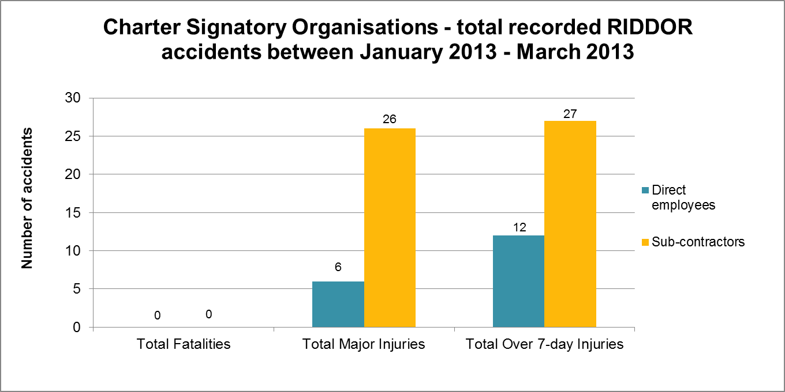
There were no fatalities from Charter Signatories January 2013 – March 2013

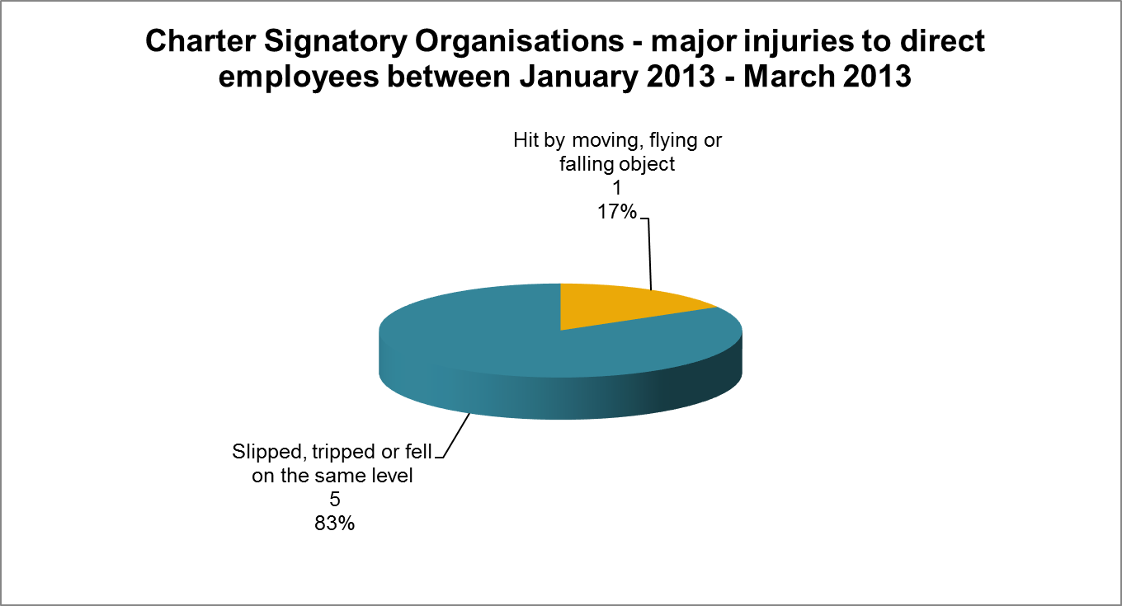
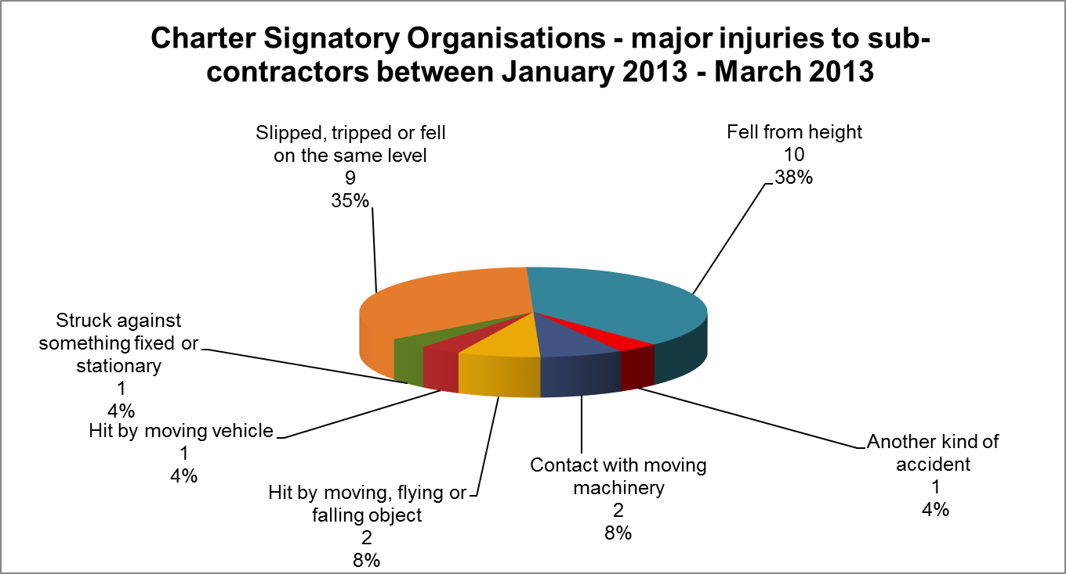
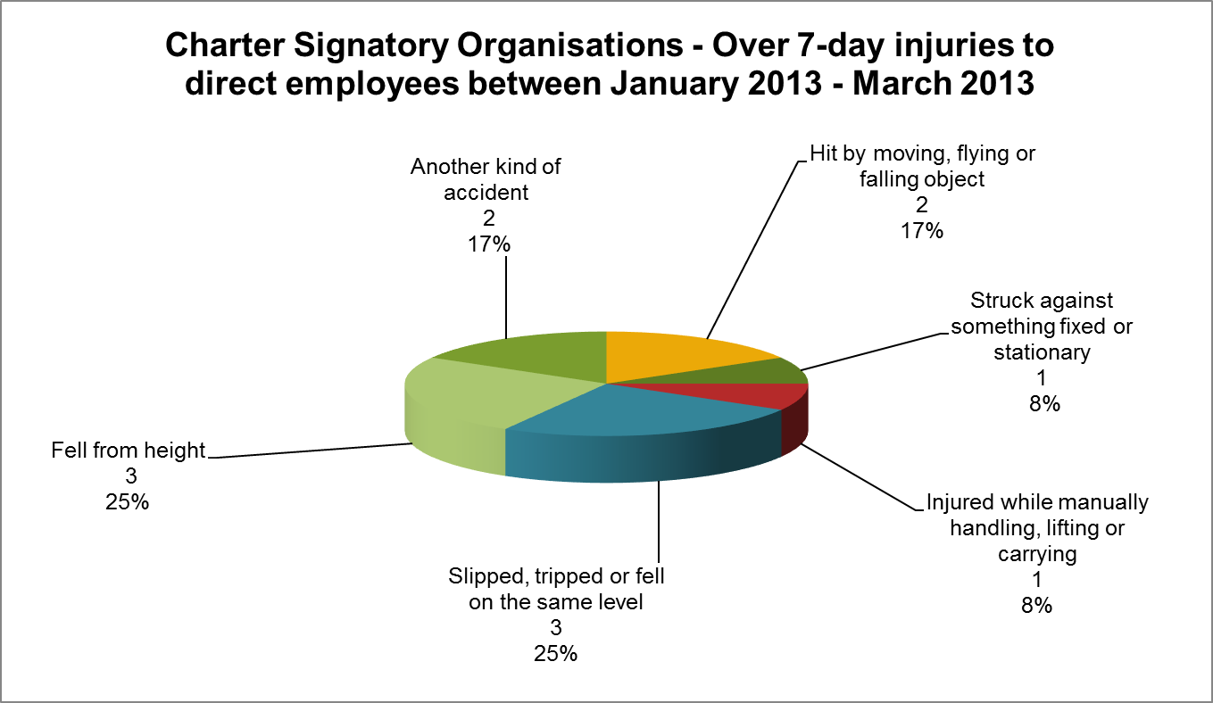
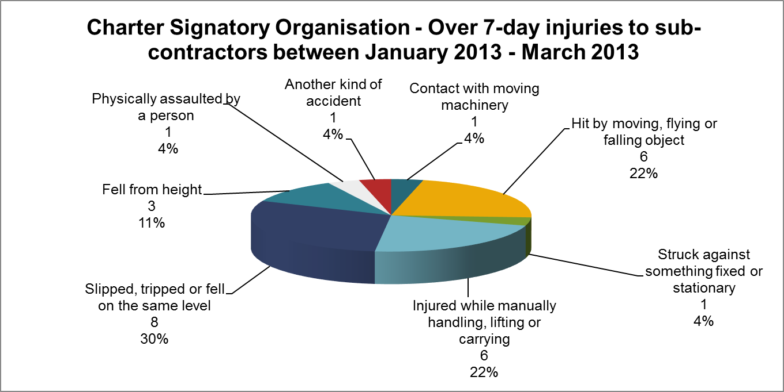
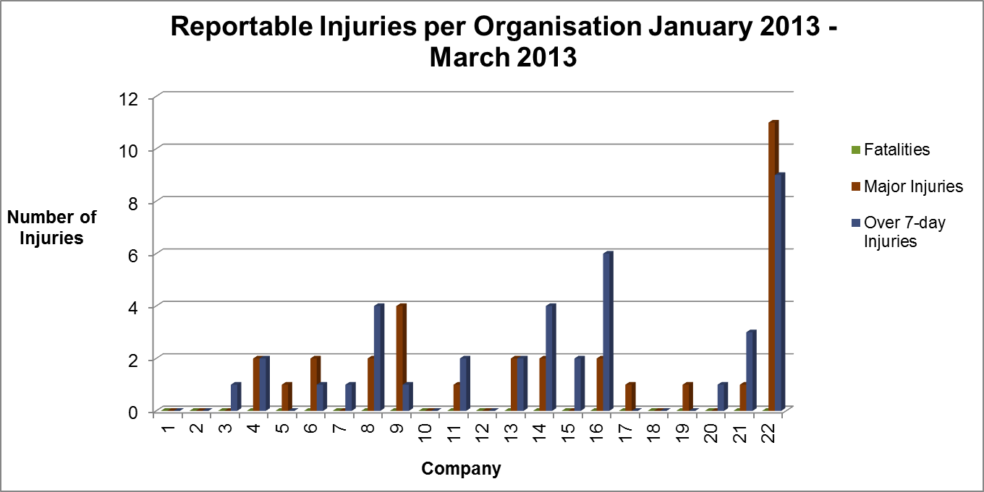

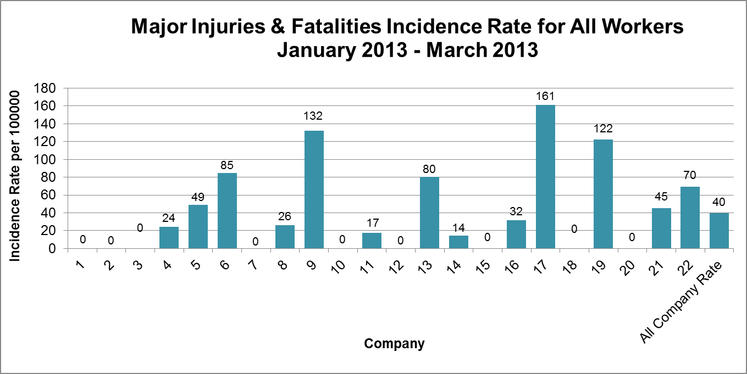

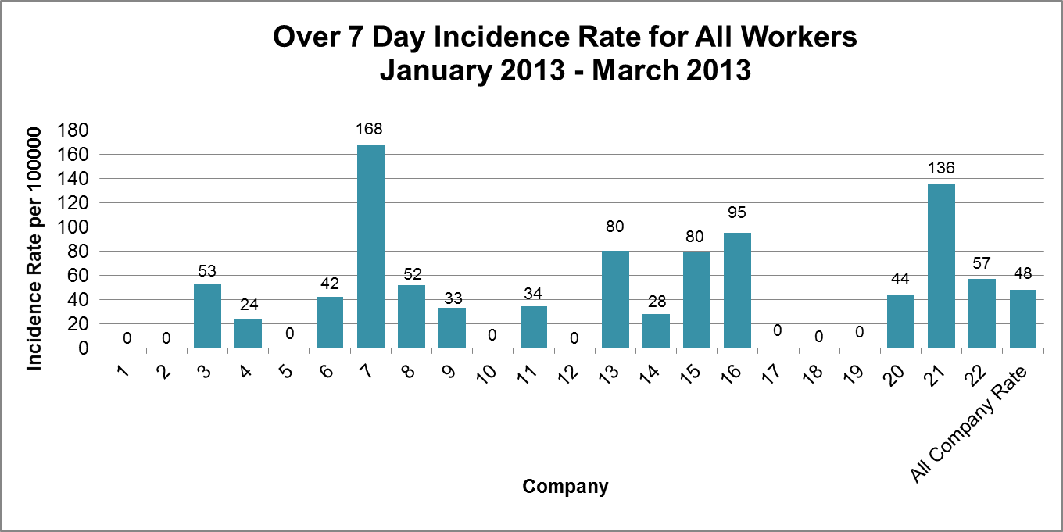

Injuries to Members of Public Q4 2012/13 (January 2013 – March 2013)

During the period Q4 2012/13 (January 2013 – March 2013) there were no reported incidents involving a member of the public.

