

HBF Health and Safety Statistical Analysis

Annual Report 2012 - 2013

Issue 001, June 2013

DRAFT



Health and Safety Statistical Analysis Report for
the Year 2012/2013

Issue 001 24th June 2013

Section 4, Figure 4.1 and Section 8 of this issue will be updated to reflect the data published in the November 2013 release of the HSE Statistical Reports.

CONTENTS:
1. Introduction
2. General Data
3. Reportable Injuries
4. Annual Injury Incidence Rate (AIIR)
5. Causes of Injury – HBF Member Organisations
6. Data on Slips and Trips
7. Fires on Construction Sites
8. Causes of Injury – HSE Figures for the Construction Industry
9. Members of the public
1. Introduction
This report deals with data provided by those HBF Member Organisations that have volunteered to provide information on injuries reported by them in accordance with the Reporting of Injuries, Diseases and Dangerous Occurrences Regulations 1995 (RIDDOR). These data have been analysed in various ways and a written summary is contained in this report. The scope of the reporting covers all locations under the control of each HBF Member Organisation with the exception of locations operated by main contractors employed by a Member Organisation as a ‘Principal Contractor’ under the Construction (Design and Management) Regulations 2007.

2. General Data
- 22 HBF member organisations contributed their data during the year (17 contributed last year).
- The 22 member organisations employed, on average, 81,470 people (last year the 17 member organisations employed an average of 74,887).
Table 2.1: Member Organisations and Average Number Employed
 | 2012/2013 | 2011/2012 | 2010/2011 | 2009/2010 | 2008/2009 | 2008/2007
Number of Member Organisations | 22 | 17 | 17 | 17 | 16 | 19
Average Number Employed¹ | 81,470 | 74,887 | 66,879 | 55,880 | 61,695 | 100,317

3. Reportable Injuries
Directly employed
- There were ZERO fatal injuries during the year - for the 5th consecutive year.
- There were 24 ‘major injuries’ (up 14% on last year’s 21).
- There were 37 ‘over 7 day injuries’ (no comparison with last year is possible since it was ‘over 3 day injuries’ which were reported last year – see Table 3.1 for details)

Subcontractors
- There was 1 fatal injury during the year, (none occurred last year).
- There were 89 ‘major injuries’ (up 2% on last year’s 87).
- There were 118 ‘over 7 day injuries’ (no comparison with last year is possible since it was ‘over 3 day injuries’ which were reported last year – see Table 3.1 for details).).

All reported injuries
The total number of injuries reported to the HSE during the year was 269. However, no comparison with last year is possible since it was ‘over 3 day injuries’ which were reported last year, rather than ‘over 7 day injuries’ as reported this year. The relevant data are given in Table 3.1 below.

Table 3.1: All Reported Injuries (employed and subcontractors)
 | 2012/2013 | 2011/2012 | 2010/2011 | 2009/2010 | 2008/2009 | 2008/2007
Fatalities | 1 | 0 | 2 | 0 | 0 | 1
Major Injuries | 113 | 108 | 108 | 90 | 94 | 180
Over 3 Day Injuries | -- | 261 | 259 | 205 | 252 | 502
Over 7 Day Injuries | 155 | -- | -- | -- | -- | --
Total | 269 | 369 | 369 | 295 | 346 | 683

4. Annual Injury Incidence Rate (AIIR)
The ‘Home Builder’ AIIR for 2012/2013 was 330 (no comparison with last year is possible because of the reporting changes already described in the above section titled ‘All reported injuries’).

The Construction Industry AIIR for 2012/2013 will be published by the HSE in November 2013 at which time a revised version of this report will also be published.

Figure 4.1a shows the HBF and HSE Annual Injury Incidence Rates for 2006/2007 to 2011/2012. The revised version of this report will include Figure 4.1b which will show the equivalent information for 2012/2013 AIIRs.
Figure 4.1a: Annual Injury Incidence Rate (AIIR) 2006/2007 to 2011/2012
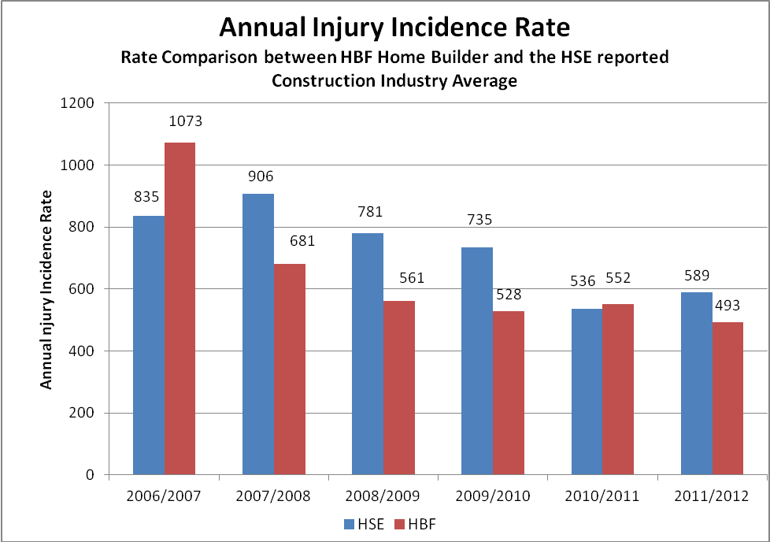
5. Causes of Injury – HBF Member Organisations
Fatal Injuries
There was one fatal injury, an operative fell from height.

Major Injuries
Table 5.1a below provides information on the top five causes of major injuries to employed staff and subcontractors in 2012/2013 and the top six causes in previous years. There are only five causes recorded for 2012/2013 because three categories – Hit by moving vehicle, Trapped by something collapsing and Other – each had four injuries in this period.
Table 5.1a: Major Injuries (employed and subcontractors)
 | 2012/2013 | 2011/2012 | 2010/2011 | 2009/2010 | 2008/2009 | 2007/2008
Slipped, tripped, fell on the same level | 50 | 33 | 42 | 37 | 42 | 57
Fall – height | 21 | 38 | 26 | 29 | 23 | 73
Hit by object | 15 | 15 | 11 | 5 | 7 | 19
Manual handling | - | 4 | 4 | 4 | 8 | 13
Contact - machinery | 6 | 3 | 7 | 3 | 3 | 7
Struck by vehicle | - | 2 | 5 | 1 | 2 | 2
Struck against something | 6 | - | - | - | - | -

Over 7 Day Injuries
Table 5.1b below provides information on the top six causes of ‘over 7 day injuries’ to employed staff and subcontractors in 2011/2012. Table 5.1.c gives equivalent information for ‘over 3 day injuries’ from 2007/2008 to 2011/2012.
Table 5.1b: Over 7 Day Injuries (employed and subcontractors)
 | 2012/2013
Slipped, tripped, fell on the same level | 53
Hit by object | 30
Manual handling | 23
Fall - height | 18
Struck against something fixed | 6
Contact with moving machinery | 6

Table 5.1c: Over 3 Day Injuries (employed and subcontractors)
 | 2011/2012 | 2010/2011 | 2009/2010 | 2008/2009 | 2007/2008
Slipped, tripped, fell on the same level | 86 | 100 | 68 | 81 | 171
Manual handling | 48 | 37 | 40 | 56 | 88
Fall - height | 34 | 32 | 22 | 22 | 69
Hit by object | 30 | 28 | 27 | 35 | 62
Struck against something fixed | 20 | 9 | 14 | 19 | 25
Contact with moving machinery | 10 | 10 | 11 | 5 | 15

6. Data on Slips, Trips and Falls on the Same Level
Of the 269 incidents reported to the HSE (see table 3.1) 103 were attributable to slips, trips and falls on the same level. Member organisations were asked to submit data on these incidents and 103 reports were received. Table 6.1 summarises the analysis carried out.

Table 6.1: Summary of Causes
 | (5A)  Slip, no fall | (5B)  Slip, fall | (5C)  Trip, no fall | (5D)  Trip, fall | (5E)  Fall | Total
Doorways / Exits | 0 | 0 | 0 | 2 | 0 | 2
Ladders | 0 | 0 | 0 | 0 | 5 | 5
Stairways / Steps | 1 | 4 | 1 | 1 | 2 | 9
Scaffold Use | 1 | 4 | 1 | 2 | 7 | 15
Footwear / Clothing | 0 | 0 | 0 | 0 | 1 | 1
Ice / Snow | 0 | 2 | 0 | 0 | 0 | 2
Wet Ground | 0 | 1 | 0 | 0 | 0 | 1
Wet Floor | 0 | 2 | 0 | 1 | 1 | 4
Materials | 2 | 6 | 2 | 6 | 2 | 18
Waste | 1 | 0 | 1 | 0 | 0 | 2
Rough / Uneven Ground | 1 | 3 | 2 | 3 | 1 | 10
Hole | 1 | 0 | 2 | 1 | 4 | 8
Lost Footing / Balance | 5 | 2 | 4 | 2 | 3 | 16
Vehicle (getting in/out) | 1 | 2 | 0 | 0 | 1 | 4
Fixed Object | 0 | 1 | 3 | 1 | 0 | 5
Trailing Cable | 0 | 0 | 1 | 0 | 0 | 1
 | 13 | 27 | 17 | 19 | 27

It can be seen from Table 6.1 that the main causes are materials, persons losing their footing or balance and scaffold use and further details are in figures 6.1. and 6.2
Figure 6.1: Histogram of slip, trip and fall contributory causes

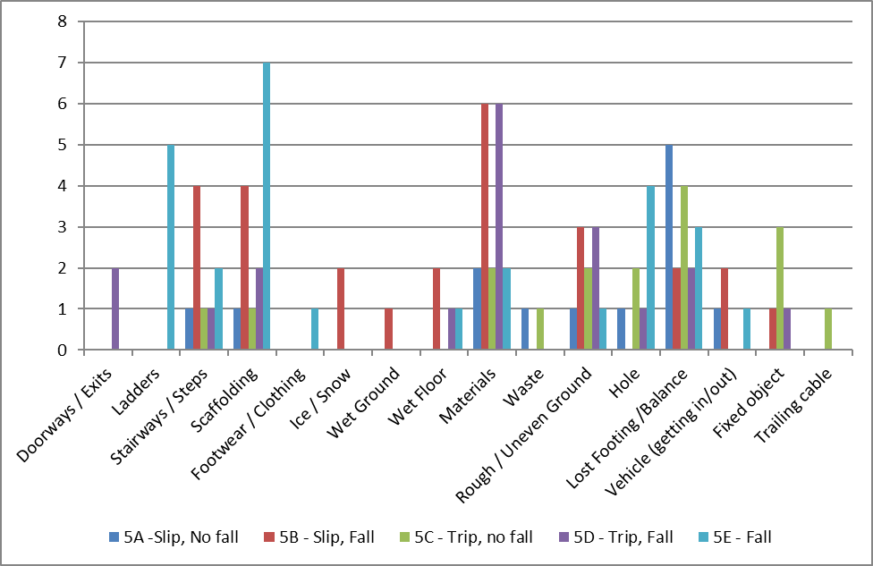

Figure 6.2: Contributory causes by percentage

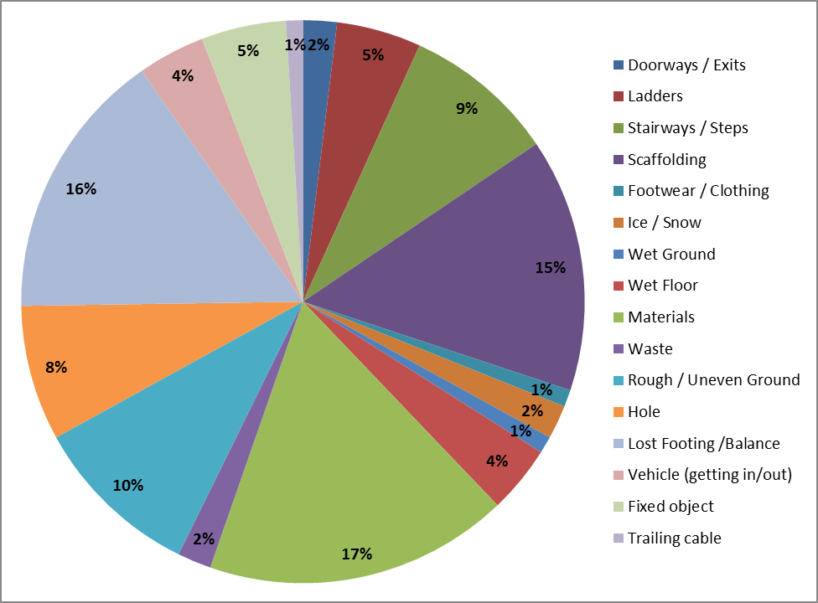

7. Fires on Construction Sites
During the year 8 fires were reported to the HBF (2 last year), one of which was arson to a timber frame house and the other 7 are detailed in the graph below:
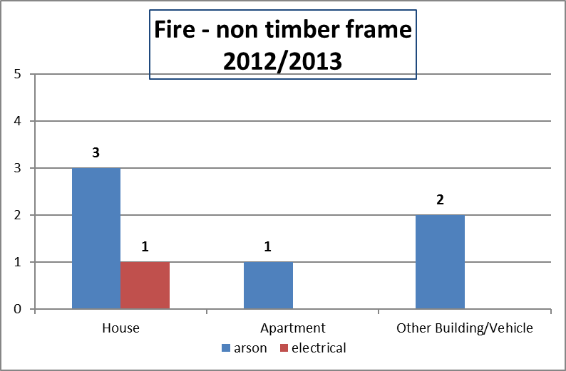

8. Causes of Injury – HSE Figures for the Construction Industry
The HSE Statistical reports ‘KIND1’ and ‘KIND2’ that list the top five causes of both ‘major injuries’ and ‘over seven day injuries’ for the construction industry are due out in November 2013. Revision 002 of this report will then be updated accordingly.

 | Major injuries |  | Over seven day injuries
1. |  | 1.
2. |  | 2.
3. |  | 3.
4. |  | 4.
5. |  | 5.

9. Members of the public
- There were ZERO fatal injuries during the year
- There were 3 reportable injuries (down 57% on last year’s 7)

All Reported Injuries (employed and subcontractors)
 | 2012/2013 | 2011/2012 | 2010/2011 | 2009/2010 | 2008/2009 | 2008/2007
Members of the public | 3 | 7 | 8 | 14 | 6 | 7

¹ Average number employed does not include the following; visitors to Member Organisation locations, Members of the public, Delivery Drivers, Main contractors employed as ‘Principal Contractor’ under the Construction (Design and Management) Regulations 2007. It does include directly employed staff and those carrying out work for Member Organisations (e.g. subcontractors).

