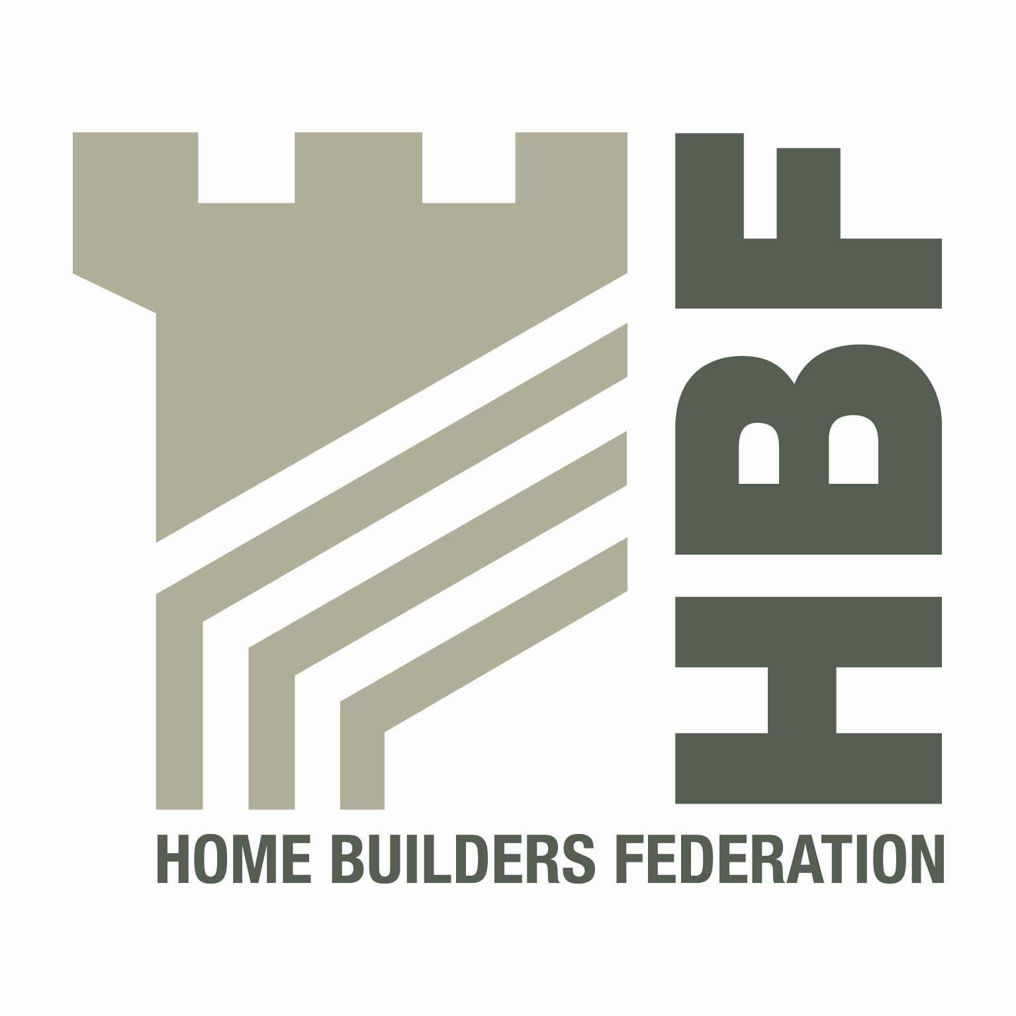
Item 2a
HBF HEALTH AND SAFETY FORUM
09.30HRS - WEDNESDAY 24 APRIL 2013

COUNTRYSIDE PROPERTIES PLC
COUNTRYSIDE HOUSE
THE DRIVE
BRENTWOOD CM13 3AT

NOTES OF MEETING
PRESENT:
Vince Coyle (Chair) | Barratt Developments | Tracey Murphy | Bellway
Barry Oliver | Berkeley Group | Paul Haxell | Bovis
Ken Millar | CALA | David Hudson | Countryside Properties
Martyn Price | Crest Nicholson | Eamonn McManamin | Davidsons Developments
Steve Allix | Fairview Homes | Steve Foley | Gladedale Group
Tony Leach | Keepmoat Homes | Ray Kelly | McCarthy & Stone
Dave Hickman | Miller Homes | Tom Kitchen | NHBC
Steve Acaster | Persimmon Homes | Silvio Petrasso | Stansted Environmental Services
Lee Mills | Stewart Milne Group | Edward Woods | Taylor Wimpey
Steve Dudman | Westleigh Developments
IN ATTENDANCE
Dave Mitchell | HBF
APOLOGIES
Peter Heenan | Bancon Group | Andrew Locker | Bloor Homes
Matthew Stubblefield | Croudace Homes | Stephen Finnigan | Galliford Try
Rick Theaker | Gleeson Homes & Regeneration | Chris Epps | NHBC
David Sanderson | Story Homes

Guest Speaker: Norman MacRitchie - Health and Safety Executive
Stefan Groch – DWF Solicitors
ACTIONS
1. | Welcome and Introductions  VC welcomed everyone to the meeting and apologies were accepted from those listed above.  VC thanked D Hudson and Countryside for providing the venue for today’s meeting.
2. | Notes of previous meeting  The notes from the previous meeting were taken as read.  An action not on the agenda was in relation to SSIP requirements for annual re-assessment. VC confirmed that he had written to SSIP raising concern and that they responded that they considered the annual requirement appropriate based on Client requirements. VC has responded informing SSIP that the members are all clients with an annual turnover of circa £12 billion and therefore we are substantial clients and their response did not reflect our views. The group felt that the matter should be pursued further and that arrangements should be made to review formally with SSIP. Tracy Murphy and Ed Woods volunteered to attend any meetings on behalf of the group.
3. | Law Update by Stefan Groch – DWF Solicitors, Head of Markets  SG presented to the group on ‘Legal and Practical Considerations’ surrounding Health and Safety.  SG talked around FFI, working together, Health and Safety Lawyers Association, using and reacting to the media.  Copies of presentation will be circulated to the group with the meeting notes.
4. | Guidance/Sub Group Updates:  - Health and Safety Charter  VC gave the group the up to date position on the HBF Health and Safety Charter. There are a couple of additional homebuilders who have shown an interest in signing up to the charter and VC will be reviewing with them. It is intended to only issue a revised Charter on a yearly basis.  - Charter Action Plan  The Charter Action Plan was reviewed and noted that progress had been made with the all items as required.  Members felt that there is a need to ensure that the MHBG and others fully understand some of the timings currently in place and that some of the items are ongoing issues.  Members were asked to consider what objectives should be set for 2013/14 and report back at the next forum meeting.  - Consortium Agreement  The consortium agreement has been finalised although it is accepted that this is an ongoing piece of work subject to continuous review.  - Home Building Scaffolds  The working group met prior to the meeting and developed a draft specification which was included in the meeting pack. The overall objective is to develop a standard specification which can be adopted by all homebuilders into their own systems but give some consistency to the industry.  Discussions took place surrounding the content of the document and how it should pull together all industry guidance affecting homebuilding scaffolds. The group also considered there should additional information regarding system scaffold.  The group were asked to come back with comments to VC on the document by 17th May and the sub-group will meet prior to the next meeting to review and propose updates to the content as required.  - Training for Direct Employees  Final draft reviewed at the meeting and a view was expressed by EW that it should be more reflective of the fact that some organisations carry out in-house training. VC asked if members can provide final comments by 24th May.  - Sun Safe Campaign  Draft poster and leaflet reviewed and all agreed that the information was appropriate. VC requested that all provide details of the numbers of leaflets/posters required by 17th May so that we can obtain a fixed unit price from the printers.  Current estimates are 4p per leaflet and 14p per poster.  VC to check with Paul Madgwick – IOSH Sun Project as to their current position with their campaign surrounding this.

5. | Accident stats update (including fire stats/Fee for Intervention)  including contacts list  Draft Stats for 3rd quarter were included in the meeting pack.  DM explained that data for the 4th quarter was now due in so that an annual report can then be finalised.  DM explained that the stats had now been viewed by both the HBF board and the MHBG. Annual report to be made available to these groups with a view to asking for advice on how and where to circulate the final report.  DM confirmed that currently both HBF board and MHBG do not want the company names circulated and remain with anonymous approach.  MP took the group through the revised stats format. This has been radically altered and is a much easier form to complete. All thanked MP for putting together what will be a more streamlined process.
6. | HSE matters  - Fireplaces  DM explained to the group that HSE had contacted him re their proposed Fireplaces Project and that on the back of that he had asked them to come along today to talk to the group about it  NM told the group that it was the unfortunate death of a child that had prompted this proposed project.  There is a risk to the occupier from modular fireplaces (add on types) when these are not securely fixed. This is more often than not due to lack of fixing details from the manufacturer.  HSE do not think that site inspection alone is sufficient and want to involve the whole industry in this project.  They will be contacting many duty holders in the next few months.  There will be a safety alert issued surrounding this issue within the next month.  Installing involves mortar and/or steel fixings which should be mechanically robust. Gluing is not enough. HSE will be looking for manufacturers to supply fixing kits for all possibilities. Manufacturers will also be asked to ensure that fixing instructions get to all installers, including sequence etc; HSE confirmed that this is more a product issue than a health and safety at work issue.  Need to share information on this and developers should look at risk assessing this through records etc;
7. | Environmental Issues  No environmental issues raised.
8. | Update from CONIAC  PH updated the group on CONIAC activities. This included the following:  - Fireplace installation being looked at (discussed under previous agenda item)  - Developing a new field project surrounding fragile materials (falls through)  - Tile cutting remains an issue for the HSE Inspectors.  - Looking at asbestos removal – this is more aligned to retail.  - Temporary demountable and timber frame structures being looked at.  - Health group looking at occupational cancer. this is an area of concern. Painting & decorating & diesel fumes are also areas of concern.  - CDM – working towards submission to board in May with a planned consultation in October 2013.  - FFI – 6 months update. HSE inspectors note varying responses- Positive responses received on some sites in term of levelling the playing field. HSE reiterate no target, but expectations on inspectors over appropriate level of enforcement (20 notices, 2-3 prosecutions per year) this reinforced as not being revenue generation related. 53 invoice queries raised, 25% have been corrected in line with complainants view. Two common areas of dispute: notification of contravention & time involvement.  - Temporary works forum looking at catastrophic risks in construction.
9. | Dates for 2013  Discussion took place on the venues for 2013/14.  With the group having increased members it is becoming increasingly difficult to find locations for these meetings within member’s offices.  It was suggested that (subject to HBF approval) that an annual contribution of around circa £200 should be put up by those companies signed up to the charter or attending meetings. This would be held by HBF to pay for venues booked any monies left over can be put towards things like paying for posters (for example Skin cancer campaign)  - Wednesday 17 July (Please note change of date)  - Thursday 3 October
10. | Any Other Business  SA requested that members provide any information on archiving processes within their businesses. Members to respond direct to SA  A member asked to establish which types of fall prevention are currently used i.e. soft landing or safety platforms. Varying responses with some using platforms and others soft landing depending on risk assessment.

