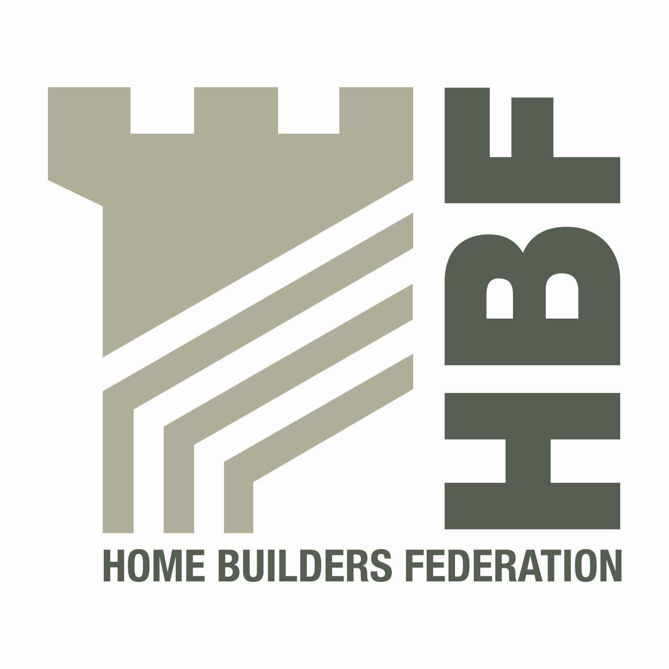 HBF HEALTH AND SAFETY FORUM
09.30HRS - WEDNESDAY 17 July 2013
(Tea and Coffee available from 9.00am)

THE PARSONAGE HOTEL
YORK ROAD, ESCRICK
NORTH YORKSHIRE, YO19 6EY

AGENDA
- Welcome and Introductions
- Notes of previous meeting
- Meeting notes
- DWF presentation
- SSIP
- GasSafe – Presentation on Gas Safety and particular items of interest for
home builders.

- Business Case – Proposed Subscription Fees for Membership of the Forum
- Guidance/Sub Group Updates:
- Contact list
- Health and Safety Charter
- Charter Action Plan
- Home Building Scaffolds
- Training for Direct Employees
- Sun Safe Campaign

- Statistics update (Reportable Injuries and Dangerous Occurrences/Fire Incidents/Fee for Intervention)

- Annual Draft
- 4th Quarter

- HSE matters
- Environmental Issues
- Update from CONIAC
- Dates for 2013
- Thursday 3 October (Venue required)

- Any Other Business

