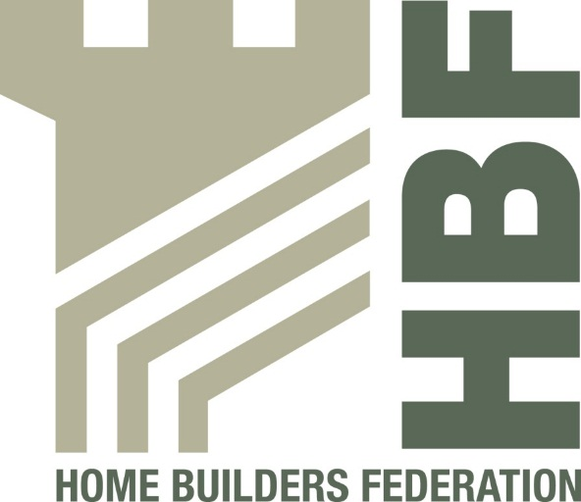
Health & Safety Statistics
Draft Report:
Data from three companies is outstanding

Data from 3 companies
October 2012 – December 2012
Q3 2012-2013 draft report

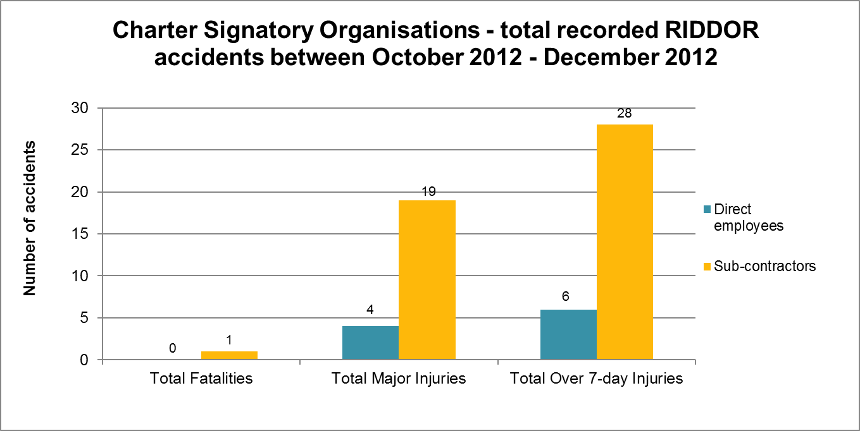

One fatality from Charter Signatories October 2012 – December 2012

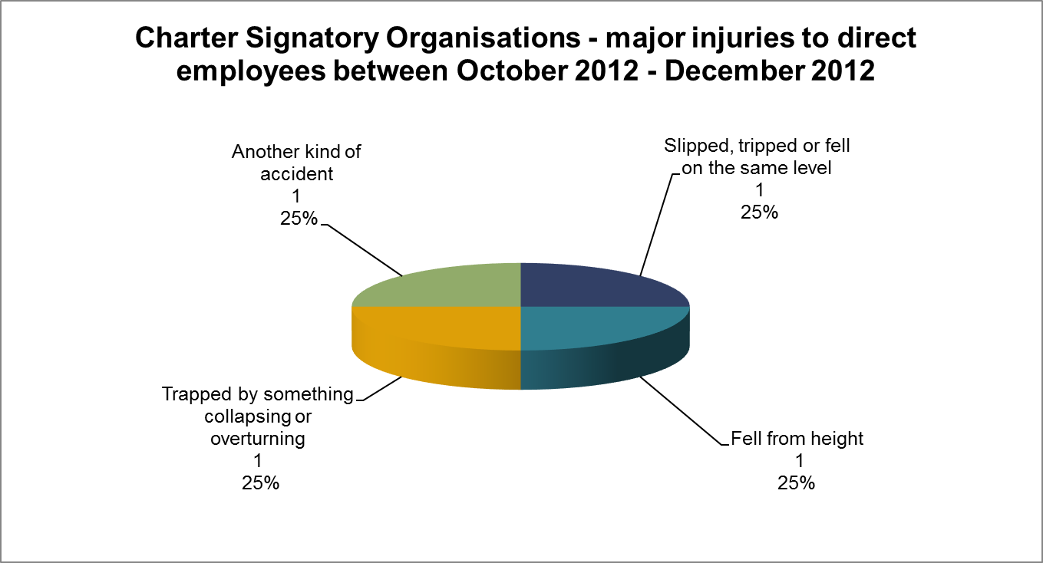

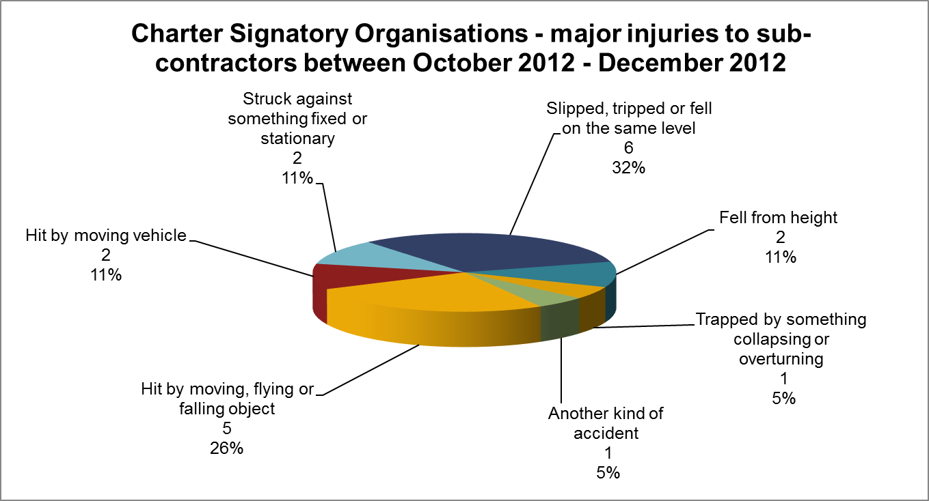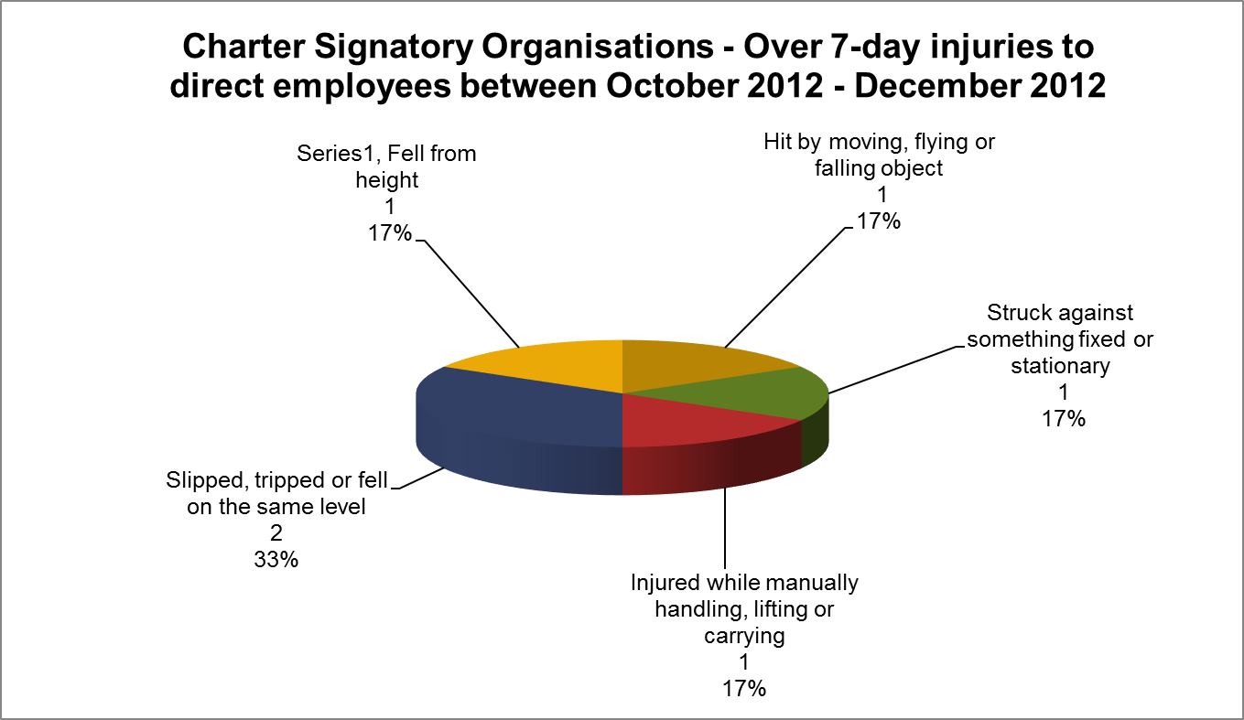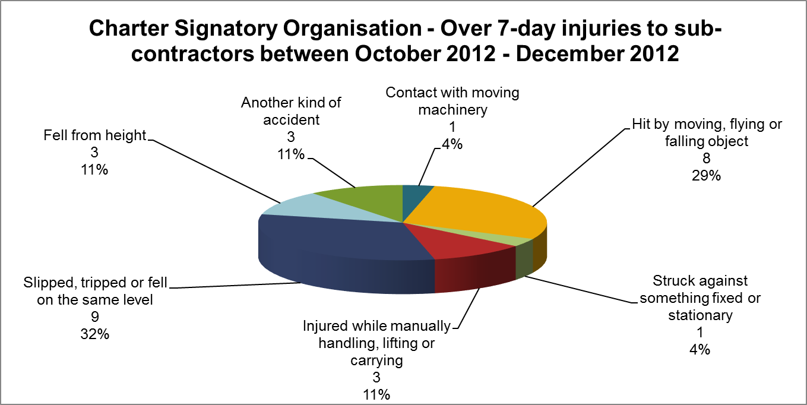
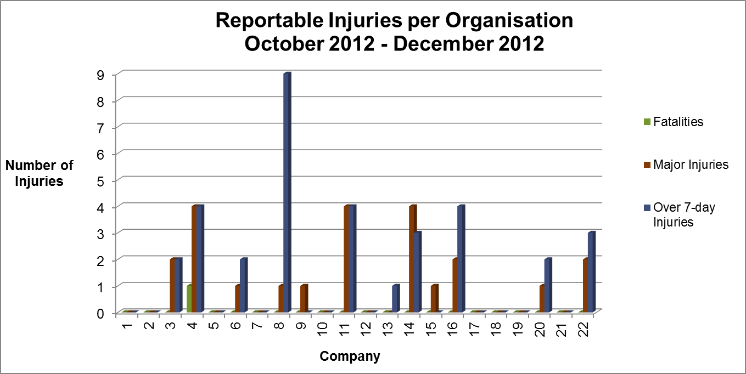

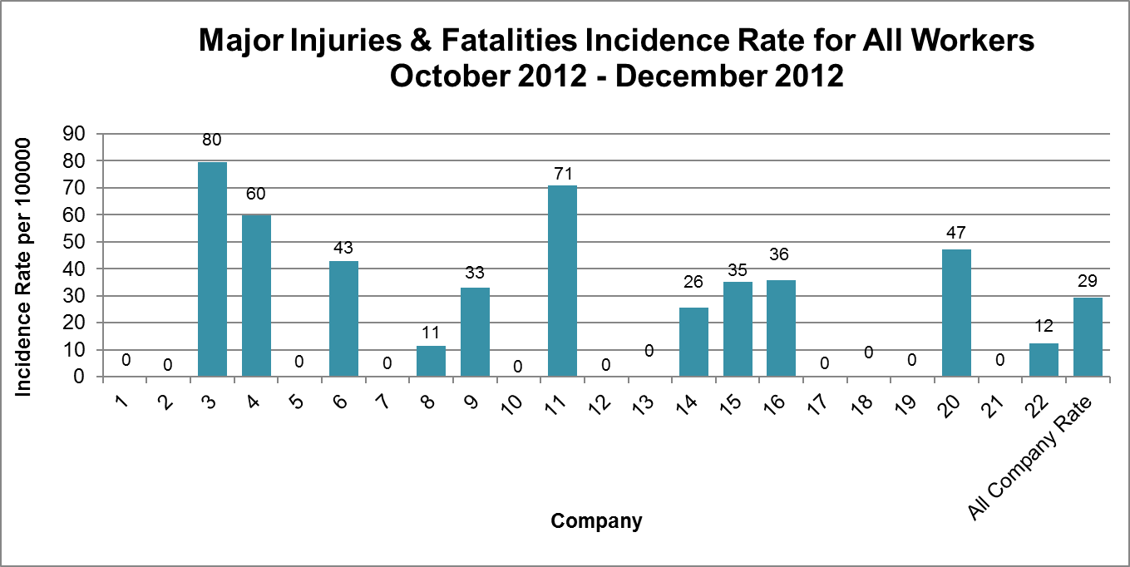

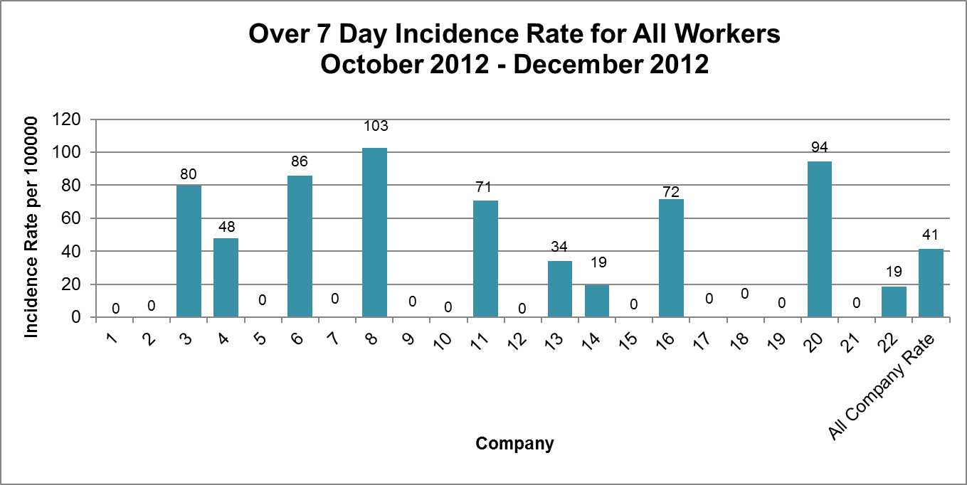

Injuries to Members of Public Q3 2012/13 (October 2012 – December 2012)

During the period Q3 2012/13 (October 2012 – December 2012) there has been 1 reported incident involving a member of the public.

