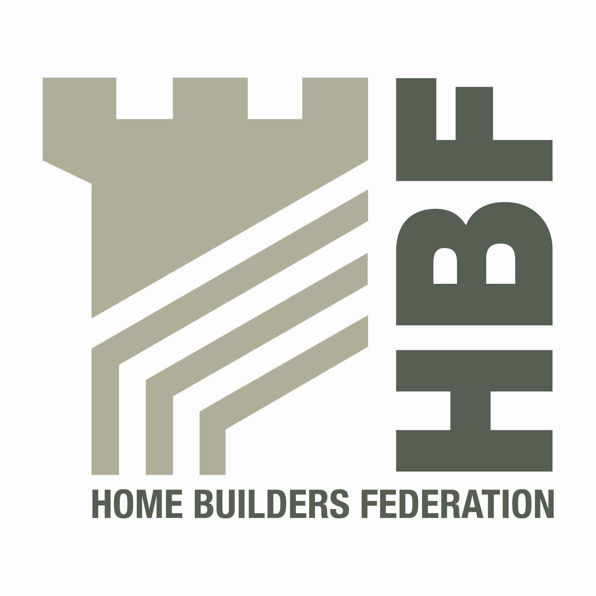 HBF HEALTH AND SAFETY FORUM
09.30HRS - WEDNESDAY 24TH APRIL 2013
(Tea and Coffee available from 9.00am)

COUNTRYSIDE PROPERTIES PLC
COUNTRYSIDE HOUSE
THE DRIVE
BRENTWOOD CM13 3AT

AGENDA
- Welcome and Introductions
- Notes of previous meeting
- Law Update by Stefan Groch – DWF Solicitors, Head of Markets
- Guidance/Sub Group Updates:
- Health and Safety Charter
- Charter Action Plan
- Consortium Agreement
- Home Building Scaffolds
- Training for Direct Employees
- Sun Safe Campaign

- Accident stats update (including fire stats/Fee for Intervention) including
contacts list

- HSE matters
- Fireplaces
- Environmental Issues
- Update from CONIAC
- Dates for 2013
- Wednesday 17 July (Please note change of date)
- Thursday 3 October

- Any Other Business

