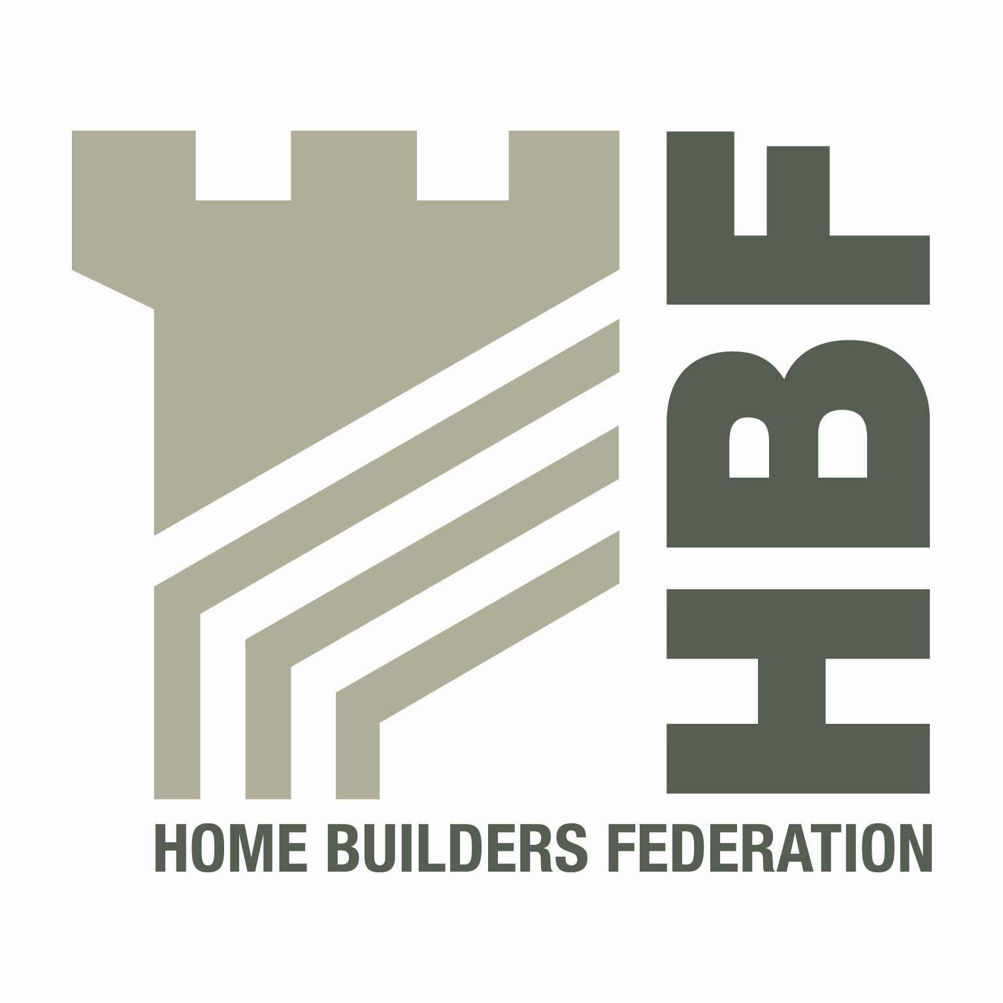
HBF HEALTH AND SAFETY FORUM
THURSDAY 4th OCTOBER 2012
9.15hrs – 14.30hrs (Lunch from 12.30 – 13.00hrs)
(Tea and Coffee available from 9.00am)

NHBC House, Davy Avenue, Knowhill, Milton Keynes, MK5 8FP

AGENDA
- Welcome and Introductions
- Presentation by Chris Lucas – HSE – Roof Tile cutting and Silica Dust
- Notes of previous meeting
- Contact List
- CONIAC Update
  - CDM Review
  - CSCS

- Guidance/Sub Group Updates
  - Health and Safety Charter
  - Charter Action Plan
  - Manouvering of Roof Trusses – Feedback from Truss Rafter Association
  - Supervisors Competency
  - Utilities Code
  - Medical Fitness for Plant Operators
  - Consortium Developments
  - Home Building Scaffolds

- Accident stats update (including fire stats)
- HSE matters
- Update to GE 700

- Fall Prevention Feedback
- Environmental Issues
- Consumer Units
- Dates for 2013 (Venues to be Agreed)
Thursday 24th January
Wednesday 24th April
Tuesday 9th July
Thursday 3rd October

