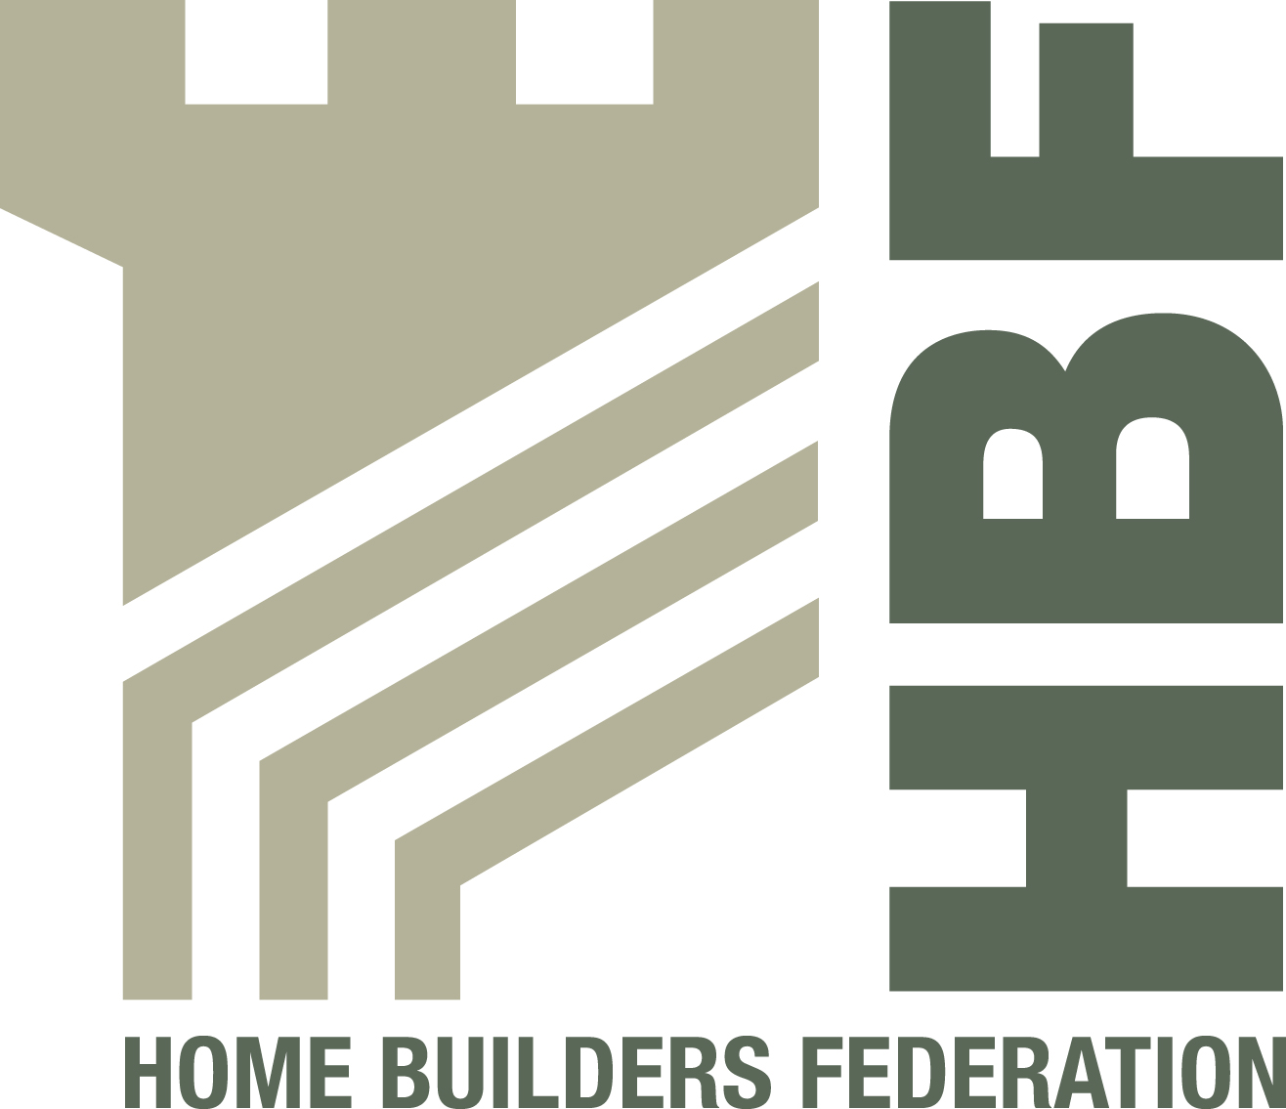

NASC
4th Floor
12 Bridewell Place
London
EC4V 6AP

22 May 2012

Dear Sir

Re: TG20 – Home Building Scaffolds

I refer to the above, and specifically the construction of home building scaffolds.

I chair the Home Builders Federation (HBF) Health and Safety Forum and our members are responsible for 80% of the new homes built in the UK, and as such have a significant number of scaffold structures erected on our developments.

An issue has been raised in respect of the erection of home building scaffolds in particular tying patterns, and when discussed at our recent meeting, it appeared members had received conflicting information from the scaffold industry.

I am aware that the Health and Safety Executive have reviewed this with NASC but it remains that there are some inconsistencies with advice and application on site.

I would like the opportunity to review the particular issues with home building scaffold with NASC or Slender Structures Ltd with the objective of understanding the requirements for structures erected on member sites.

Yours faithfully

Vince Coyle
Chair HBF Health and Safety Forum

Tel No: 01604 664500 Email: Vince.Coyle@barrattplc.co.uk
Return address: Barratt Northampton, Barratt House, Sandy Way, Grange Park, Northampton NN4 5EJ

