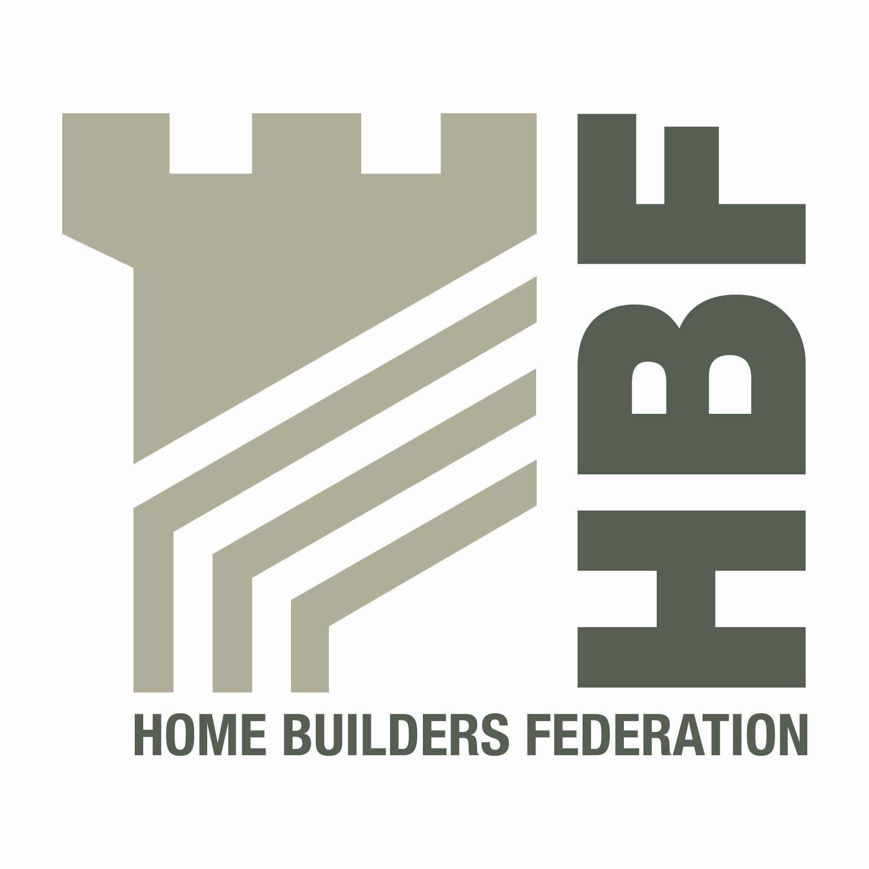 HBF HEALTH AND SAFETY COMMITTEE
09.30hrs - THURSDAY 5th JULY 2012
Best Western Appleby Park Hotel, Junction 11 of the M42 motorway
Atherstone Road, Appleby Magna, DE12 7AP

AGENDA
- Welcome and Introductions
- Notes of previous meeting
- Contact List
- Presentation by Paul Madgwick – IOSH Sun Project
- Guidance/Sub Group Updates;
  - Health and Safety Charter
  - Delivering Safely – Update on current position
  - Maneuvering of Roof Trusses via Telehandler
  - Supervisors Competency
  - CDM Group update
  - Utilities Code
  - Occupational Health – Medical Fitness for Plant Operators
  - Consortium Developments
  - Home Building Scaffolds
  - Electric Gates

- Draft BS 7121 – Cranes (General, Mobile and Overhead)
- Accident stats update (including fire stats)
- HSE matters
- Environmental Issues
- Update from CONIAC
- Section 278 Works
- Date of next meeting (and venue)
Thursday 4th October at NHBC: NHBC House, Davy Avenue, Knowhill, Milton Keynes, MK5 8FP

