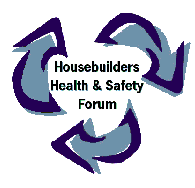
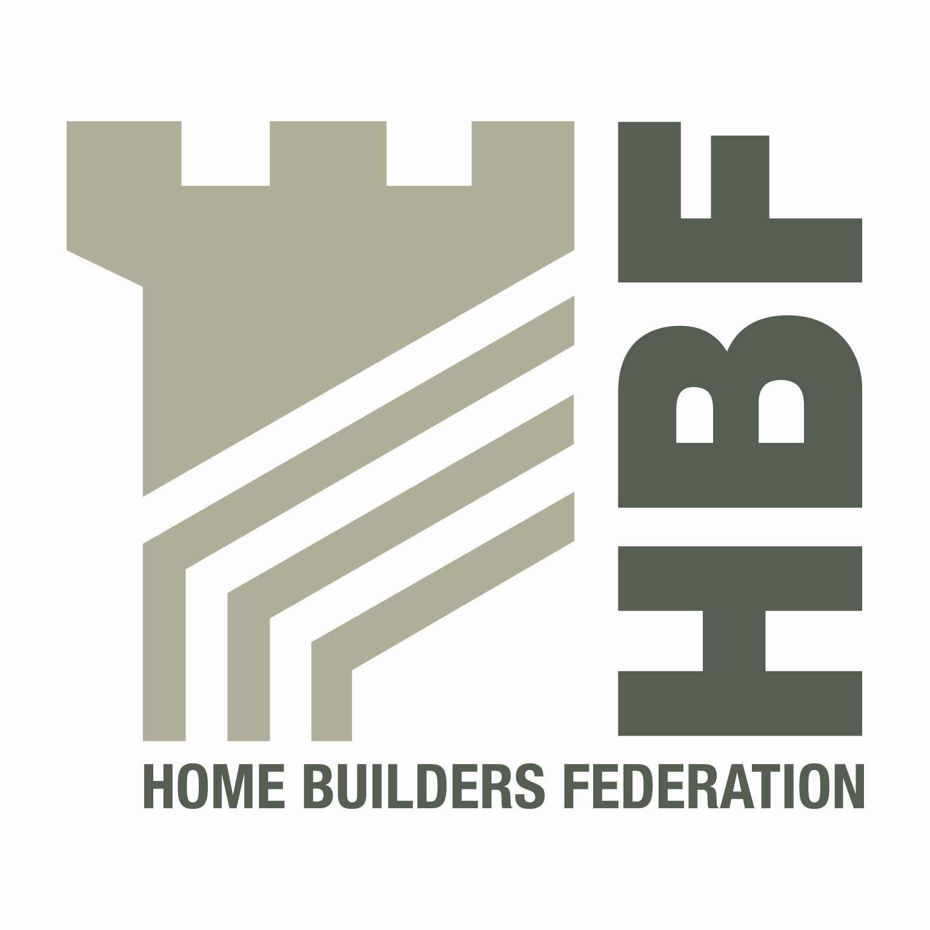
Home Builders’ Regional Health and Safety Groups
Home Builders H&S Groups | Contact
Scottish Housebuilders’ Health & Safety Forum | Edward Woods, Taylor Wimpey  edward.woods@taylorwimpey.com  Tel: 0141 849 5525
North West Construction Safety | Marcus J Hall  m.hall@baas.co.uk  Tel: 01282 437304
North East Housebuilders’ Group | Glyn Neasham  Glyn.Neasham@yuill.co.uk  Tel: 01429 851168
Working Well Together – North Yorkshire | Richard Thorpe  Richard.thorpe@hse.gsi.gov.uk
Working Well Together – Cumbria | David Sanderson  David.sanderson@storyhomes.co.uk
North West Homebuilders Safety Group | David Ford  david.ford@redrow.co.uk
South West Developers Forum | Lisa Phillips  lisa.phillips@taylorwimpey.com
South Wales Developers Forum | Alex Minett  07812 342833

