
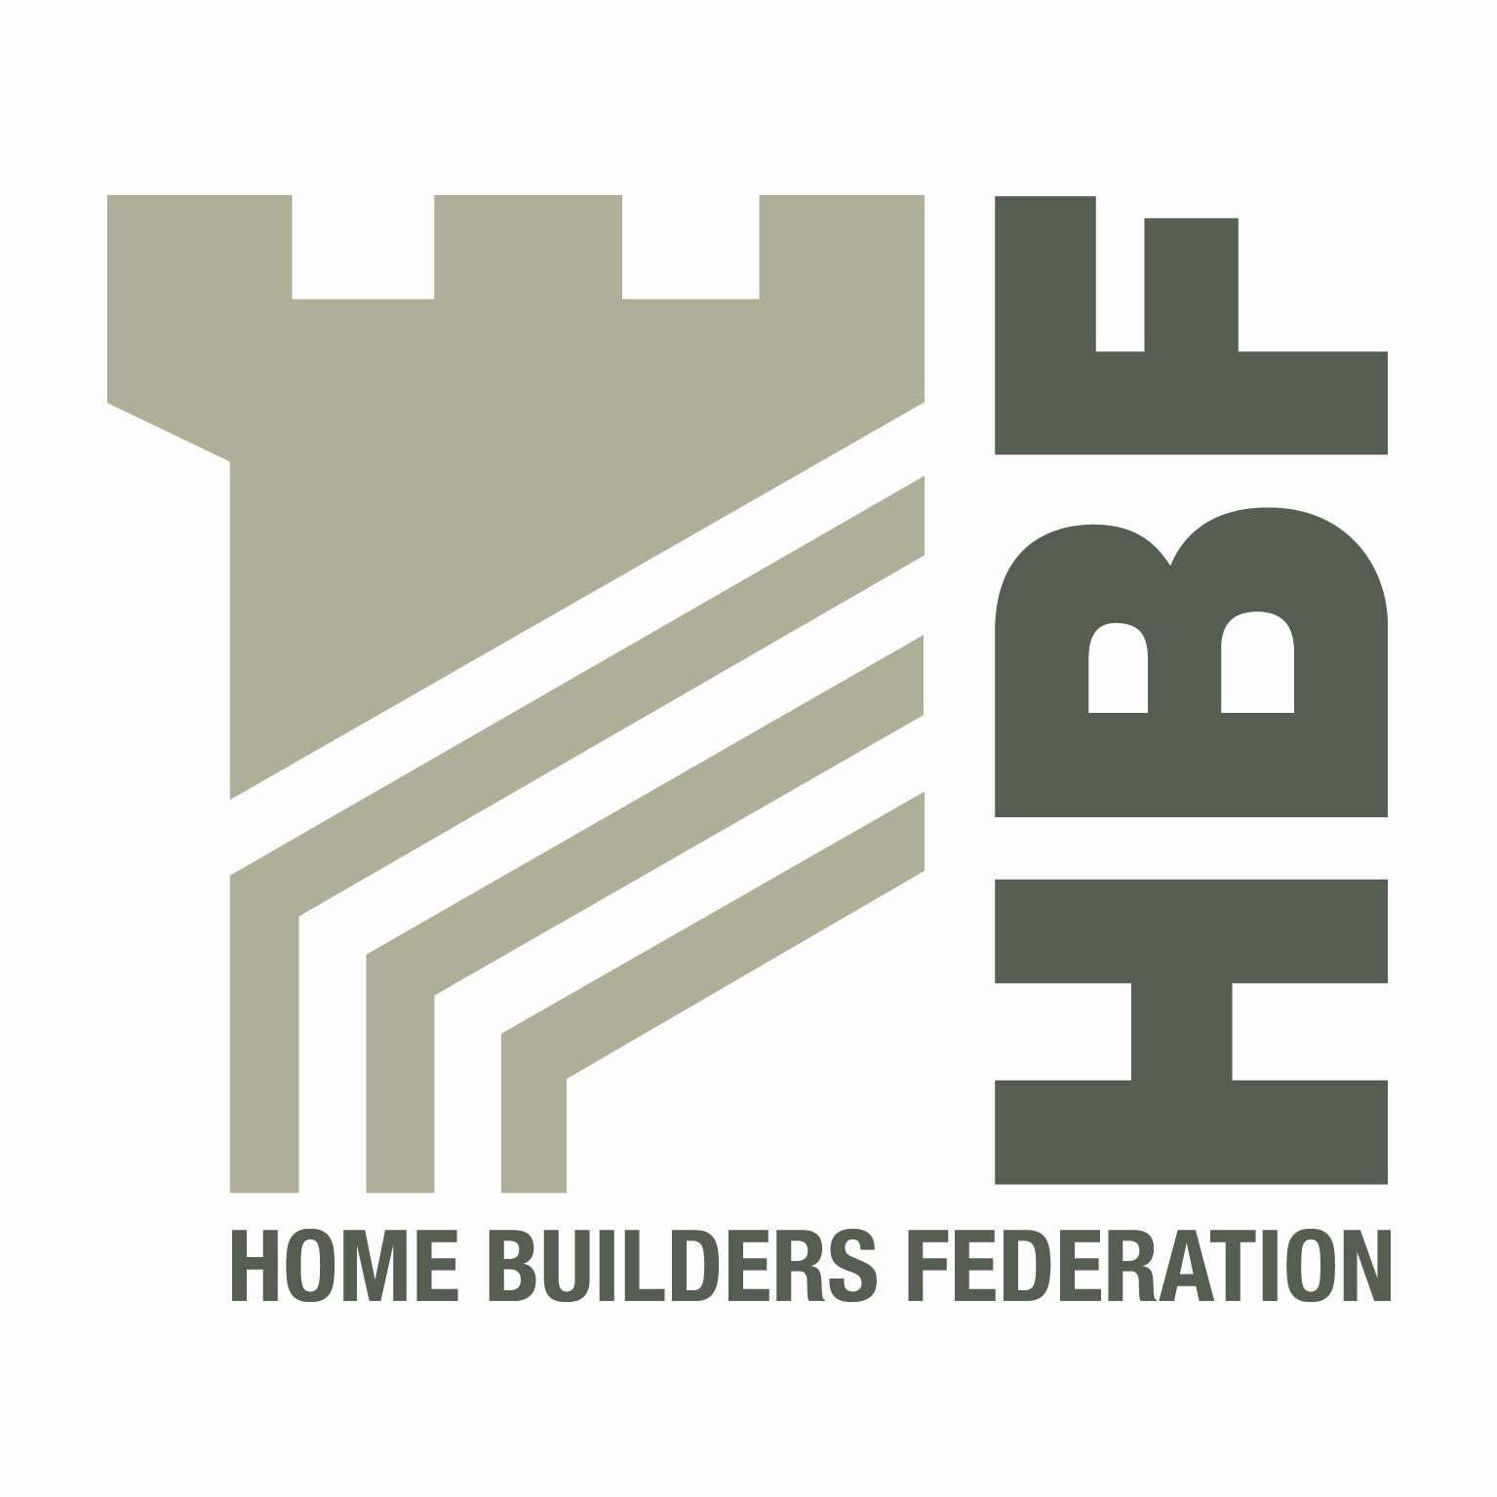

HBF HEALTH AND SAFETY COMMITTEE

AND

HOUSEBUILDERS’ HEALTH AND SAFETY FORUM
09.00 for 09.30 am THURSDAY 19th APRIL 2012
Kier Partnership Homes, Tungsten Building, Blythe Valley Park, Solihull,
West Midlands, B90 8AU

AGENDA
No | Item
1 | Minutes of previous meeting
2 | Contact List
3 | Presentation by Ben Young from the Building Product Delivery Working Group
4 | Injury Statistics
5 | HSE Matters
6 | Draft Health and Safety Charter / Review of existing supporting information/guidance
7 | CDM Guidance for Home Builders
8 | Utilities Code of Conduct
9 | Sub-Contractor Supervision Guidelines
10 | Occupational Health Strategy
11 | Use of Telehandlers to manoeuvre roof trusses
12 | Environmental Issues  - Road Sweepers on Construction sites
13 | Update from CONIAC
14 | Date of Next Meeting:  - Thursday 5th July  Bloor Homes, Ashby Road, Measham, Swadlincote, Derbyshire, DE12 7JP  - Thursday 4th October  NHBC, NHBC House, Davy Avenue, Knowhill, Milton Keynes, MK5 8FP

