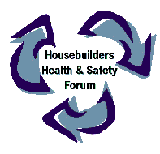
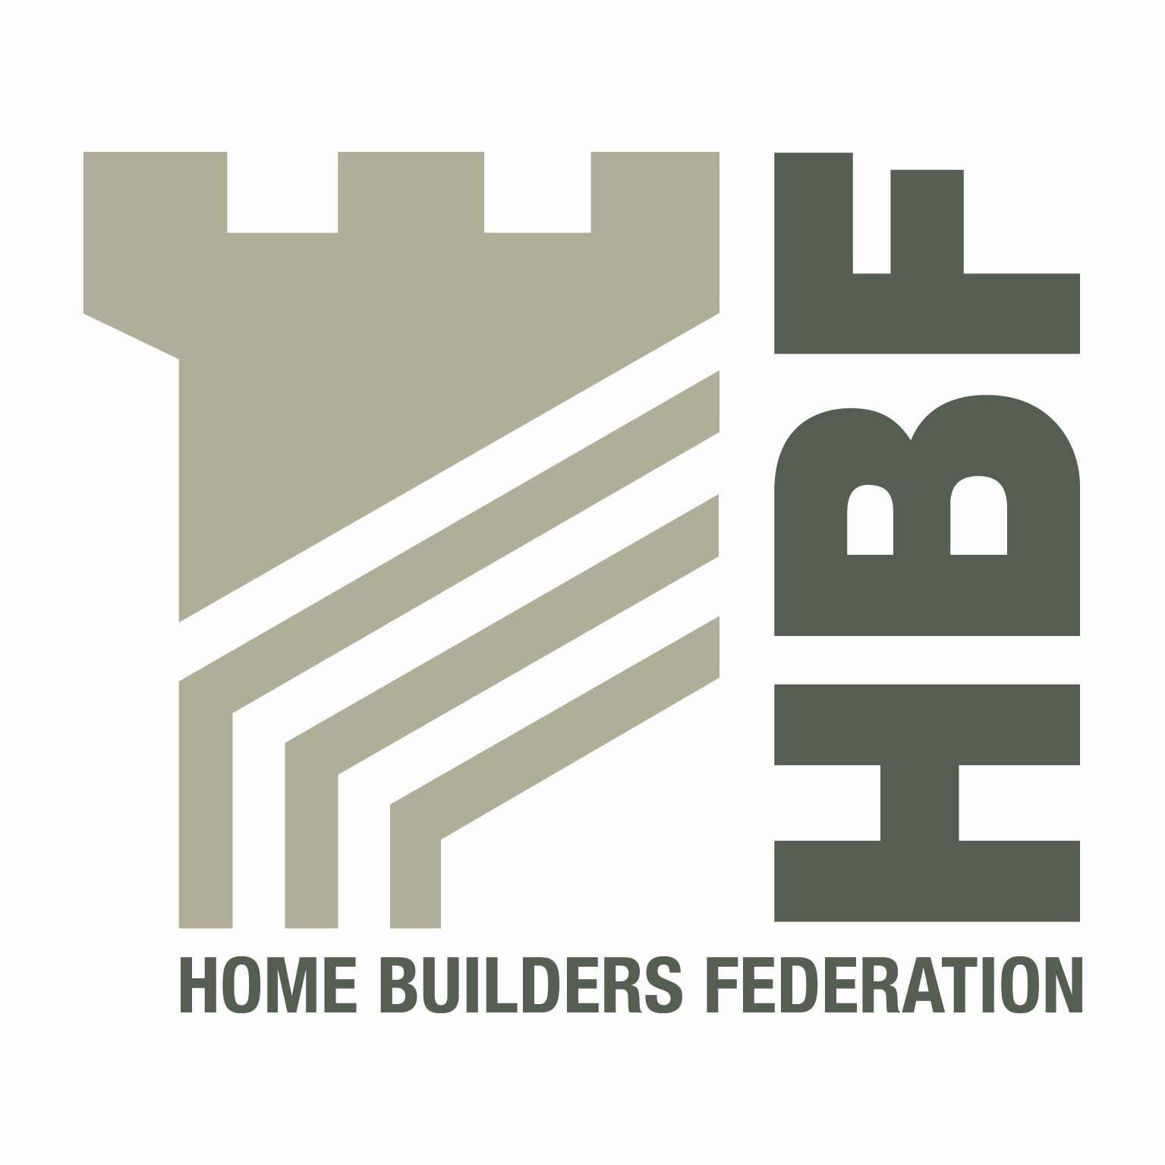
Home Builders’ Regional Health and Safety Groups

Home Builders H&S Groups | Contact
Scottish Housebuilders’ Safety Forum | Edward Woods, Taylor Wimpey  edward.woods@taylorwimpey.com  Tel: 0141 849 5525
North West Construction Safety | Marcus J Hall  m.hall@baas.co.uk  Tel: 01282 437304
North East Housebuilders’ Group | Martin Laverick  Martin.laverick@esh.uk.com  Tel: 0191 3774570  Mob: 07970 935004
Working Well Together – North Yorkshire | Richard Thorpe  Richard.thorpe@hse.gsi.gov.uk

