
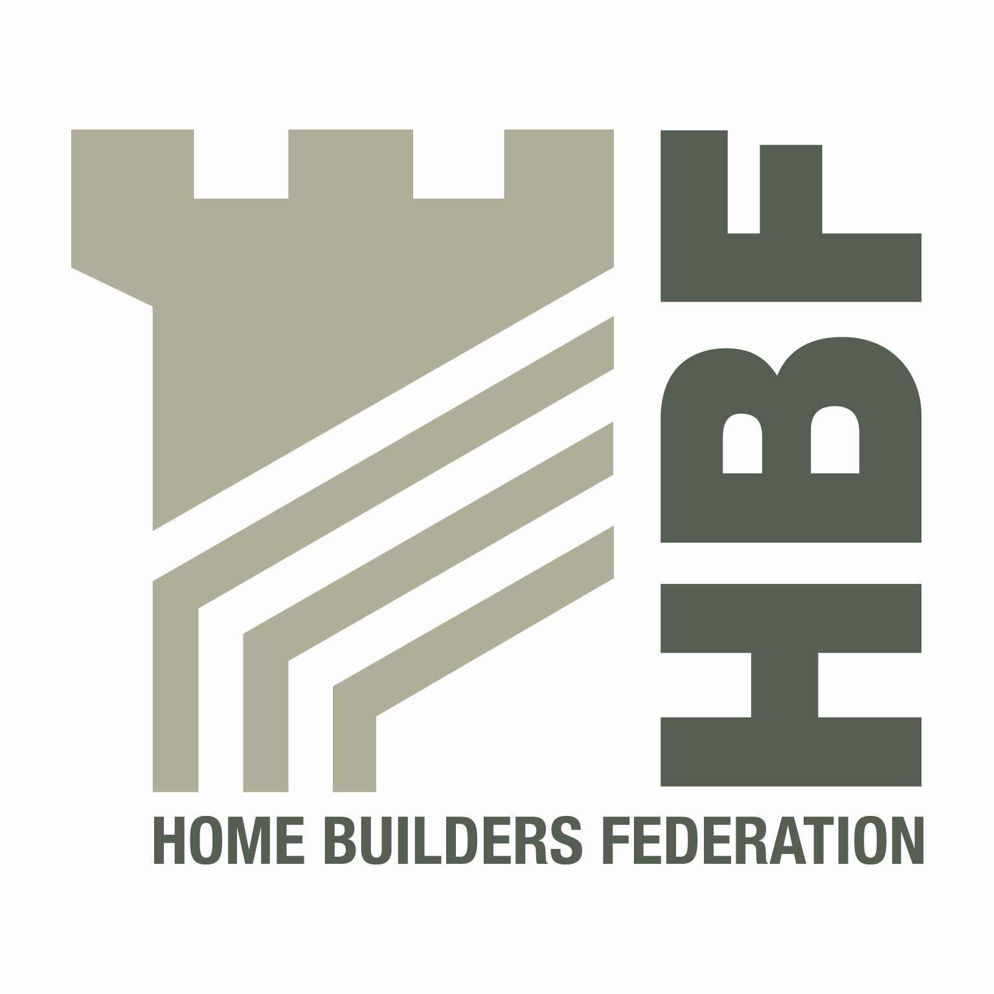

HBF HEALTH AND SAFETY COMMITTEE

AND

HOUSEBUILDERS’ HEALTH AND SAFETY FORUM
09.00 for 09.30 am TUESDAY 31st JANUARY 2012
David Wilson Homes East Midlands,
Unit 1a, Forest Business Park,
Cartwright Way, Bardon Hill
Leics; LE67 1GL
AGENDA
- Welcome and apologies

- Notes of last meeting 27/10/11 and Matters Arising

- Contact list – latest date
- Fire stats
- CDM Practice Note
- Temporary Works

- Timber Frame – presentation from UKTFA

- Utilities Code of Conduct (draft 17) - GN

- Health and Safety Group, sub-groups and working parties

- Health and Safety Charter

- Regional H & S groups – All

- Review of lists produced to date.

- Accident Statistics update

- Accident Stats – DM
- Change to calculations of HSE AIIR – HSE reported that changes to the SIC codes affected the Construction Sector because of inclusion of Real Estate from April 2011.

- HSE matters – Nic Rigby

- Enviromental Issues

- Site Waste Management Plans – All

- Date of 2012 meetings

- Tuesday 17th April Kier Partnership Homes, Tungstan Building,
Central Boulevard, Blythe Valley Park, Solihull, B90 8AU

- Thursday 5th July Bloor Homes, Ashby Road, Measham,
Swadlincote, Derbyshire, DE12 7JP

- Thursday 4th October NHBC, NHBC House, Davy Avenue, Knowhill,
Milton Keynes, MK5 8FP

- Any Other Business

Given the fullness of the agenda, could you please try, if at all possible, to provide advance details of any issues you may wish to table under AOB 2-3 days prior to the meeting.

