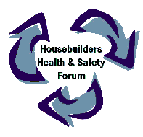
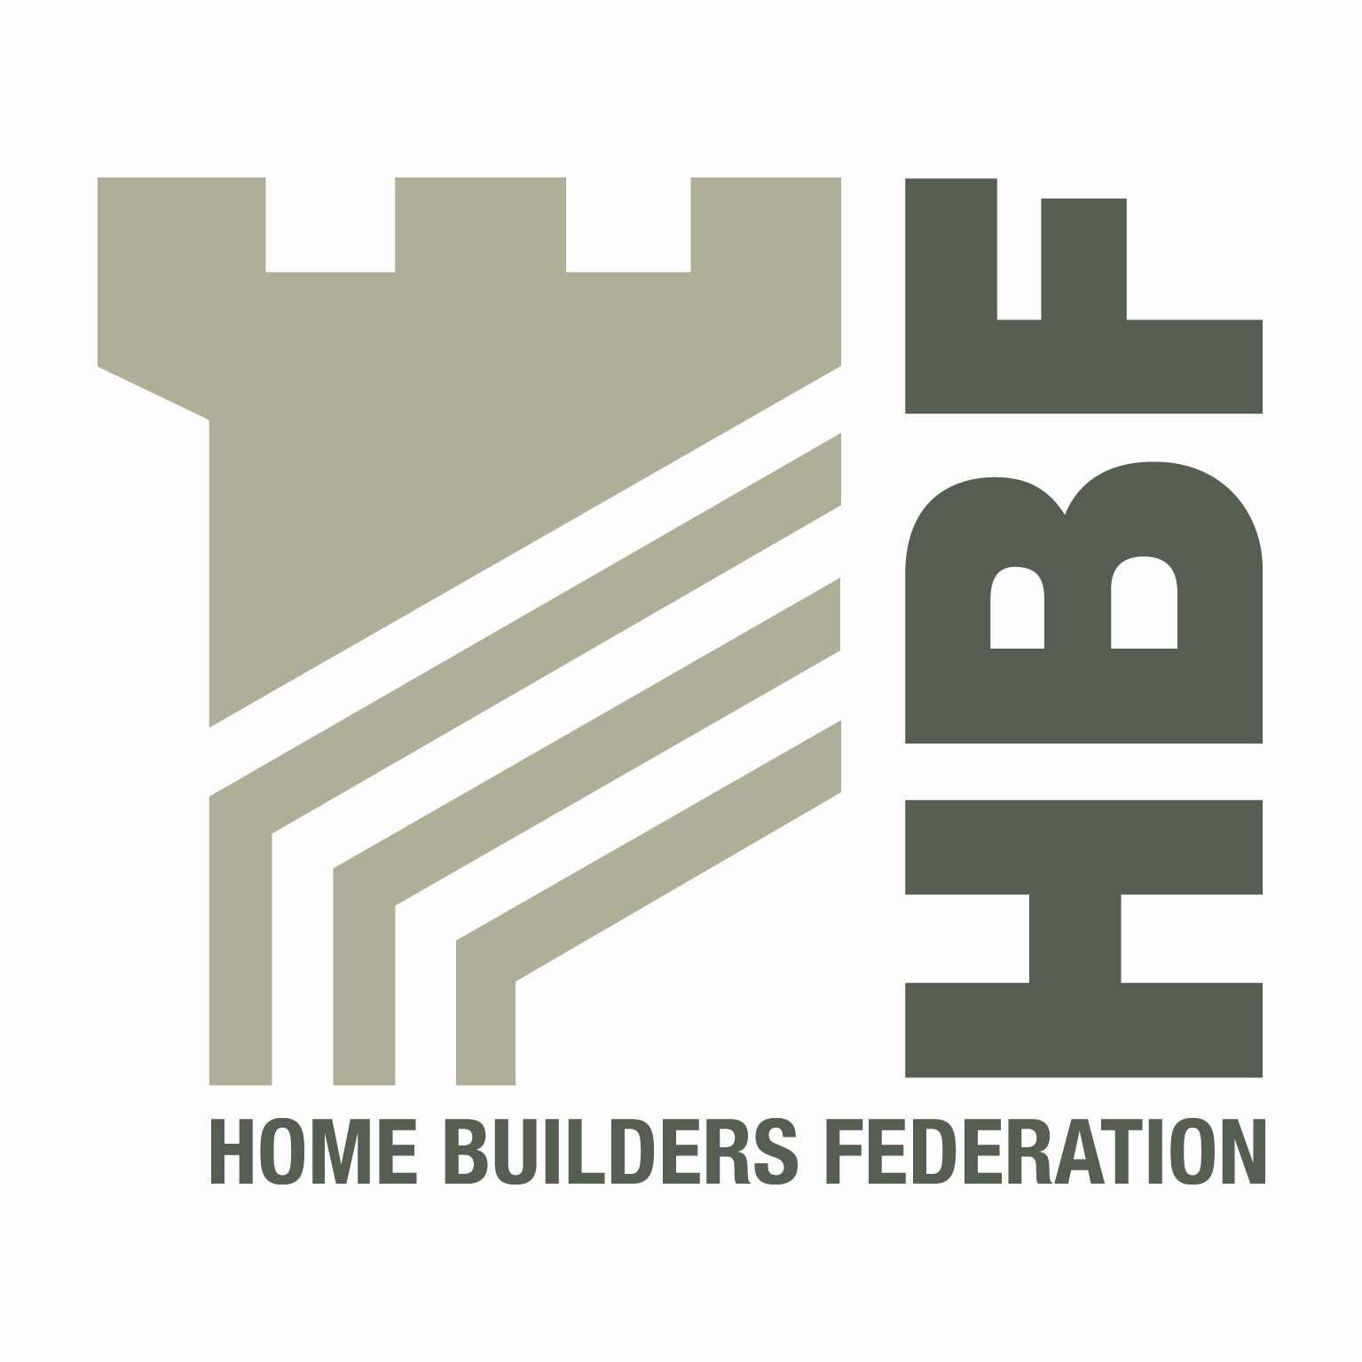

HBF HEALTH AND SAFETY COMMITTEE

AND

HOUSEBUILDERS’ HEALTH AND SAFETY FORUM
09.00 for 09.30 am THURSDAY 27th OCTOBER 2011

Berkeley Homes, 380 Queenstown Road, London, SW8 4PE

AGENDA

- Welcome and apologies

- Notes of last meeting 14th April 2011 and Matters Arising
- H&S Charter documentation update - DM
- Contact List Details update – All
- Statistics (fire) – data compilation, Fire Template & other fire documentation – circulation – DH/DM/MP
- HSE proposal for extending cost recovery consultation – PH
- CDM practice notes – SA

- Temporary Works

- Health and Safety Group, sub-groups and working parties

- Regional H & S groups - All

- Accident Statistics update
- Accident Stats – DM
- Future steps – sub groups proposal

- Roof work update work at heights – Justin Lee

- HSE matters - Nic Rigby

- Environmental Issues

- Site Waste Management Plans - All

- Date of 2012 meetings - all venues to be agreed
- Thursday 2nd February
- Tuesday 17th April
- Thursday 5th July
- Thursday 4th October

- Any Other Business

