Health and Safety:
Reportable Injuries Diseases and Dangerous Occurrence Regulations (RIDDOR) DRAFT results October 2009 – September 2010

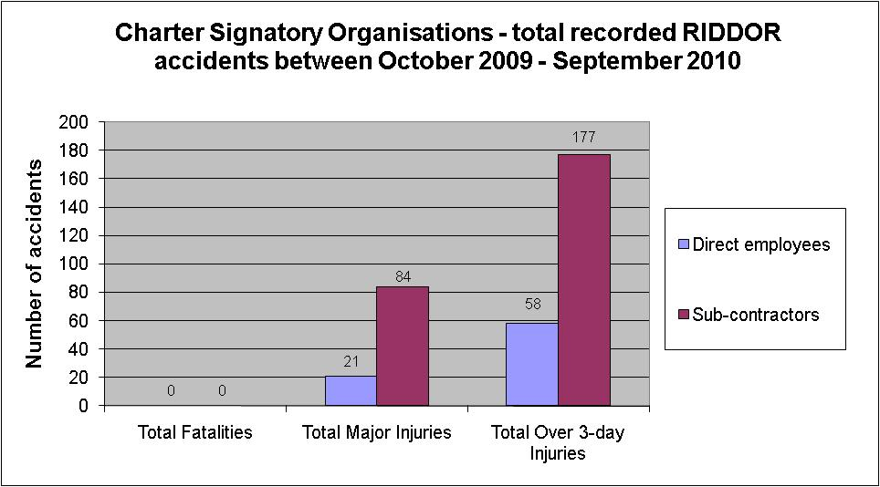

No fatalities from Charter Signatories October 2009 – September 2010

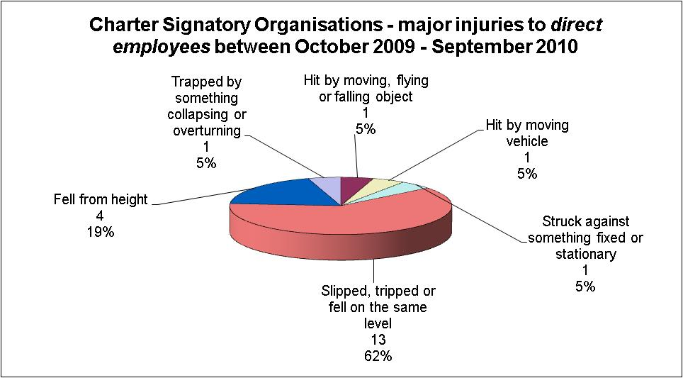

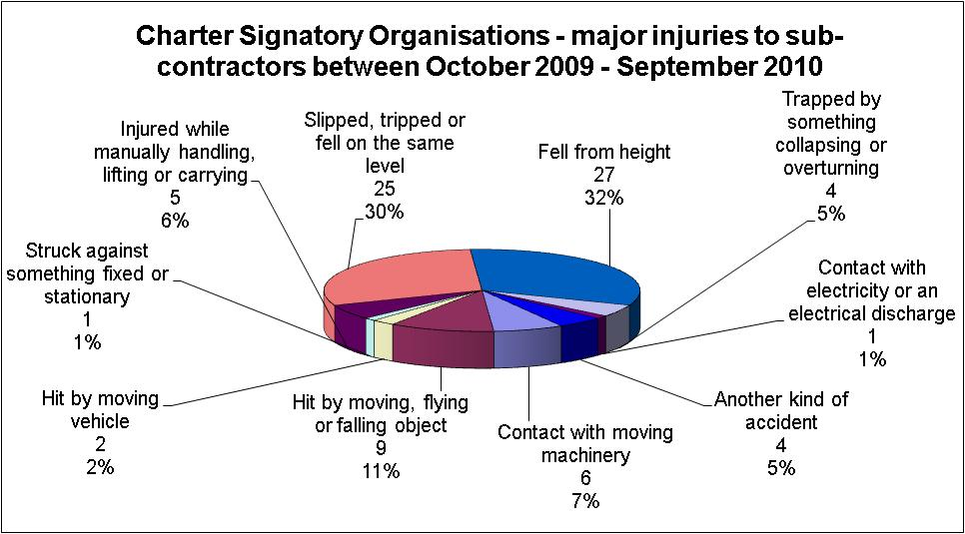

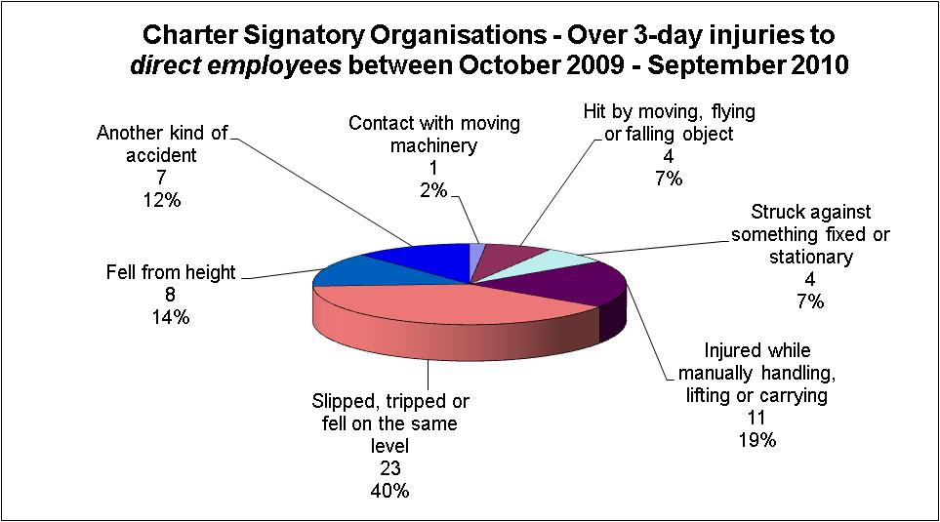

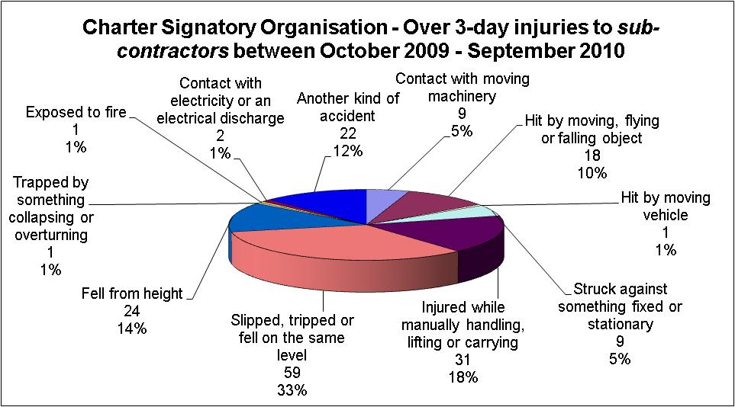

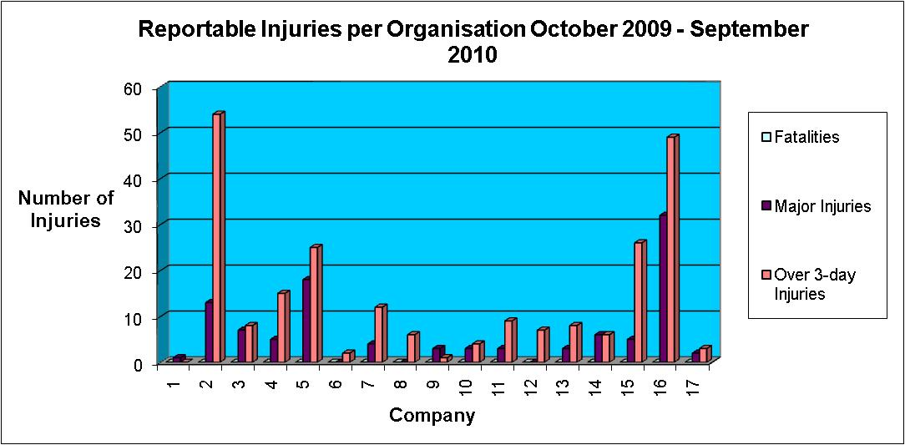

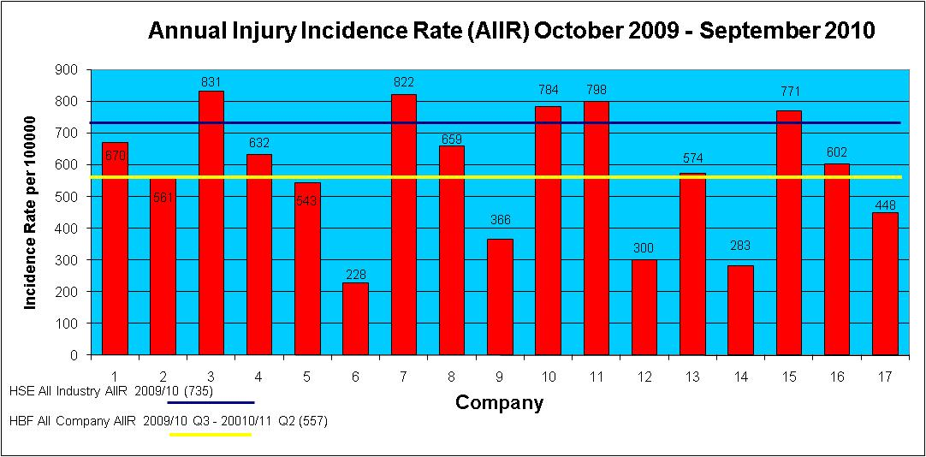

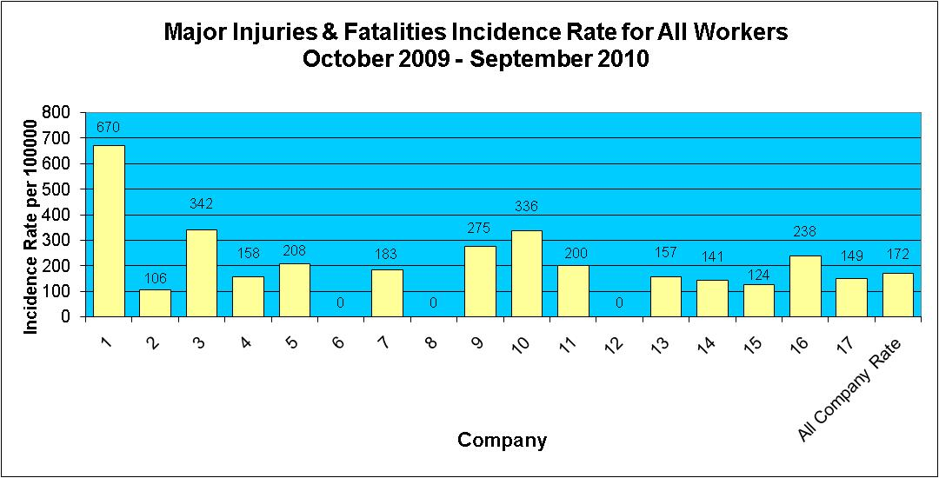

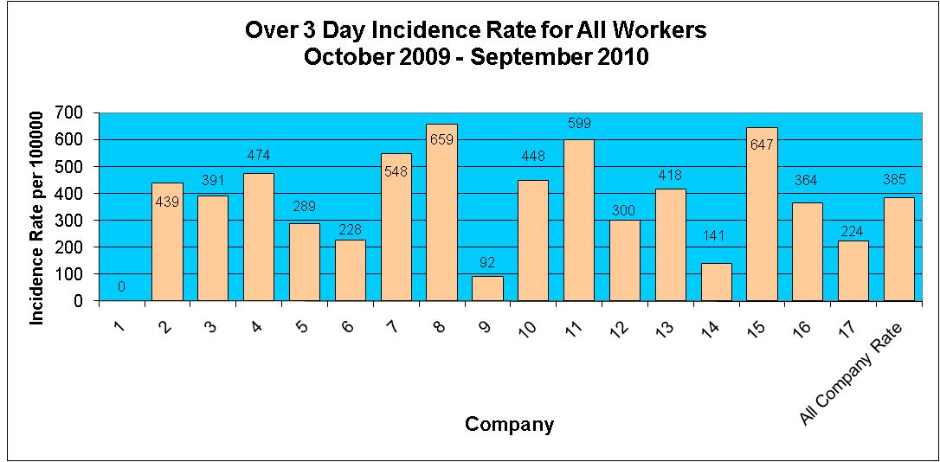

Injuries to Members of Public October 2009 – September 2010

During the period October 2009 - September 2010 there have been 11 reported incidents involving a member of the public.

