Health and Safety:
Reportable Injuries Diseases and Dangerous Occurrence Regulations (RIDDOR) results July 2010 - September 2010

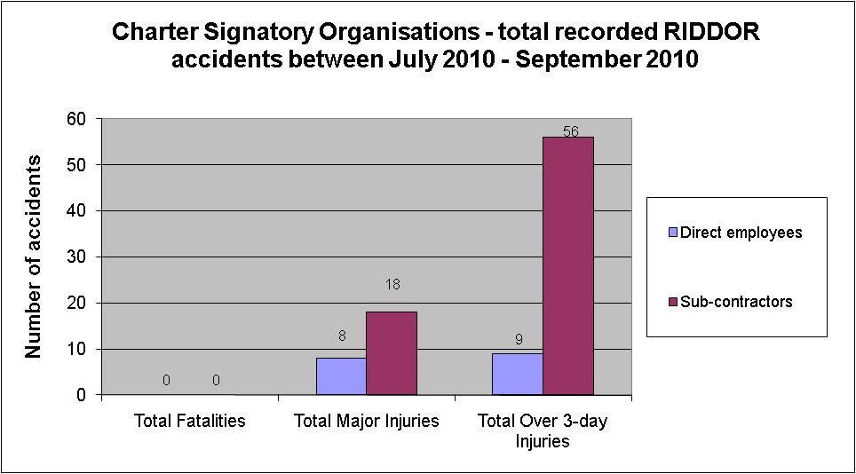

No fatalities from Charter Signatories July 2010 - September 2010

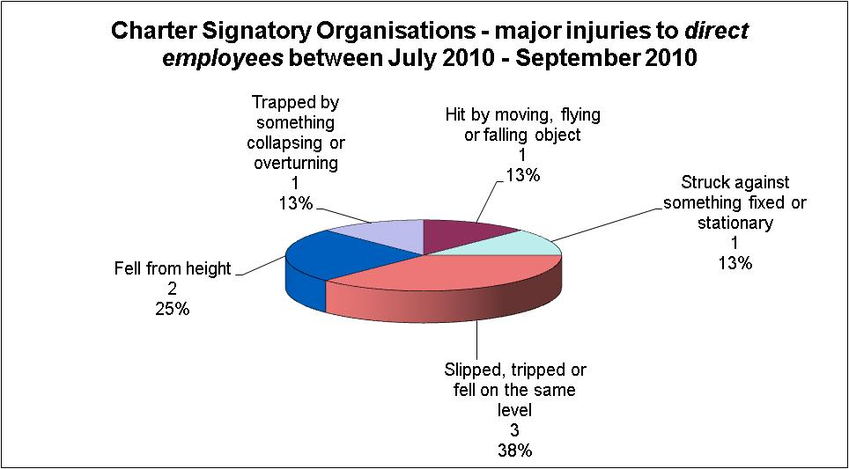

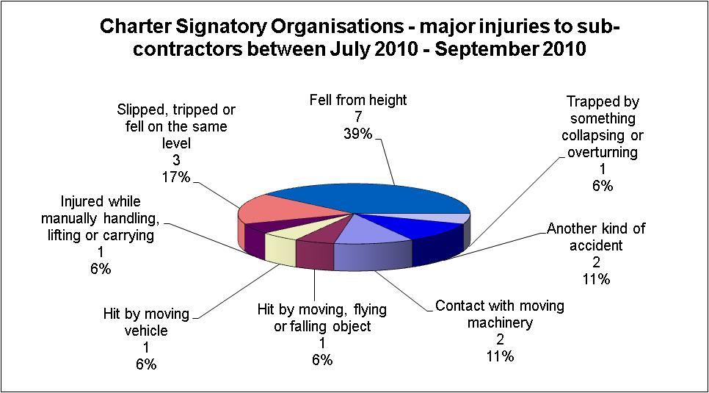

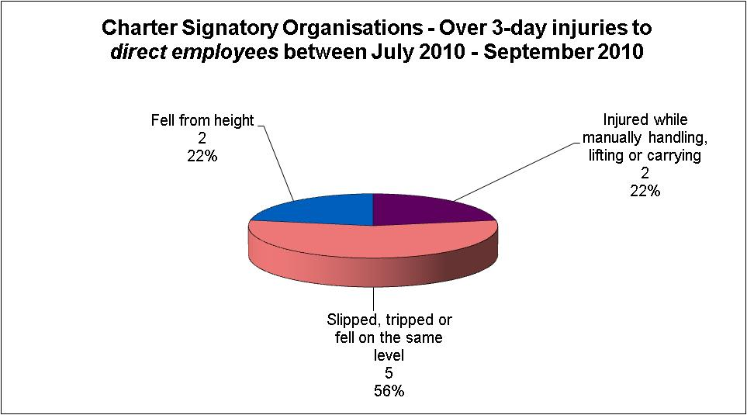

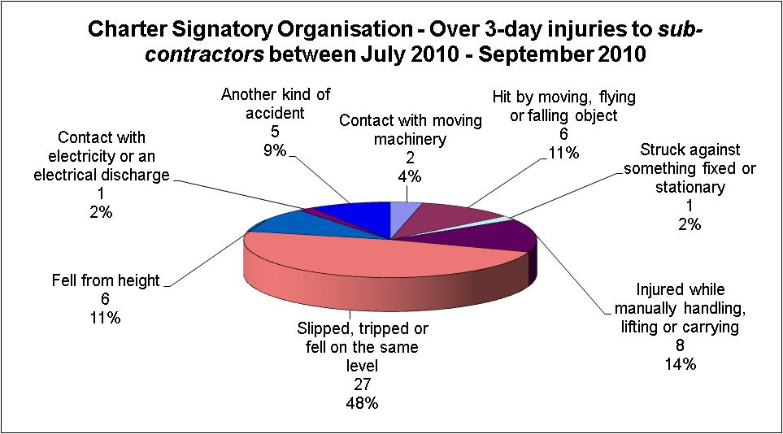

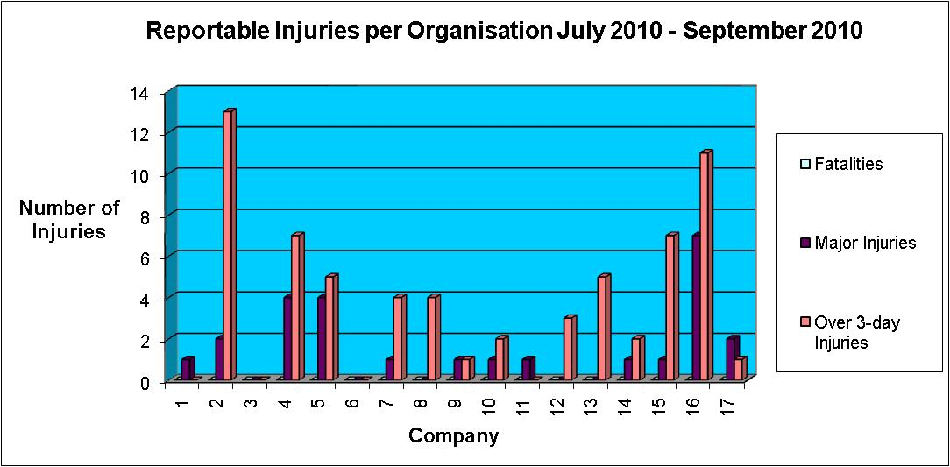

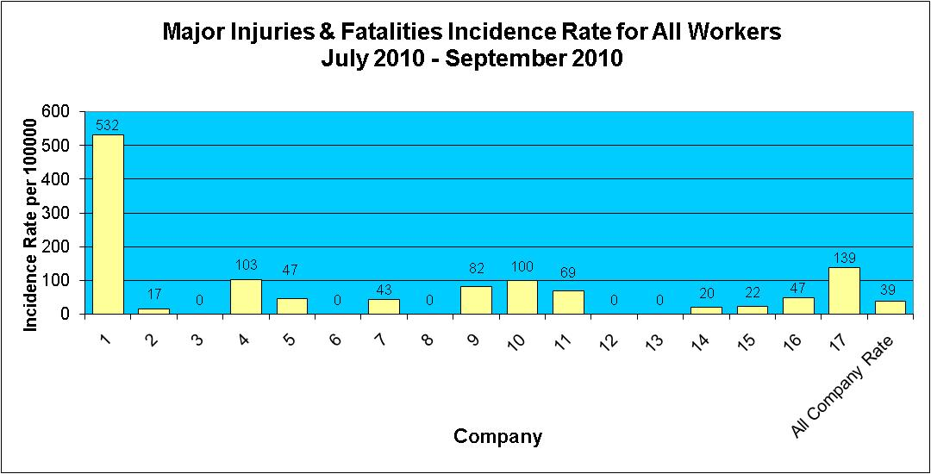

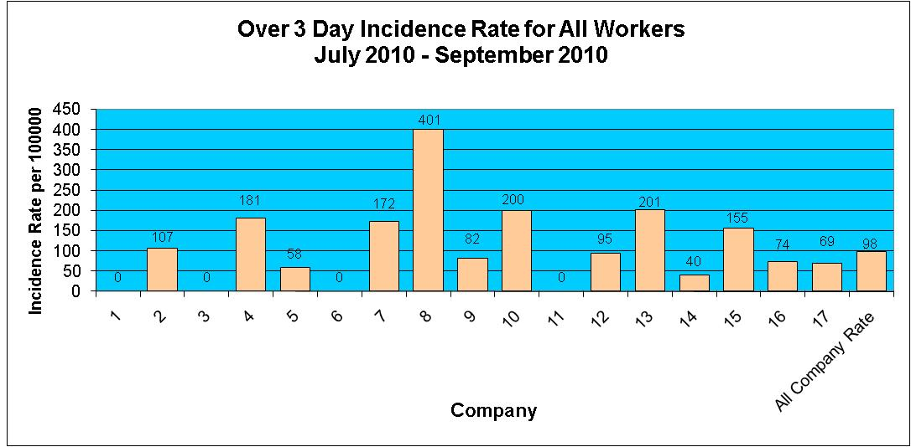

Injuries to Members of Public July 2010 - September 2010

During the period July 2010 - September 2010 there have been 4 reported incidents involving a member of the public.

