Health and Safety:
Reportable Injuries Diseases and Dangerous Occurrence Regulations (RIDDOR) results July 2009 – June 2010

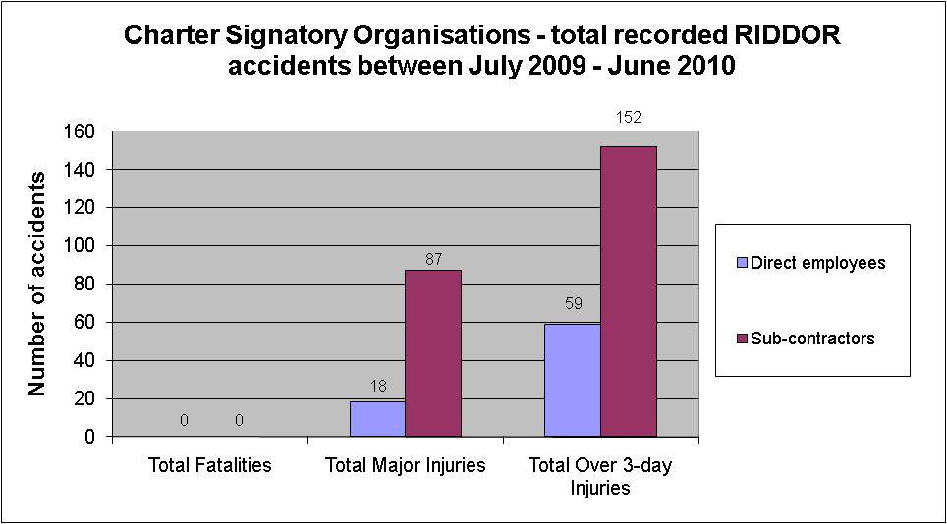

No fatalities from Charter Signatories July 2009 – June 2010

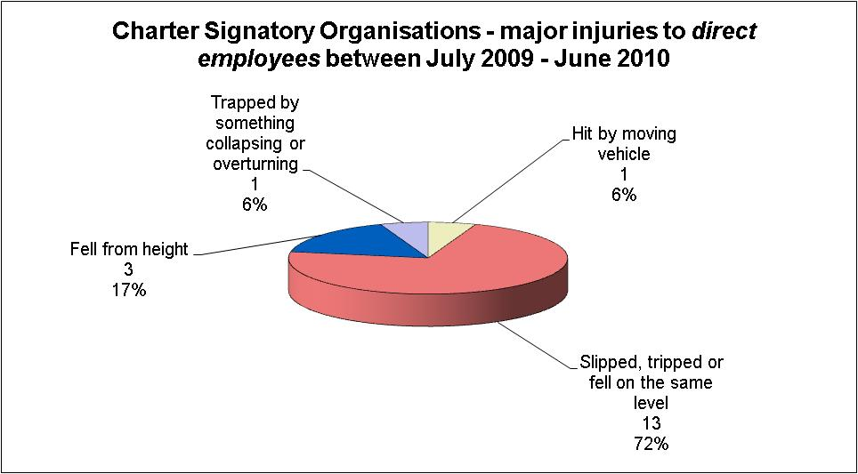

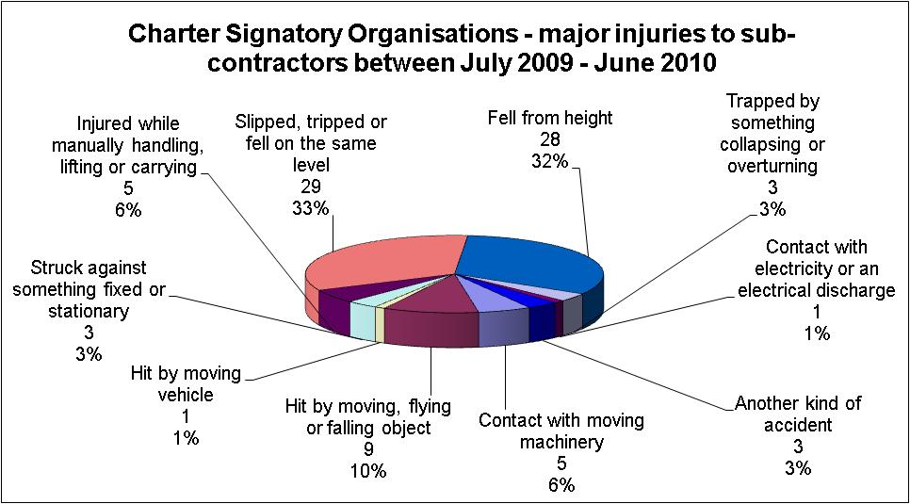

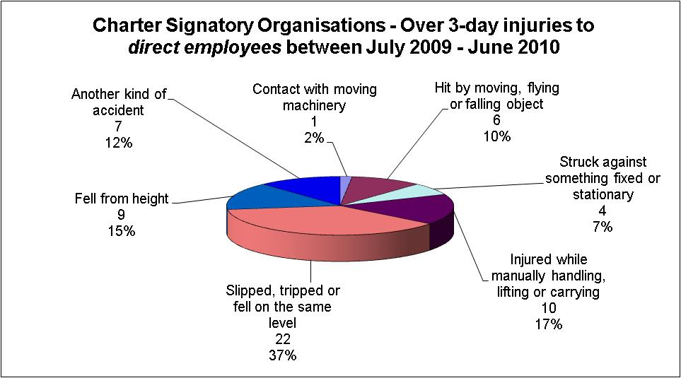

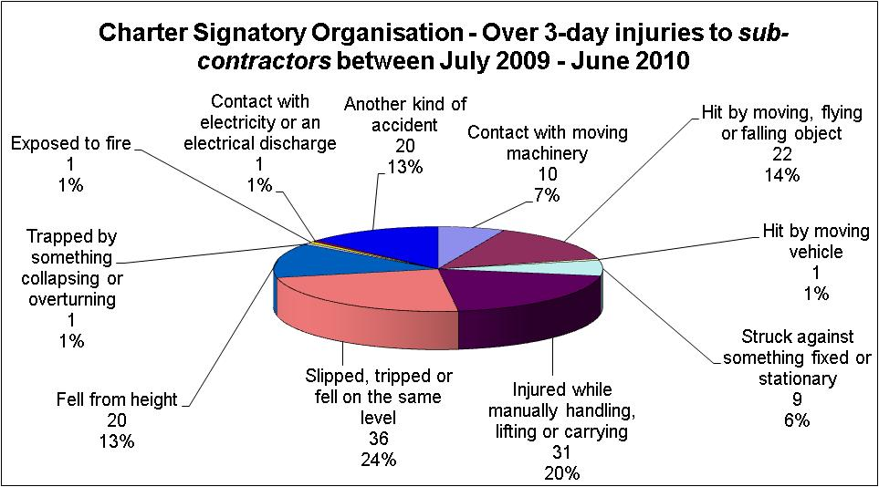

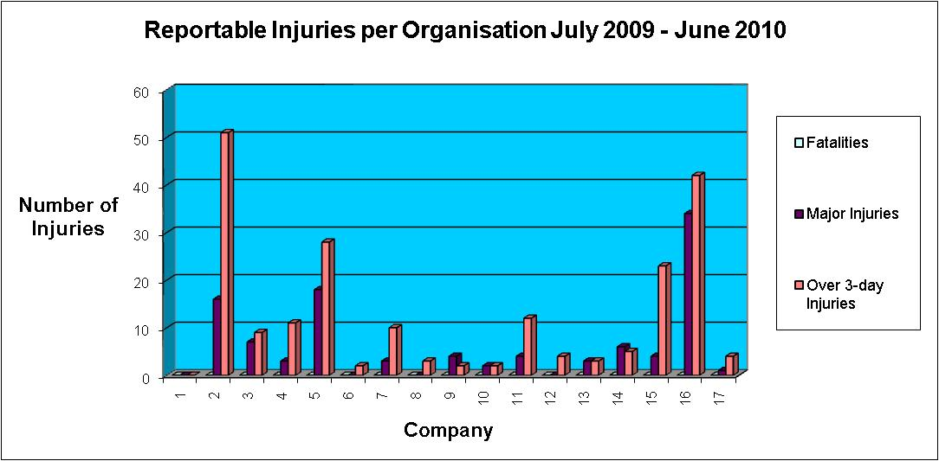

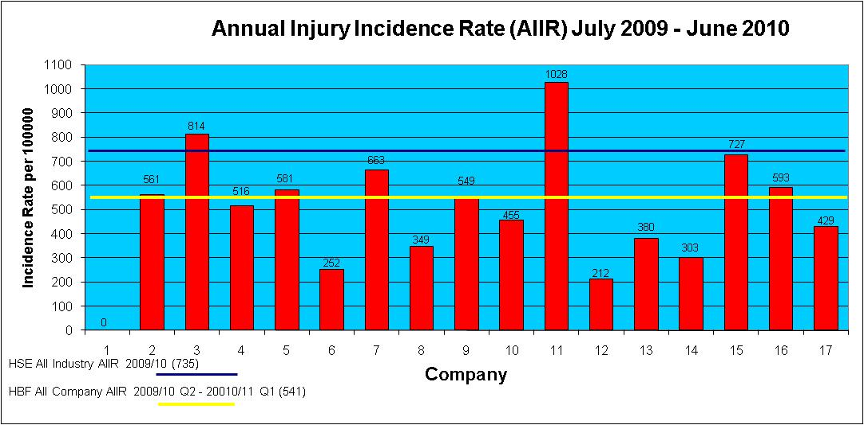

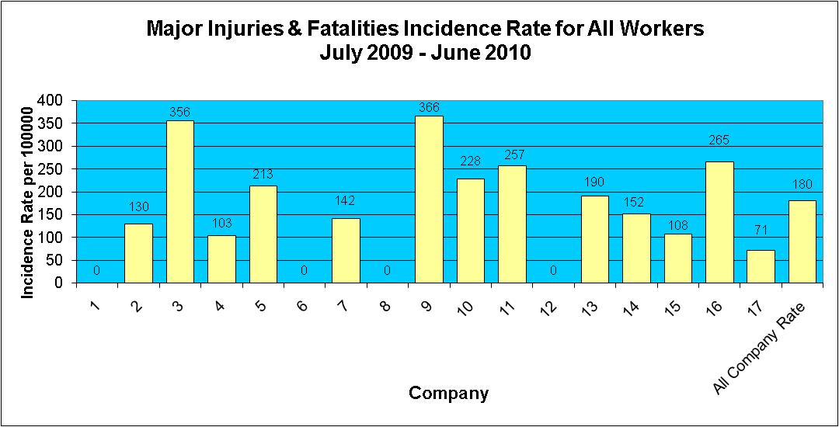

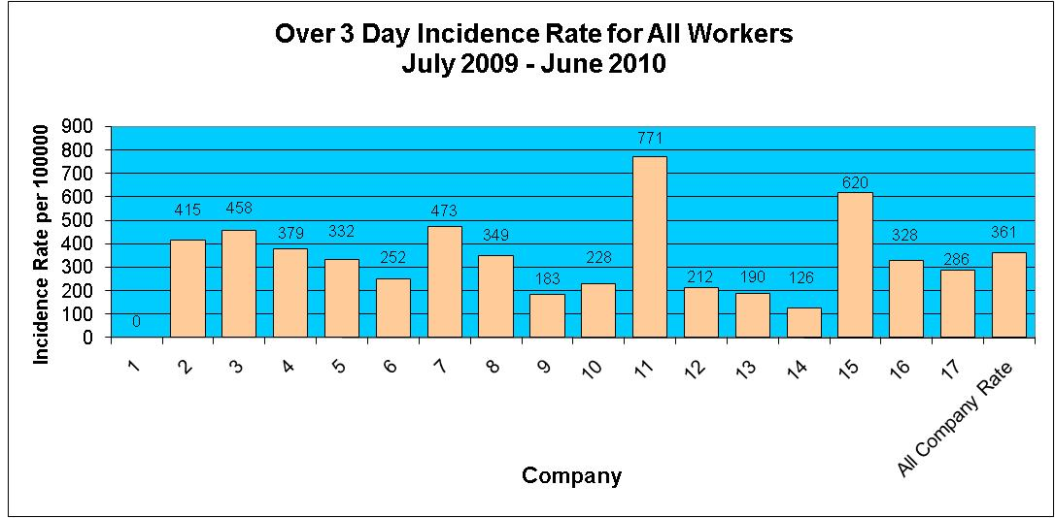

Injuries to Members of Public July 2009 - June 2010

During the period July 2009 - June 2010 there have been 9 reported incidents involving a member of the public.

