Health and Safety:
Reportable Injuries Diseases and Dangerous Occurrence Regulations (RIDDOR) results April 2010 - June 2010

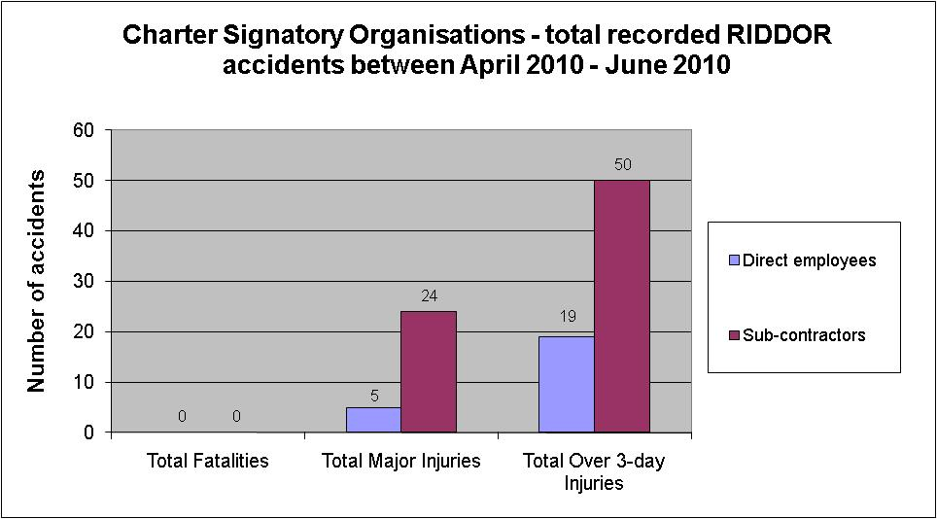

No fatalities from Charter Signatories April 2010 - June 2010

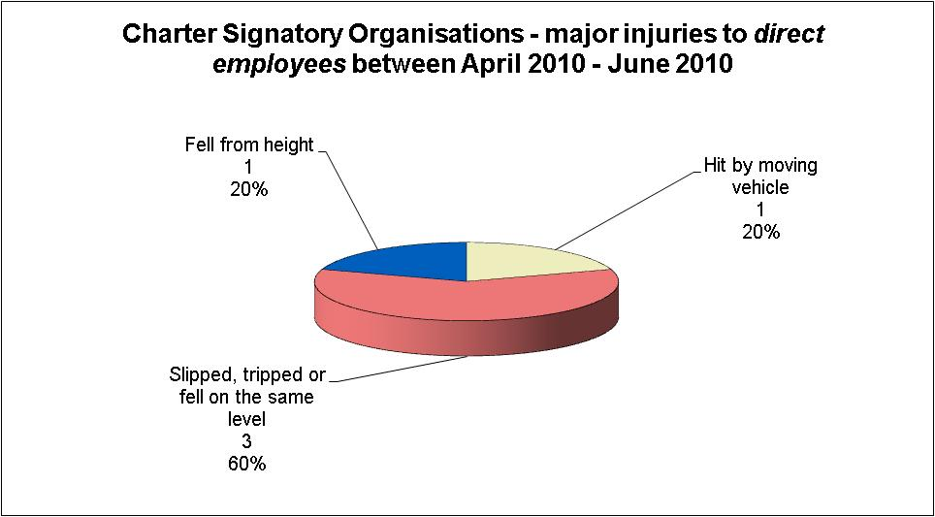

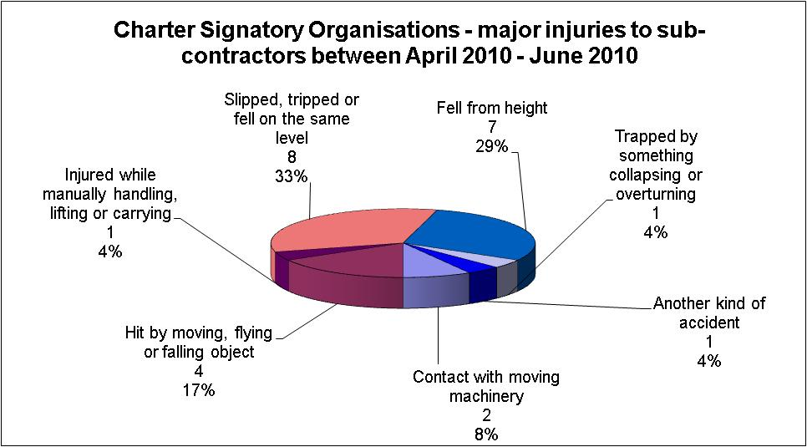

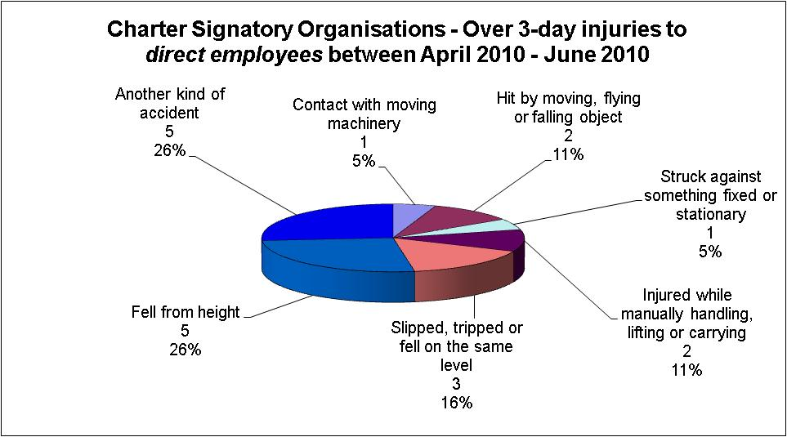

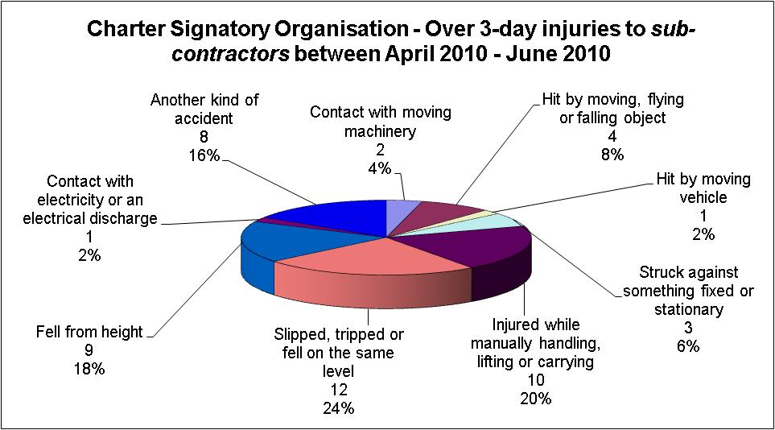

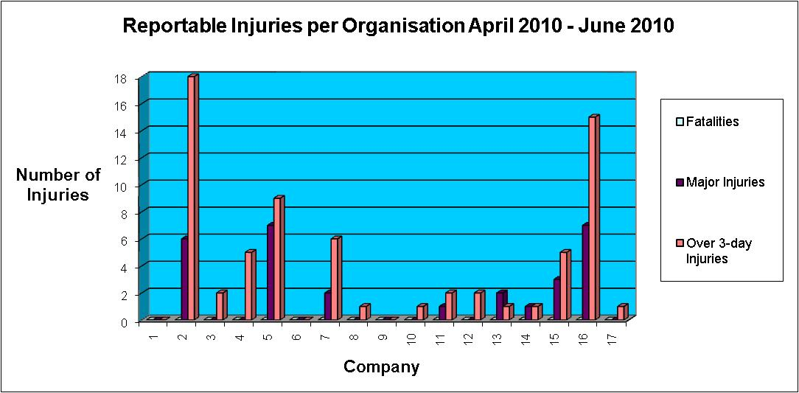

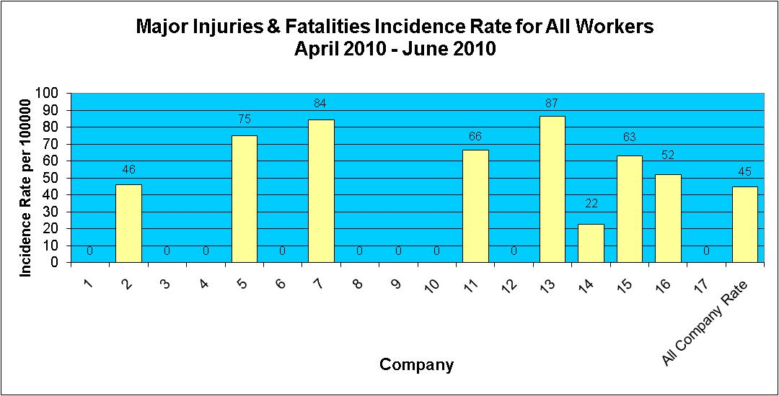

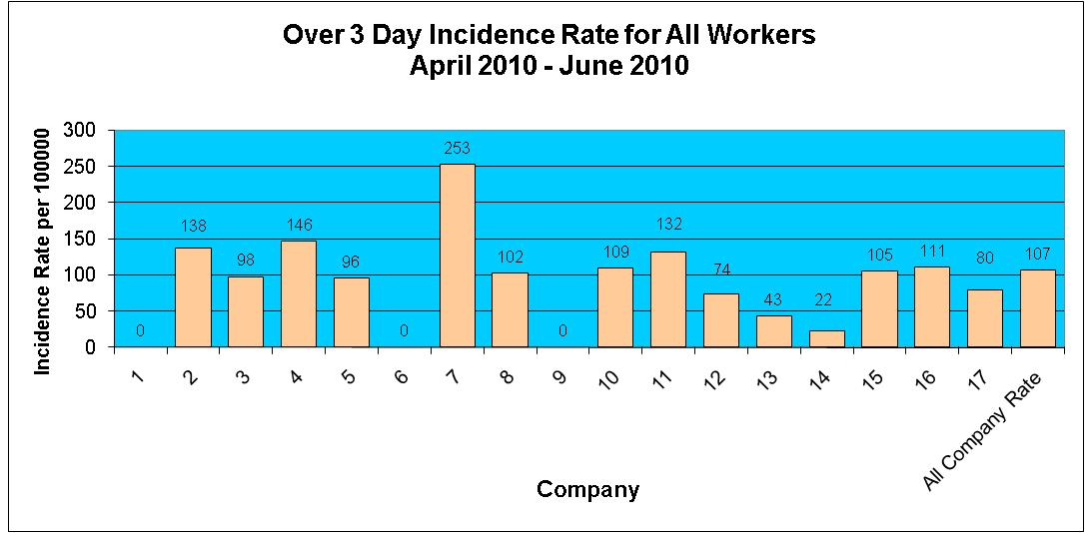

Injuries to Members of Public April 2010 - June 2010

During the period April 2010 - June 2010 there has been 1 reported incident involving a member of the public.

