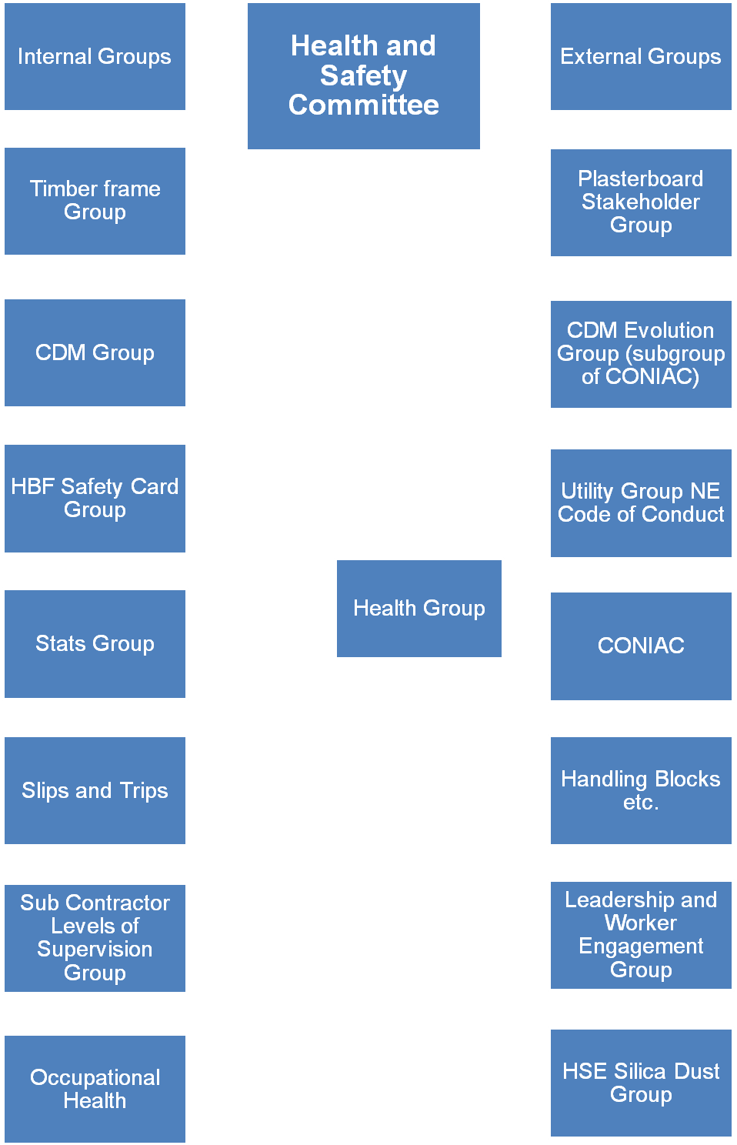

Health and Safety Committee

Internal Groups:
- Timber Frame Group
Dave Hudson (Countryside)
Barry Oliver/ Ian Viveash (Berkeley Homes)
Dave Lieberick (Galliford Try)
Mike Ackling (Persimmon)
Stephen Finnigan (Galliford Try)

- CDM Group
Steve Acaster (Persimmon)
Dave Hickman (Miller Homes)
Bob Sayers (Redrow)

- HBF Safety Card Group
Bob Sayers (Redrow)
Jane Puncher (Countryside)
Paul Beesley (Barratt)

- Stats Group
Martyn Price (Crest Nicholson)
Dave Hickman (Miller Homes)
Rosie Hinchliffe (HBF)
Dave Mitchell (HBF)

- Slips and Trips
Paul Haxell (Bovis)
David Hudson (Countryside)
Chris Epps (NHBC)
Ian Viveash (Berkeley)
Georgina Spake (HSE)

- Sub Contractors Levels of Supervision Group

Steve Foley (Gladedale)
Steve Allix (Fairview)
Dave Hudson (Countryside)
Glyn Neasham (Yuill Homes)
Barry Oliver (Berkeley Homes)

- Occupational Health
Dave Hickman (Miller Homes)
Caroline Haslam (Miller Homes)
Steve Foley (Gladedale)
Steve Acaster (Persimmon)
Chris Coatsworth (Barratt)
Glyn Neasham (Yuill)

External Groups

- Plasterboard Stakeholder Group
Dave Hickman (Miller Homes)

- CDM Evolution Group (subgroup of CONIAC)

As CDM group above

- Utility Group NE Code of Conduct
Glyn Neasham (Yuill)

- CONIAC
Paul Haxell (Bovis) (Main CONIAC Group)
Caroline Haslam (Miller Homes) (Health Group)

- Handling Blocks etc.
Dave Bolton (Morris Homes) at HSE group in London representing HBF

- Leadership and Worker Engagement Group

Names needed

- HSE Silica Dust Group
Chris Contsworth (Barratt)
Dave Hickman (Miller Homes)

