
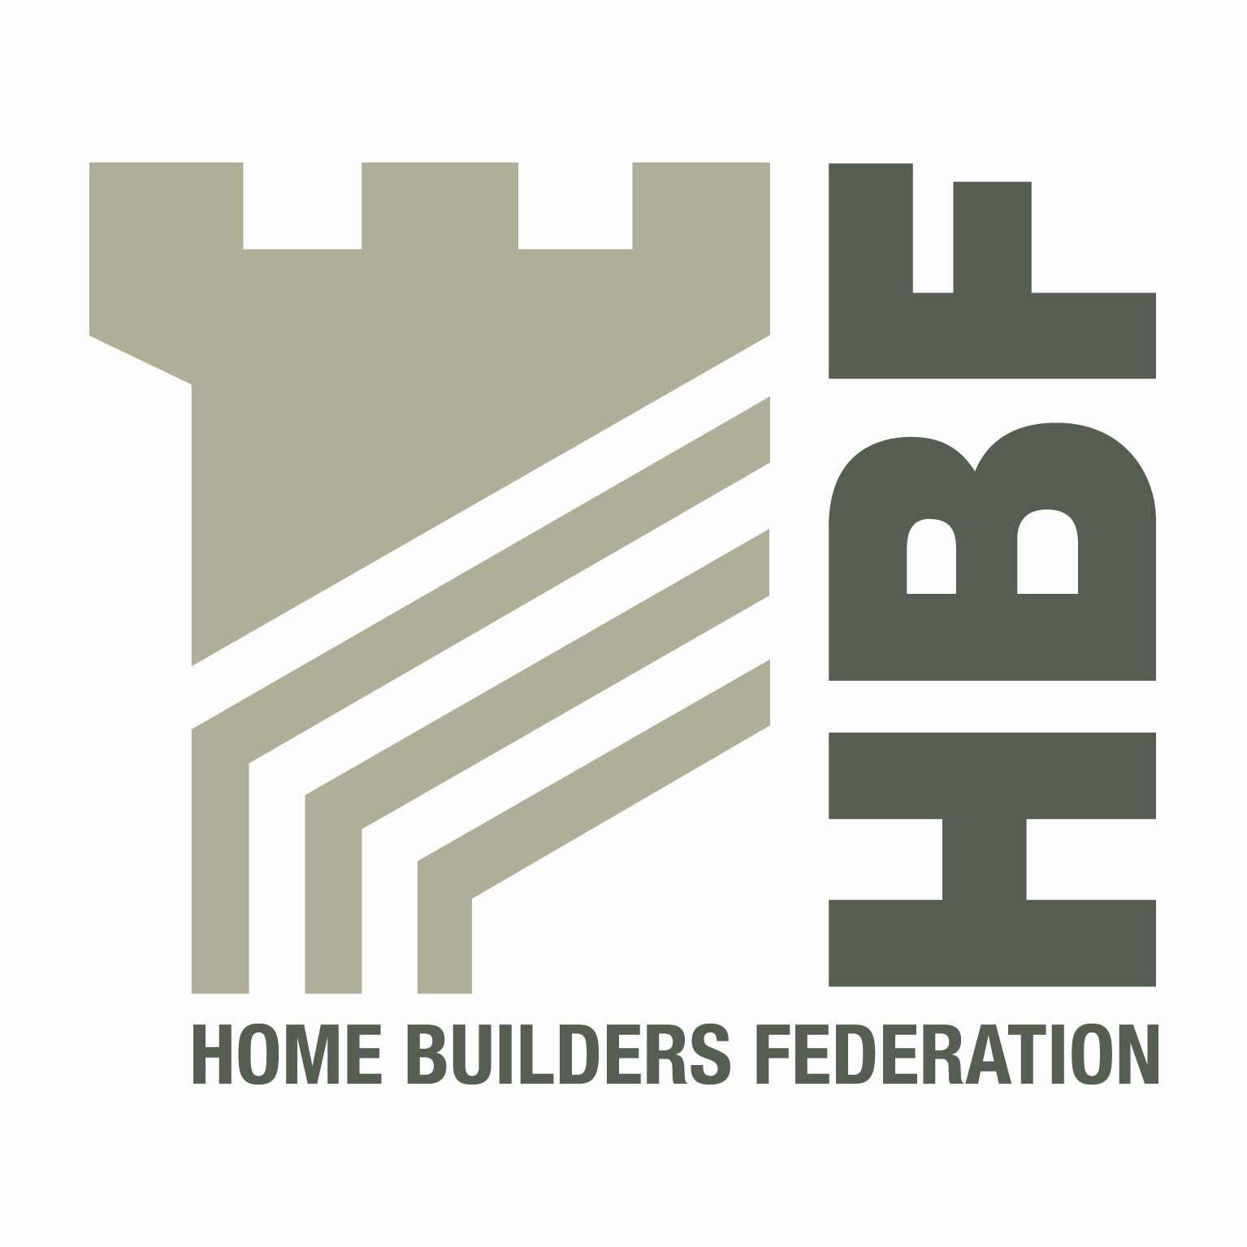
HBF HEALTH AND SAFETY COMMITTEE
AND
HOUSEBUILDERS’ HEALTH AND SAFETY FORUM

9.30 THURSDAY 3RD FEBRUARY 2011
BEN BAILEY HOMES LTD

NOTES OF MEETING
PRESENT
Andy Green | CALA Homes | Andrew Locker | Bloor Homes
Steve Foley | Gladedale Group | Bob Sayers | Redrow Homes
Simon Mantle | NHBC | Chris Epps | NHBC
Steve Acaster | Persimmon | Richard Theaker | Gleeson Homes
Matthew Stubblefield | Croudace Homes | Alan Craddock | HSE
Glyn Neasham | Yuill Homes | Vince Coyle | Barratt Developments
David Appleby | Taylor Wimpey | David Bolton | Morris Homes
David Hudson | Countryside Properties | Ian Viveash | Berkeley Homes
Martin Price | Crest Nicholson | Will Cameron | Keepmoat Homes
Caroline Haslam | Miller Homes | Nic Rigby | HSE
David Sanderson | Story Homes Ltd | Paul Haxell | Bovis Homes
Claire Walker | Bellway Homes | David Hickman | Miller Homes
Simon Hughes | Simian Risk Management
IN ATTENDANCE
Dave Mitchell | HBF

APOLOGIES
Nigel Squires | Bellway | Barry Oliver | Berkeley Homes
Kendrick Jackson | KJ Technical Services | Mark Starling | Kier
John Smith | McCarthy & Stone | Steve Allix | Fairview
Tony Murphy | Grainger | Stephen Finnigan | Regeneco
David Scott | European Timber Systems | Ken Millar | CALA
Dirk McCaffrey | Banner | Richard Lockwood | Barratt
David White | Regeneco | Dave Bell | Kier
Garry Rapson | Croudace | Edward Woods | Taylor Wimpey
David Leibrick | Regeneco

1. Welcome and apologies
DH welcomed everyone to the meeting and apologies were accepted from those listed above.

DH also thanked SF and Ben Bailey Homes for providing the venue for today’s meeting.

2. Notes of last meeting 27th October 2010 and Matters Arising
These were approved as read and the following are matters arising  Charter List – info for new signatories  DM reported that there had not been much progress on this and that any member with original documentation should forward information to HBF  It is hoped to have more detail at next meeting  Contact List and Groups update  Updated contact and group information sheets were issued with the meeting notes etc for this meeting.  DM requested that all members should check their details and let Rosie know of any changes/amendments needed.  The list will be re issued at each meeting.  Legal update  One side update of legal update from Rupert Nevin (RN) – DWF LLP speaker at last meeting had not yet been received. SA offered to chase these up for the group.  Safety of Electrical Gates  DM explained that all technical groups (national and regional) had been advised to look at any specifications they have surrounding these gates and to risk assess any situations where they might have been previously fitted.  A technical group would not be set up to look at this. It was felt that communication of the problem to members was sufficient and that members could then assess the best way of dealing with this within their own organisations  The link to the HSE safety alert on regarding this is;  Risks to pedestrians from crushing zones on electrically powered gates  NHBC are looking at this. There is a need for designers to consider carefully the positioning and environment where these types of gates are fitted. There is also a duty on manufacturers regarding this.  MP indicated that he is willing to attend any future meeting following on from the ‘gates safety summit’  Fire Plan Template for circulation.  BO was not able to attend this meeting. Should be available for next meeting.  WRAP Waste Forums  VC attended. Very useful forum and advised members to look at the WRAP website for further information.  Fire Place Data Sheet  This was issued with the papers for this meeting. SA advised that there should be an audit trail for the fitting of such fireplaces and that there should be a completion sign-off. This had been asked for in the preparation of this data sheet. | ALL  ALL  SA  BO
3. Health and Safety Groups, sub groups and working parties
CDM Evaluation Group  SA reported that the work of this group is now finished. HSE are reviewing CDM with the wider industry  CONIAC  PH reported on the latest discussions, which included:-  - Focus on leadership and worker engagement  - Series of tools being developed for the management of SMEs  - Safety working group looking at the strategy for work at height and making it socially unacceptable to work unsafely.  PH also reported on fatalities against SIC 41202 – Domestic Building from April 2010 to Jan 2011. These included:-  - 5 on refurbishment  - 2 on repair  - 2 on new build  - 2 unspecified  Health Working Group/CONIAC  CH told the group that there had been 3 meetings surrounding this. The CONIAC Health Working Group are to produce a position paper  CH gave the group a presentation. Copies of this will be circulated with these minutes.  Sub Contractor Levels of Supervision  DHu circulated a paper from the Supervision forum meeting on the 24th January. This shows a rough protocol which needs refining into a ‘matrix’ in order to give clarity. Comments on protocol to be put back to DHu | ALL  DM  ALL
4. Accidents Statistics
Accident Statistics Update  Final stats for period 1 and 2 were issued to the group with these meeting notes. Currently putting together period 3. Rolling year stats were circulated in draft form.  There was some debate surrounding whether rolling year stats were useful. Overall feeling was that these should be produced for each meeting.  HBF statistical report for the year 2009 – 2010 had now been finalised.  This would be made available on the HBF website  Additionally, MP and DHu (as per fire discussion) to advise on potential items to be collated as part of our regular data collection.  Where to now?  This sub group to come back to main committee at next meeting with proposals etc.  DM to add this as an agenda item for next meeting. | DM  MP/DHu  DM
5. Focus on Fire
Timber frame – fire during construction – meeting with minister  DM reported that HBF had attended a ministerial roundtable meeting on Monday 29th November 2010 to look at and discuss Fire in Timber Frame buildings. This meeting was in order to gain a greater understanding from all partners/stakeholders as to how they perceived current issues and how where necessary any problems could be rectified/managed.  A further meeting will be scheduled for March time.  As a result of this meeting with the minister a meeting of the health and safety timber frame working group had been organised and all of the health and safety committee house builders had been invited. This meeting took place on Thursday 13th January 2011.  Feedback from timber frame working group meeting - Thursday 13th January 2011  DM/DHu took the group through the discussions that took place.  The group looked at the UK TFA 16 steps to Fire Safety on timber frame construction sites and the HSE document HSG 168 – Fire Safety in Construction. The group considered that these are both very good documents but there are some discrepancies between them.  The following proposal came from the working group and they are looking for the full committee approval to take this back to the next meeting with the minister.  The proposal is that;  - UK TFA to be asked to check their publication and where necessary bring it into line with the HSE HSG168 document. They should also make mention of the HSE HSG168 document in their publication.  - An up to date list of all the fires (dates, cause and construction method) occurring in the last year be circulated to everyone present at the last roundtable meeting.  - A detailed list of all fires on newbuild construction sites in the next 12 months (masonry and timber frame) to be circulated to everyone at the roundtable meeting with a view to reviewing the situation in 12 months.  - All partners/stakeholders present at the last roundtable meeting should make themselves familiar with the contents of the 2 documents mentioned in 1 above to be able to inform their members accordingly.  The HBF main health and safety committee fully supported this proposal.  Separate to the above 4 items, to take back to the Minister, all members to provide brief details (as 2 above) for any fire on their developments over the last 5 years to DHu and MP as part of the statistical analysis.  Fire Safety re Sales and Show Areas  GN took the group through this talking about the need for secondary exits and assembly points.  It was agreed to share information surrounding this and to discuss further at next meeting.  DM to add this as an agenda item for next meeting. | DM  ALL  ALL  DM
6. Standard Loading Bays
Simon Hughes – Simian Risk gave a presentation on Scaffolding Loading Towers taking the group through the current legislation surrounding this.  General thoughts considered a 15kN/m² and 7/8 boards wide tower to be suitable for most house building uses.  Copies of presentation will be available with these notes  Simon e mailed HBF after the meeting thanking us for the opportunity to present.  He also said he would welcome any feedback that members might wish to make and would be willing to present in the future on any other scaffolding related issues | DM  ALL
7. HSE matters
NR talked about HSE’s work surrounding campaign surrounding refurbishment working at height and asbestos investigations.  He also mentioned a letter HSE had received from NFRC surrounding the top lift of scaffold and the excessive distance between this working platform and the roof edge causing dangers to their members.  Feedback from members regarding this required.  This is to be an agenda item at next meeting  AC talked to the group on their enabling project of ‘where we go from here’. HSE are looking at how they can in the future make the best use of the resources they now have. Generally agreed that this approach would be met positively. | ALL  DM
8. Gas Flues
On the 2nd December the HSE issued an updated safety alert regarding gas flues in voids. This provides updated information to the original safety alert issued on 2nd October 2008.
This updated safety notice can be found on the following link http://www.hse.gov.uk/safetybulletins/fluesinvoids.htm
The revised TB008 (edition 2) document entitled ‘Room-sealed fanned-draught/flue systems concealed within voids’ has also been released along with the TB008 (edition2) CIP-RACL document entitled ‘consumer information pack and risk assessment checklist’
As these are only available on the membership side of the Gas Safe website HBF have put them on there website, on the membership side under a gas safe logo in the Technical Section.

These come into force from 1st January 2011.

9. Environmental Issues
None to report to date
10. Dates for 2011 meetings
Thursday 14th April – Barratt’s, Northampton

Wednesday 3rd August – McCarthy & Stone, Bournemouth

Thursday 6th October – Berkeley, London NOTE: This date needs to change.

11. AOB
Utilities Code of Conduct  The extended use of the Code is to be raised as part of the agenda in a National meeting for utilities meeting in March.  TG28:09  SA highlighted the ongoing issue and dialogue on design of scaffolds for timber frame in accordance with TG28:09 and volunteered to pursue clarity with the various parties on the issue on behalf of the group.  Liability for Snow Clearing  GN raised the issue in respect of public areas and the liability for the public slipping on ice or snow. The Government have produced some guidance on this Snowcode, available at  www. direct.gov.uk/en/Nl1/Newsroom/DG_191868  SG4:10  An item was raised on expectations of the HSE on the implementation of this (advance guard rails, use of stools etc.) NR clarified that the HSE would expect the guidelines to be followed. | SA

