
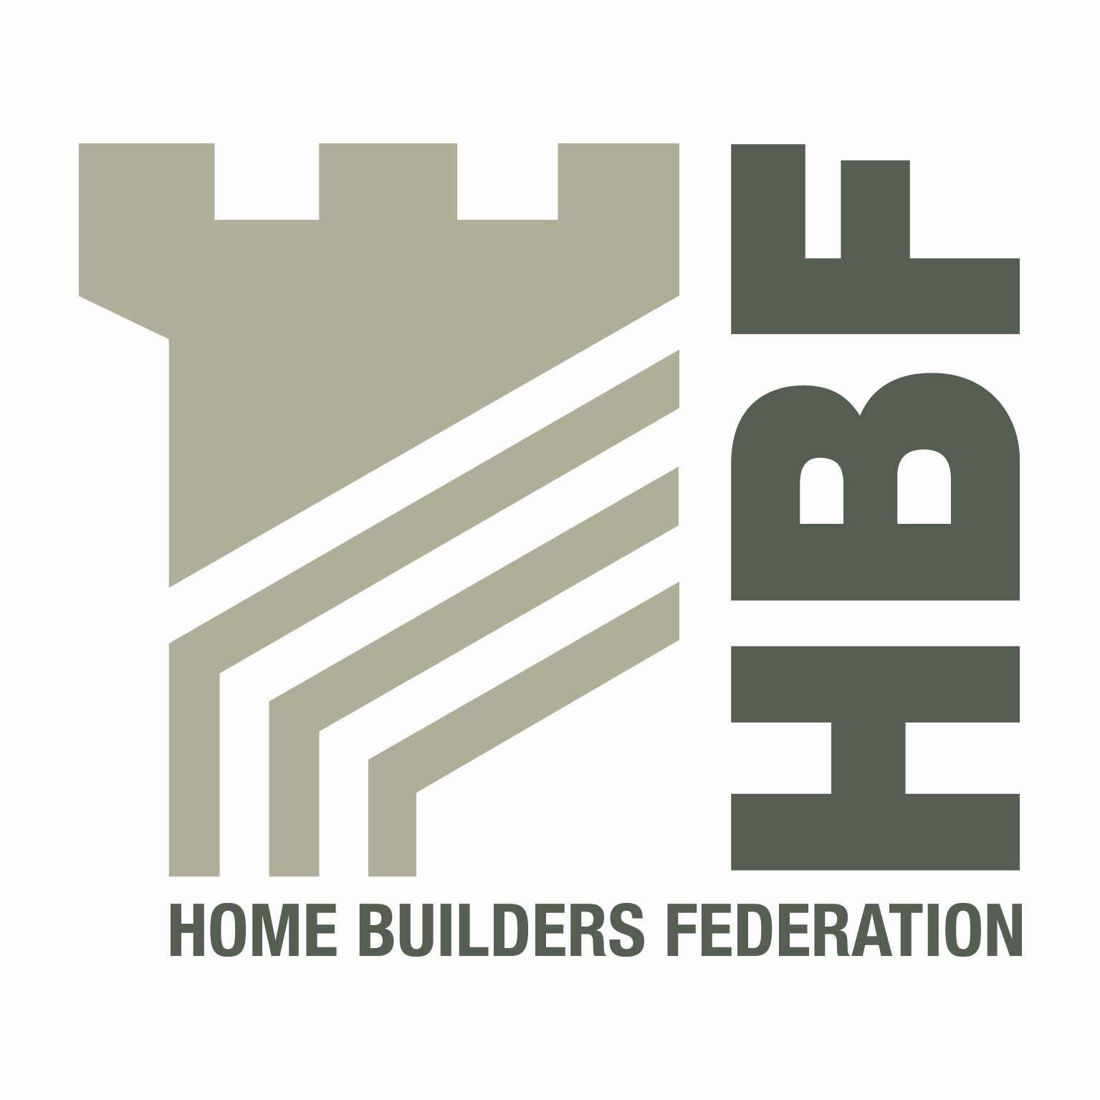

HBF HEALTH AND SAFETY COMMITTEE

AND

HOUSEBUILDERS’ HEALTH AND SAFETY FORUM

0900 for 0930 A.M. THURSDAY 14TH APRIL 2011

Wilson Bowden Developments Ltd., Forest Business Park, Bardon Hill, Leicestershire, LE67 1UB

AGENDA

- Welcome and apologies

- Notes of last meeting 3rd February 2011 and Matters Arising

    - H&S Charter original documentation availability – All
    - Contact list update – All
    - Legal update – circulation of notes – SA
    - Fire Statistics - All
    - Fire Plan template – circulation – BO
    - TG28:09 - SA

- Health and Safety Group, sub-groups and working parties - update

- CONIAC – PH
- Supervision Group - DHu

- Accident Statistics

- Accident Stats update – DM
- RIDDOR - proposed changes to reporting, LTIs or RIDDOR AIRs - DH
- Where to now – sub groups proposals - MP

- Focus on Fire

  - Timber Frame – fire during construction - update - DM
  - Fire Safety re Sales and Show Areas – Glyn Neasham

- HSE matters - Nic Rigby

- Environmental Issues – All

- Roofwork

- Top lift scaffold and excessive distance between working platform and roof edges - All
- Roofing Felt & Battens - DH

- Utilities – Code of Conduct update - GN

- Dates for 2011 meetings

- Wednesday 3rd August – McCarthy & Stone, Bournemouth NOTE: new date
- Thursday 27th October – Berkeley, London NOTE: new date

- Any Other Business

- External Safety Alerts – MEWP Fires, Telehandler and Skips, Excavator Crush - DH
- Legal Briefing - Osborn Abas Hunt – DH
- Agency workers – employer responsibility? - DH
- Jepson’s Safe Lorry Access - PH

