
Strategic Planning and Development
London Borough of Bexley
Wyncham House
207 Longlands Road
Sidcup
Kent
DA15 7JH 25 July 2008

BY EMAIL ONLY

Dear Sir/Madam

BEXLEY OPEN SPACE STRATEGY

Thank you for consulting with the Home Builders Federation on Bexley’s Open Space Strategy.

Open space across Bexley

The provision of new open space by developers is contingent upon the land being identified by the local authority, the suitability of that land for housing (if the developer is a housebuilder) and the financial viability of either providing new open space or contributing to the maintenance of existing space. The council has indicated in this document where it believes there to be a deficit of open space, but has not related this information to its spatial vision for the direction of development within the borough and where it proposes to direct future housing development.

It will need to consult upon this as it proceeds with the preparation of its core strategy.

The viability of providing or maintaining existing open space

The ability of house builders to meet the council’s aspirations to provide more open space is an important question when all other section 106 demands are taken into consideration, not least the costs of providing affordable housing. The council will need to have regard for development viability. Contributions levied to support infrastructure and other community facilities will need to be prioritised. Priorities should be set which relate to the specific needs of the development location. The amount of development contribution that can be secured must reflect development viability and the availability of public subsidy as spelt out in paragraph 29 of PPS3.

The new PPS12 also requires LPAs, as part of their core strategy, to provide evidence of the need for additional green infrastructure (paragraph 4.8). The council must specify who will provide this infrastructure and when it will be provided. Infrastructure plans need to be costed and realistic about the ability of stakeholders to deliver the required infrastructure within the prescribed timescales. Therefore the LPA will need to have recourse to a viability appraisal to ensure that its goals are achievable. Contingency options should also be prepared in case obstacles to delivery begin to be encountered in the council’s preferred development locations.

Locations for residential development

We note the observation on page 7 that local needs will vary within local authority areas. This seems certainly true in the case of Bexley where the research in this report reveals a more generous provision of open space of most types in Sidcup and Bexleyheath (pages 10-11). This would suggest that Sidcup and Bexleyheath might be able to accommodate more residential development, allowing new residents to benefit from the better amenities that are available in this area. This would be consistent with paragraph 36 of PPS3 which requires LPAs, when considering locations for housing, to take into account the availability of existing infrastructure: “ensuring that housing is developed in suitable locations which offer a range of community facilities with access to jobs, key services and infrastructure”.

Providing additional housing in Sidcup and Bexleyheath could also help with the creation of more mixed and sustainable communities. The council should consult the public on this possibility as part of its core strategy issues and options consultation.

The council should also have regard to the findings of the GLA’s Strategic Housing Market Assessment (SHMA) when this is published, as well as the results of its own SHMA, both of which will indicate areas where the market demand for housing is strongest as well as providing valuable information about population and household migratory patterns. Both of these studies should influence where the council provides new housing and this, in turn, should inform the council’s open space strategy and whether there will be any need to provide additional open space (say in the case of Sidcup and Bexleyheath) beyond possibly play space and estate gardens immediately related to the developments in question.

I hope this is helpful. I would be delighted to discuss further with the council any of the issues raised.

Yours faithfully

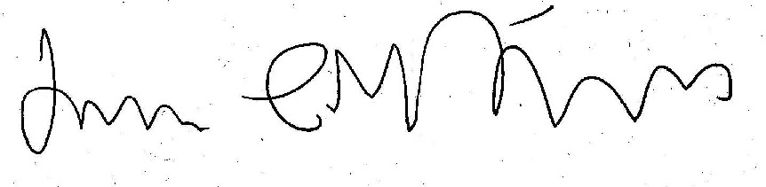

James Stevens
Regional Planner for London

Email: james.stevens@hbf.co.uk
Tel: 0207 960 1623

