

Acting Chief Planner
London Borough of Bromley
Room N33
Civic Centre
Stockwell Close
BR1 3UH

18 July 2008

BY EMAIL ONLY

Dear Sir/Madame

BROMLEY: ORPINGTON TOWN CENTRE SPD

Thank you for consulting with the Home Builder’s Federation on Bromley’s town centre masterplan draft SPD for Orpington.

Page 48: residential use

We notice that it is the council’s intention to make provision for mixed uses, including residential uses, as part of the regeneration of the town centre. We would be interested to learn how many units the council proposes to deliver in this way in the town centre. What proportion of Bromley’s total target of 4,850 net additions by 2017 does the council propose to deliver through this masterplan?

We ask because we have some concerns associated with the problems of delivering mixed use schemes (where dwellings are provided above shops) since these can prove problematic. The problems are:

- Access: especially for older people, given the drive towards making all homes meet Lifetime Homes standards, can adequate access be provided in homes above retail and commercial uses?
- Cost: the service charge costs for residents associated with paying for lifts and other elements of the scheme: will these schemes be affordable for residents, especially social tenants and the elderly?
- Is there a market? Presumably the council is hoping to attract, younger, more affluent professionals to Orpington town centre. But what evidence does the council have to show that they want to move there and live in flats? Of course, this partly depends on how far into the future the scheme will be delivered. In the current downturn the masterplan is unlikely to be realised. In an upturn, the scheme may prove viable. However, in the current downturn the council should not rely on strategic schemes such as this one to deliver against its housing targets. The sites that are likely to prove marketable in the current climate are lower density schemes in more suburban neighbourhoods. How far (or will) has the masterplan draw upon information from a Strategic Housing Market Assessment?
- Affordable housing: is the council relying too much on this scheme to deliver higher densities in order to optimise the number of affordable homes it can secure? What alternative options will the council pursue if this scheme cannot be realised quite as soon as it anticipates to secure the affordable housing it needs? In accordance with paragraph 29 of PPS3 the council will need to carry out an assessment of the viability of any affordable housing policy that it might seek to apply in the town centre.

Page 49: section 106

Depending on the project timetable, we would urge caution regarding the council’s expectations of the amount of s106 tax it can lever from the development. Development margins are tight, especially for house builders, and increasingly for commercial developers too. Their ability to meet higher regulatory demands, urban design standards, s106 obligations and affordable housing donations in a falling market is limited. In the past decade, the rising cost of development has been absorbed by new house buyers in the form of rising house prices. This is no longer possible.

In accordance with the new PPS12, in preparing DPDs, the council must calculate:

“what physical, social and green infrastructure is needed to enable the amount of development proposed for the area...This evidence should cover who will provide the infrastructure and when it will be provided.”

We recognise that this is an SPD, but the document will need to draw down from the core strategy – which is in preparation – the latter document’s estimated calculation of the infrastructure needed for the town centre in order to realise the vision. It is not satisfactory for the council to have an open ended list. The scale and kind of contributions that will be demanded must be calculated in advance so that developers have some forewarning of the extent of their s106 liability.

I hope these comments are helpful. Please get in touch if you wish to discuss these comments further with me.

Yours faithfully

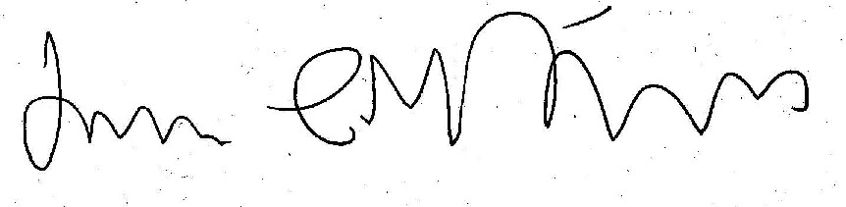

James Stevens
Regional Planner for London

Email: james.stevens@hbf.co.uk
Tel: 0207 960 1623

