

BY EMAIL ONLY

LDF Consultation

Policy and Implementation
Runnymede Civic Centre
Station Road
Addlestone
Surrey KT15 2AH

24th July 2008

Dear Sir/Madam,

RUNNYMEDE CORE STRATEGY – ISSUES & OPTIONS – HOUSING PAPER

Thank you for consulting the Home Builders Federation (HBF) on your council’s core strategy issues and options papers.

HBF has a number of comments to make on the housing paper and the SHLAA which accompanies it as set out below. These build on our comments on the previously submitted core strategy in our letter dated 7th April 2006.

Key Issue 1

As a minimum the council’s core strategy must make provision for the delivery of at least 5,720 dwellings in the borough between 2006 and 2026. This includes 2,500 at the former DERA site. Housing targets, including those in the South East Plan, are now set as minima to be exceeded wherever possible given Government’s overall objective of increasing housing supply across the country and the national targets of 2 million new homes by 2016 and 3 million by 2020.

However, given the nature and extent of demand for new housing in Runnymede, it is likely that the SHMA will identify a need for housing significantly in excess of this figure. It would not be surprising if the need for affordable housing alone is not in excess of this figure. Therefore, there would be merit in considering a higher target once the results of the SHMA are made available if these needs are to be met.

Key Issue 2

HBF is concerned that what the council suggests is a SHLAA (as one of the accompanying papers to this housing report) is not, in fact, a SHLAA as it has not been carried out in accordance with CLG’s practice guidance. SHLAAs are supposed to be carried out collaboratively with stakeholders involved throughout their preparation. Stakeholders include local landowners, developers, house builders, estate agents and so on. There has been no such involvement in this study to date which means its findings must be questionable to say the least.

PPS3 (para 59) is clear that windfalls should not be included in housing supply calculations for the first ten years of the strategy period post the anticipated date of adoption unless the council is able to provide clear and robust evidence of genuine local circumstances that prevent specific sites being identified. This is reiterated in the correspondence between the council and Government appended to the SHLAA and this topic paper. The council has provided no such evidence. The fact that the council has seen a high rate of windfall development in the past is not a justification for relying on windfalls in the future – certainly not to the extent proposed here where windfalls make up approximately 50% of anticipated supply (excluding the DERA site).

The council appears to be misunderstanding the requirements of PPS3 and the advice given to it by CLG officials and Baroness Andrews. The issue is not “is the council able to demonstrate exceptional circumstances why a windfall allowance should be included” which is the way the council has interpreted it. The issue is, “is the council able to demonstrate exceptional circumstances which prevent it from identifying specific sites”. This is a wholly different thing.

The SHLAA as it stands is fundamentally flawed and unsound and cannot be considered robust and credible evidence; certainly not sufficiently robust and credible to inform this core strategy’s approach to housing delivery. The SHLAA must seek to identify these potential windfalls as well as assessing the developability and deliverability of the Greenfield sites put forward by landowners and developers. Representatives of the house building and development industry should also be involved in refining the assumptions being applied in the SHLAA in order that the final result can be considered robust and credible evidence. Until this happens, the windfall allowance should be deleted from the housing supply calculation and the council should take the necessary steps to bring in some of the Greenfield sites suggested by developers in order that it is able to demonstrate that it has sufficient identified supply.

In that regard it should be borne in mind that, in recommending a slight increase to Runnymede’s housing figure, the South East Plan EIP Panel recognised that this may necessitate some small scale review of Metropolitan Green Belt boundaries in Runnymede (in common with a number of other districts in the London Fringe). Paragraph 20.75 of the Panel’s Report refers.

Following on from this, another key issue omitted from the consultation is a policy on delivery. As we stated in our comments on the strategy two years ago, there needs to be a policy included in the core strategy which addresses the release and delivery of identified sites; in other words, a plan, monitor, manage policy which lists the identified housing sites and sets out the criteria for their release, should the results of monitoring show they are needed. In view of the high reliance on windfalls at present, some of those sites may need to be released sooner rather than later.

Key Issues 3 & 4

It is premature for these issues to be consulted upon as the results of the council’s SHMA are not yet available. Any comments that are put forward are of limited value until we have this evidence of need for the overall amount of housing required as well as the need for affordable housing and any specific size and type of affordable housing needed. It is worth pointing out here that PPS3, the SE Plan EIP Panel and even SEERA’s own consultants state that it is not helpful or acceptable for local authorities to seek to dictate or prescribe the nature, size and type of market housing provided. They may seek to influence it through negotiation and they may seek to prescribe the type of affordable housing but they must not prescribe the mix, size and type of market housing provided.

Key Issue 5

Yes, without question. The need for affordable housing is not generated by private market housing development. Provision of affordable housing in association with market housing is only a material planning consideration because Government has unilaterally declared it so. However, there is a clear and strong link between the provision of new employment development and the need for housing to go with it. So, if private housing developers are expected to provide affordable housing then so should commercial developers as it is their employees who benefit directly.

Key Issue 6

Does the council fully understand what it is asking here ? Is it really a sensible option to add between £10,000 and £30,000 to the cost of a new flat/house (according to Government’s recently published estimates) in one of the highest house price areas in the country ? This suggestion demonstrates a complete lack of understanding of the Code for Sustainable Homes and Government policy on this matter.

Developers will be legally obliged to comply with the ever tightening standards set out in the C4SH as they will be implemented through successive tightening of the building regulations. There is no need for any additional standards to be imposed through the planning system or for local authorities to try to ‘out-green’ each other by seeking to impose higher standards still or to advance the timescale by which the various Code levels should be met.

Such actions are actually counterproductive as they lead to confusion, uncertainty and an adversarial approach to addressing the problem whereas this is one problem which should be addressed by all parties based on mutual understanding of each others’ positions. Only by approaching it in a consistent and co-ordinated way are the policy objectives of tackling the various elements of climate change likely to be achieved.

All the core strategy need do, therefore, is refer to the need for new development to comply with the requirements of the national Code. The Code targets as they stand are extremely challenging, not only for the house building industry but also for the supply industries and consumers alike. This is particularly the case in the current market. Requiring anything more than the Code will be counter- productive and will significantly hinder overall housing delivery which will obviously impact on the delivery of affordable housing.

Key Issues 7 & 8

The council should be guided by the requirements of PPS25 and the results of its own SFRA on these matters.

Just to make a point on SUDS, HBF and its member companies are keen supporters of the concept of sustainable urban drainage systems (SUDS) and seek to implement them wherever this is practicable. However, there is an acknowledged problem with SUDS, in that many water companies and local authorities refuse to adopt and take on responsibility for future management and operation of SUDS in new developments.

Given this reluctance on the part of the local water companies to acknowledge the benefits of SUDS and to adopt them as with traditional drainage systems, it would be excessive and unreasonable for any policy to require the provision of SUDS as a pre-requisite to development being granted planning permission in all cases.

I hope that these comments are helpful and that they will be taken on board prior to the publication of the submitted version of the core strategy. Either way I would be pleased to be kept informed of progress on the core strategy and any other LDDs the council will be producing in due course.

Yours faithfully,

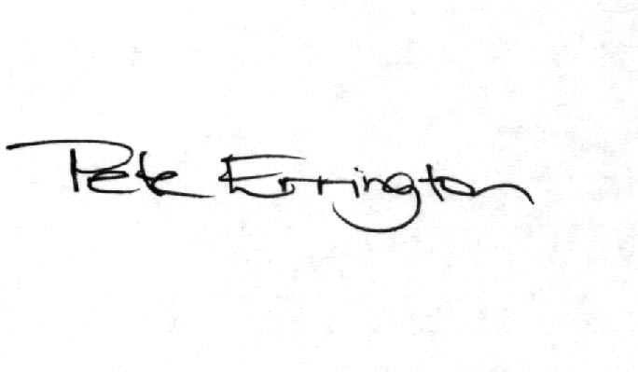

Pete Errington
Home Builders Federation
Regional Policy Manager (South, East & London)

