

BY EMAIL ONLY

Kristoffer Hewitt

Thames Basin Heaths Project Manager

Natural England

Phoenix House

33 North Street

Lewes

East Sussex BN7 2PH

25th July 2008

Dear Kristoffer,

TBHSPA MONITORING STRATEGY

Thank you for affording the Home Builders Federation (HBF) the opportunity of commenting on the draft TBHSPA monitoring strategy.

HBF does not have a great deal of comment to make, certainly not on the detail of what is proposed as this is somewhat beyond our normal sphere of operation. However, we do have a number of general comments which hopefully can be taken on board. These build on comments already raised by HBF and others at recent TBHSPA board and officer meetings.

Firstly we welcome the fact that this strategy has been produced. It is fairly pointless undertaking any actions if there is no attempt to try to ascertain whether or not those actions are effective. However, HBF’s aim is to ensure that the strategy proposed meets the criteria set out in your letter of 26th June in terms it being appropriate, proportionate and fit for purpose in the context of monitoring the impacts of new residential development on the SPA and the effectiveness of mitigation measures proposed in association with new development. That is setting aside our fundamental position that this is all totally unnecessary since the impact of new development is infinitesimally small in the context of existing impacts and other non-development-related factors. We are concerned that what is proposed in this strategy goes considerably above and beyond what is necessary just to monitor the impacts of new development and the effectiveness of mitigation. Instead, it is a comprehensive ‘gold-star’ SPA monitoring strategy.
There is nothing wrong with that in principle. However, if it is finally decided that a comprehensive monitoring strategy is the best solution, then there should not be the expectation that it is funded solely from new development. Other bodies and other sources of funding should be employed. Much of what is proposed is actually monitoring work which already happens and is already paid for by bodies such as the local authorities, wildlife trusts, Natural England itself and major landowners such as the MoD and the Forestry Commission. Developers should not be expected to pay to supplement or duplicate this work. Nor should they be expected to pay for monitoring of existing problems. They should only pay for those aspects of the monitoring strategy which relate to new development and the key impact which is walkers with dogs on the SPA and the effectiveness of SANGS.

So, while we note the costings set out in section 12 of the report, it should not automatically be assumed that all of this should be borne by the development industry. In addition to work which is carried out already, the TBHSPA board should seek funding from all the SPA board Members. Not least it should seek contributions from Natural England itself which initiated this whole process and through SEERA in the form of bids to the Regional Infrastructure Fund. Funding could also be sought from central and European Government to assist with this monitoring as this is an innovative and ground-breaking study which will have impacts across the country if not the EU. TBHSPA developers should not be seen as guinea pigs and be required to fund the entirety of this monitoring programme given these wider benefits.

This is particularly the case in terms of the extent of the monitoring period proposed. It is acknowledged that the SE plan runs to 2026 and that monitoring needs to be fairly long term. But the costs set out in the report assume that there has to be uniformity of monitoring across the whole 17 year period. This may not be necessary. It should only be necessary to undertake comprehensive monitoring for a much shorter period (say 5 years) with successive scaling down of the intensity and regularity of the monitoring the more time elapses beyond this. At present, this scaling back only seems to be applied to SANGS monitoring. There is no reason why a similar scaling-back could not be applied to other aspects of the monitoring programme.

Conversely, if this is solely to be funded from developer contributions then the monitoring strategy should be significantly scaled down to be more proportionate and reasonable. Key savings could be in terms of deleting the requirement for dedicated staffing and abandoning or scaling back the household postal survey. But also, issues relating to dog fouling, fires and the intensity of survey work could easily be scaled back with minimal adverse consequences on the effectiveness of the monitoring results. They are not directly related to the impact of new development and are largely pre-existing problems which landowners and managers should be seeking to address already. Things like collation of data and storage of records, like staffing, should be subsumed within existing SPA board partners rather than having to be provided externally.

Turning to the appendices of the study, appendix 2 deals with determining the capacity of SANGS. The third paragraph boldly states that the 8ha mitigation requirement is untested. This is not so. This figure (and alternatives put forward by Natural England in the original Delivery Plan, and others) was tested as part of the SE Plan EIP Technical Sessions. Ultimately the Technical Assessor, faced with the evidence from all sides, recommended the figure of 8ha in response to a proposal put forward by HBF based on the existing use of the SPA rather than the alternatives before him.

The issue for developers is not ‘what is the capacity of the SPA per se in some form of ideal world’. Rather it is a more proportionate and measured approach which focuses on mitigating the impacts of development compared to a pre-existing baseline position related to existing use of the SPA. If the capacity of the SPA improves with time or if visitors stop using the SPA with time due to the existence of SANGS, then so be it. But the assumed baseline position must be current use of the SPA and ensuring that that is not made worse by new development. In that regard the 8ha figure has been tested in the broadest sense in that it came about as a result of an independent testing process – the EIP. It has only not been tested in terms of monitoring out in the field. But then that applies to the whole ISDP / SANGS approach. The starting point must be that 8ha is the standard and there should be no attempt to alter this by any distortion of either the baseline position or the monitoring strategy as a whole.

Turning finally to Appendix 3, many of the things listed in Part A “What needs to be monitored” will already need to be monitored as part of the planning process. Many already will be monitored as part of the planning condition compliance and discharge process and through the monitoring of s106 agreements. Developers already pay for these processes through their planning application and associated fees. There should be no assumption that additional charges are levied (or included in the monitoring schedule costings) to cover things already paid for elsewhere.

I hope that these comments are helpful and that they will be taken on board prior to the finalisation of the strategy. HBF considers that there should be further consultation on the allocation of these costings and further efforts made to secure supplementary sources of funding before those costs are allocated to the various interested parties. Either way I would be pleased to be kept informed of progress on the strategy in due course.

Yours sincerely,

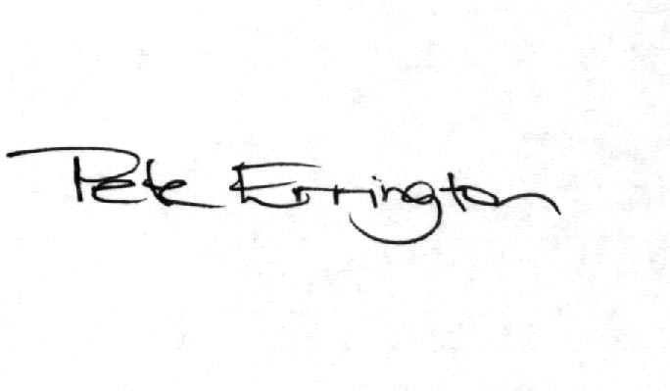

Pete Errington
Home Builders Federation
Regional Policy Manager (South, East & London)

