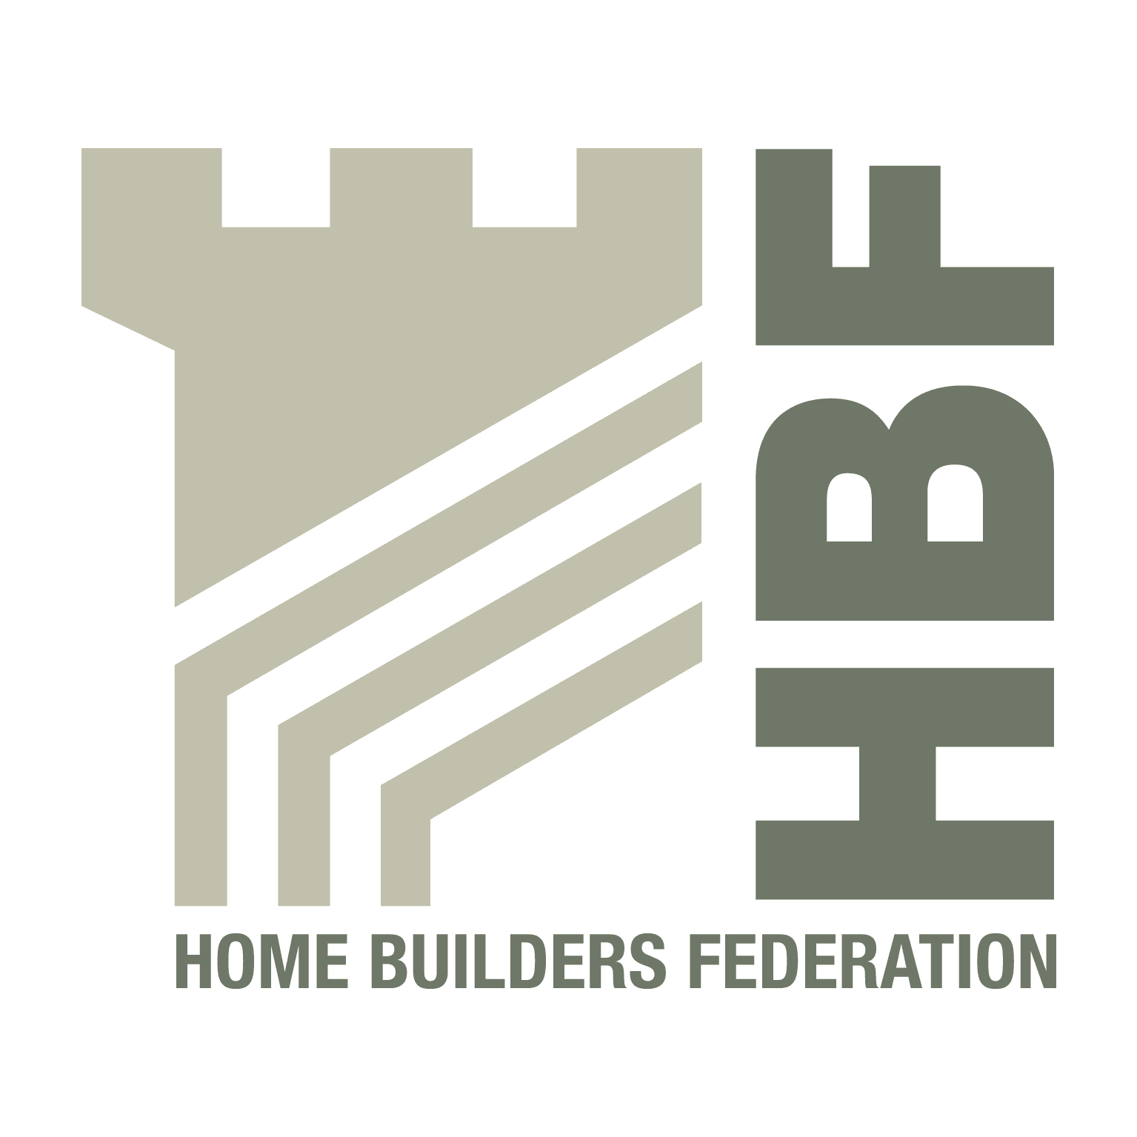
Ms Anna Cronin
Reigate & Banstead Borough Council
Town Hall
Castlefield Road
Reigate
Surrey
RH2 OSH 11 July 2008

BY EMAIL ONLY

Dear Sir/Madam

REIGATE & BANSTEAD STRATEGIC HOUSING LAND AVAILABILTY ASSESSMENT

Thank you for consulting the Home Builders Federation on the proposed methodology for this study.

Stage 1: Planning the Assessment

We are unsure whether it is the council’s intention to engage more fully housebuilders and other stakeholders. This should not be confined to consulting them on the methodology but involving them in stages 6 and 7 of the assessment: assessing the suitability, deliverability and developability of sites. Will an attempt be made to involve housebuilders on the Partnership Board? We recognise the difficulties in the current period in engaging with certain stakeholders, but we would welcome some move on the council’s part to engage with the sector.

Stage 2: Determining sources of sites

The council must ensure that its Five Year Land Supply (FYLS) is adequate to support the council’s plans in the early years of its core strategy. It needs to assess whether the sites contained in the FYLS are deliverable and developable in accordance with the guidance in the SHLAA practice guide, otherwise its plans may be unrealistic and it may have drawn upon housing sites from the supporting 10 year trajectory earlier than expected.

Windfalls are not permitted in the first 10 years of the plan (see page 5 of the CLG Practice Guidance). They should not be counted as sites within the planning process for the purposes of preparing for the delivery of the council’s Core Strategy, even if they were permitted under earlier guidance.

We feel the council is excluding too many sites from its initial assessment and in this area the draft methodology it departs from the spirit of the CLG’s practice guidance. Many of the areas excluded could potentially make a contribution to housing land, even if it is a small one. Aside from SSSIs which would clearly be unsuitable for housing (see paragraph 21 of the practice guidance), AONBs, areas of Green Belt including urban extensions, and conservation areas all have the potential to make some contribution even if the council does not ultimately draw upon them to make up its FYLS. The Isle of Wight, for example, is an AONB yet is accommodating quite considerable housing development.

We also would question whether non-statutory designations such as Areas of Great Landscape or Townscape Value should be excluded from the survey when they could potentially make some contribution. They should not be accorded the same degree of protection as statutory designations. Furthermore, it does not automatically follow that surveying sites in these areas will lead to these sites going into the FYLS or 10 year trajectory. Ultimately, in accordance with paragraph 21, any decision regarding what types of areas are excluded from the survey will need to be decided and justified by the Partnership Board. That is why it is especially important that the Board fairly represents all interests, including those of the housebuilding industry.

Stage 3: Desktop review of existing information

It is unclear from table 3 whether the council intends to review the potential contribution from public sector land (Register of Surplus Public Sector Land) or whether such data is incorporated in other council studies, such as RBBC’s National Land Use Database.

Stage 4: Determining which sites and areas will be surveyed

The council states that it has already identified sufficient sites to meet the Draft South East Plan Panel Report. Setting aside the possibility that the modifications may raise RBBC’s housing target higher, this does not account for the timeframe of the Core Strategy which should plan for housing delivery over a period of 15 years. The SHLAA, therefore, needs to plan for housing delivery from the likely date of adoption of the core strategy and at least 15 years beyond this. This would take the SHLAA beyond 2017 (less than 10 years from now) up to 2023.

New sites, therefore, will need to be identified to feed the 11-15 year trajectory.

Stage 6: Estimating housing potential

This will need to be carried out in conjunction with housebuilders and landowners. The council cannot assume that existing permissions will still serve as a useful guide in assessing likely site yields: this will be subject to changes in policy and changes in market demand. For example, we are witnessing a movement away from very high density, flatted schemes, to lower density and family housing even around transport nodes. Also, the demand for greater play and recreational space will influence the eventual housing yield of sites.

Stage 7: Assessing when and whether sites are likely to be developed

Once again, we believe that it is vital that the council involve housebuilders and landowners at this stage of the assessment to ensure that its assessments of deliverability and developability are realistic. We would welcome confirmation that it intends to do so.

Stage 8: Review

We welcome the council’s commitment to reviewing the assessment. This should include reconsidering the contribution that might be made from sites previously dismissed as unsuitable for development (stage 7a) on the grounds of policy restrictions (Green Belt, conservation areas) all of which can potentially make a contribution.

We hope these comments are helpful. Please get in contact if you need clarification of any point.

Yours sincerely



James Stevens
Regional Planner, London and Surrey

Email: james.stevens@hbf.co.uk
Tel: 0207 960 1623

