
David Dewar
Planning Policy Officer
Wycombe District Council
Freepost HY120
Planning and Sustainability
Queen Victoria Road
High Wycombe
Bucks HP11 1BB 9 July 2008

EMAIL ONLY

Dear Mr Dewar

WYCOMBE DISTRICT COUNCIL: DEVELOPER CONTRIBUTIONS

Thank you for consulting with the Home Builders Federation. We would like to make the following comments on the accompanying guidance document.

Status of the guidance

As you will be aware, this, like the Supplementary Planning Document which it is designed to accompany, is a non-statutory document and therefore cannot be binding on developers. Discussions of levels of planning obligations must relate to tests of viability which will, in turn, impact on delivery of new development on the ground. We hope that housing will not be regarded as an inconvenience or problem for which it is necessary to extract the maximum possible amount of planning gain before housebuilding can be considered acceptable. We do not need to remind you that the losers in the process if development viability is stretched will be people in desperate need of housing.

Secondly, we are curious as to why the council is choosing not to revise the planning obligations SPD in line with the recently approved, but as yet to be adopted, Core Strategy? This is the proper course to follow, not the issuing of non-binding accompanying guidance which has no formal status. We would also challenge whether the policies in the Core Strategy are capable of supporting the new demands outlined in the guidance, such as contributions to the police service, since paragraph 5.9 of the Core Strategy makes no mention of these.

Lastly, we would query the benefit of the council issuing a non-statutory document which is intended to provide guidance to an SPD which in turn expands upon policies which are meant to be contained in Wycombe’s Core Strategy when this latter document is adopted. May we suggest that this is an unnecessary expenditure of resource? This bureaucratic, multi-tiered approach, hardly assists in providing clarity for the public and developers and is contrary to the spirit of more open government.

Key questions for consultation

ii) Environmental Improvements – Places of Distinction projects

In accordance with Circular 05/2005 only developments taking place within the parameters of the council’s ‘places of distinction’ can be subject to this particular levy, and even then, it must take its place in the queue behind other, more pressing s106 priorities, namely the delivery of affordable housing.

iii) Thames Valley Police

No, we do not agree that police services should be subsidised from the construction of desperately needed new housing. We fail to see why prospective new households should necessarily generate more crime than existing households. Afterall, households living in the second hand stock may be subject to much greater change in composition than those moving into any new homes and may be responsible for generating more demand on police services than residents of new housing (e.g. the issue of the sub-division of houses into flats).Many people who move into new housing will already reside locally and so will either be law-abiding citizens or not.

Furthermore, they are also already paying for this through central and local taxation. Because they are not generating additional demand there should be no grounds to demand subsidy for such services from planning obligations in accordance with paragraph B8 of Circular 05/2005 which states that “obligations must...be directly related to the proposed developments”. The Circular goes on, in the next paragraph, to make clear that planning obligations should not be used to “resolve existing deficiencies in infrastructure provision or to secure contributions to the achievement of wider planning objectives that are not necessary to allow consent to be given for a particular development.” Nor should they be used to subsidise what should be paid for out of local taxation. Or perhaps the council is going to reduce council tax bandings for new housing as opposed to the second hand stock?

iv) Education

The council needs to establish the causes of the projected deficiency and whether this is solely attributable to new demand generated by housing construction. Furthermore, in accordance with Circular 05/2005, the council (or Buckinghamshire County Council) cannot insist that every development in Wycombe makes a contribution to secondary education: evidence of additional need generated by the development, within the catchment or planning area, and taking into account existing school roles and surplus school places will have to be provided.

v) Administrative fees

We strongly object to the part of the guidance relating to administrative fees. At a time when planning application fees continue to rise and local authorities receive higher settlements from Government through the Planning (and Housing) Delivery Grant, the HBF objects to the proposals to tax development to cover admin and legal fees incurred in the preparation of s106 agreements, to discharge what are effectively core responsibilities. These responsibilities should be carried out as part of the statutory planning process for which local authorities are remunerated and for which developers and applicants for planning permission already pay.

We hope the council will carefully consider these comments. It cannot continue to expect to extract from development a growing proportion of the land value. In the past ten years rising land values, driven by inflating house prices and significantly higher densities, has allowed builders to absorb the increasing cost of regulation and s106 obligations and for the public sector to gain by extracting a larger share of the land value. The new economic context changes things: falling house prices and densities (the latter a combination of local authority demand for larger, family sized homes, and dwindling market demand for flats) will add to the downward pressure on land values thereby reducing the proportion of planning gain the council can feasibly extract. It is essential therefore, that the council prioritises its’ planning obligations accordingly to reflect site viability and to ensure housing delivery.

Yours sincerely

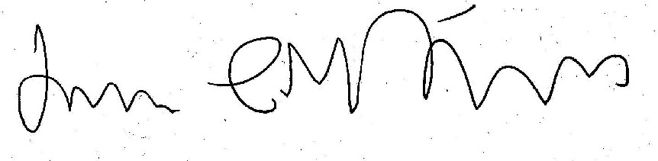

James Stevens
Regional Planner

Tel: 020 7960 1623
Email: james.stevens@hbf.co.uk

