
Planning LDF Team
Reigate and Banstead Borough Council
Town Hall
Castlefield Road
Reigate
Surry
RH2 OSH 20 June 2008
BY EMAIL ONLY
Dear Sir/Madam
REIGATE & BANSTEAD: REDHILL TOWN CENTRE DPD – ISSUES & OPTIONS

Thank you for the opportunity to comment on the above document. We would like to make the following comments:

Land use and activity: housing

We note the council’s intention to provide up to 1,200 new homes in the town centre area. It would be useful to know whether these are net additions or whether the figure includes replacement dwellings.

Strategic question: what types and tenures of housing should be provided in the town centre

The answer to this question should be informed by evidence from the council’s Strategic Housing Market Assessment (SHMA) and the views of existing residents. The SHMA which will provide important evidence of the demand for housing in Redhill town centre its type, size and tenure. For example, what is the current market demand for flats in the town centre, or is there a demand for terraced housing with gardens? The council should also enter into early dialogue with interested housebuilders and RSLs to consider the supply of housing types in the area, the feasibility/viability of this, consideration of other barriers and likely timescales for delivery.

Section 106 obligations

We note that the document contains very little information regarding the total likely section 106 package that will need to be levied to support the council’s proposed regeneration of the town centre. Issues such as how much will be required in total, for what, by when, and by whom (i.e. what will be the likely division between housebuilders, RSLs and other developers) have not been addressed in the document but will need to be at the next stage in the consultation process.

We would draw your attention to the new PPS12, and paragraphs 4.8 to 4.12 which address the question of infrastructure delivery and the need for this to be supported in the local spatial planning process. While we acknowledge that this is really a requirement for the core strategy (the council therefore may consider that the best place to scope out the s106 requirement for the town centre will be in its core strategy) the principles need highlighting. As paragraph 4.8 of the new PPS12 states:

“The core strategy should be supported by evidence of what physical, social and green infrastructure is needed to enable the amount of development proposed for the area, taking account of its type and distribution. This evidence should cover who will provide the infrastructure and when it will be provided.”

The local authority’s ambition for the town centre will be contingent upon establishing a positive and productive partnership approach with other developers. The level of obligations levied should therefore be fair and reasonable, having regard to the tests of reasonableness in Circular 5/2005, and having regard for the need for housebuilders to secure an adequate return on investment.

Building Design

We recommend that the council provides clear guidance for applicants with regard to what it expects to see in the Design and Access statements in specified parts of the town centre to avoid misunderstanding and delay at later stages. The council should avoid arbitrarily dismissing schemes and work with developers to articulate clearly what it wants.

I hope these comments are useful. Please contact me should you require further clarification.

Yours faithfully
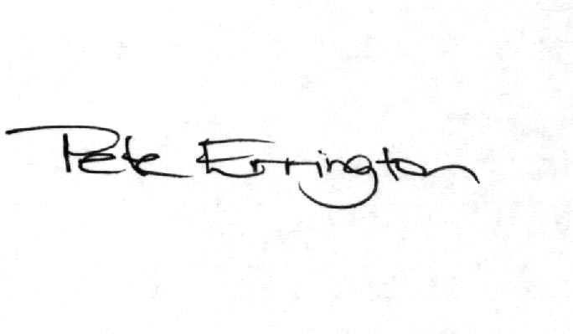

Pete Errington
Homes Builders Federation
Regional Policy Manager (South, East and London)

