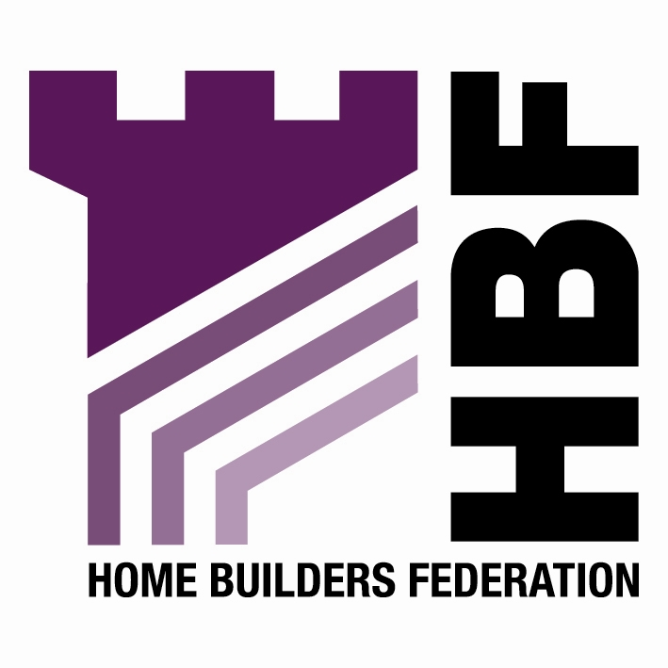

BY EMAIL ONLY

Terence Genis

Senior Planning Officer

Rushmoor Borough Council

Council Offices

Farnborough Road

Farnborough

Hants GU14 7JU

14th June 2008

Dear Terry,

RUSHMOOR BOROUGH SHLAA METHODOLOGY

Thank you for consulting the Home Builders Federation (HBF) on your council’s proposed SHLAA methodology. HBF generally welcomes the approach proposed in the document and the fact that the methodology is in general accordance with the government’s SHLAA practice guidance. We do have one comment, however, and that relates to the issue of stakeholder engagement in the process.

Obviously HBF very much welcomes the fact that we and other stakeholders have been consulted on the methodology and we note that the council is undertaking a call for sites as part of this initial consultation. However, it would appear that this stakeholder engagement is largely focussed at either end of the study in terms of commenting on the methodology and suggesting sites for inclusion at the beginning of the process and then commenting on the finished product as part of the core strategy issues & options consultation at the end. HBF considers that there is a missing stage in the middle.

The CLG SHLAA guidance refers in a number of places to continuous stakeholder involvement throughout the process. We are concerned, therefore, that the council is proposing to present stakeholders with a fait accompli and only asking them to comment on that once the assessments have been completed rather than allowing them the opportunity to assist and inform those assessments as they are being made.

HBF does not have a problem with the assessment being conducted in house. Nor to consultants being brought in to assist the council with Stage 7 of the process (paragraph 5.25 of the methodology). However, these consultants should not be brought in as a proxy for direct engagement with landowners, developers, house builders and local estate agents. There must still be the opportunity for these stakeholders to influence the discussions over the PPS3 ‘ables’ (deliverable, developable, achievable, suitable etc) while the study is being undertaken rather than at the end.

HBF would suggest that it could also be quite dangerous for the council to go down this route given how contentious these matters can be if misunderstood by general members of the public. It may be, therefore, that the council’s published assessment could contain sites which stakeholders consider should not be included because, for example, they do not meet one or all of the PPS3 ‘ables’. We would suggest it would be better from a public perception and management point of view for there to be discussion with stakeholders on the sites identified by the council as part of the assessment process and prior to the publication of a final document (even a draft final document) in order to avoid this confusion and in order that the process is as robust as it can be. HBF would be happy to try to facilitate such engagement amongst its Members if the council would find that helpful.

I hope you find these comments helpful and I trust they will be considered and the methodology amended and clarified prior to work commencing on the study in earnest. Either way I would be pleased to be kept informed of progress on the SHLAA as it evolves.

Yours sincerely,

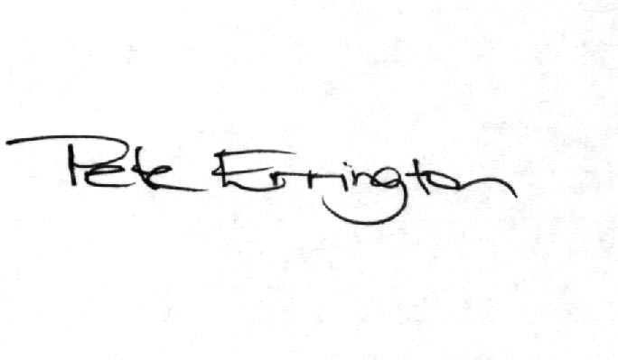

Pete Errington
Home Builders Federation
Regional Policy Manager (South, East & London)

