

BY EMAIL ONLY

Planning Policy Team

Clerk & Chief Executive’s Department

Mole Valley District Council

Pippbrook

Dorking

Surrey RH4 1SJ

19th June 2008

Dear Sir / Madam,

CORE STRATEGY REVISED PREFERRED OPTIONS

Thank you for consulting the Home Builders Federation (HBF) on your council’s revised core strategy preferred options.

HBF has a number of comments to make on the document and these are set out on the attached sheets in the order in which they appear in the document. These largely reiterate comments made in respect of the further issues and options in February of this year and even the original issues and options paper published in January 2006.

I hope you find these comments helpful and I trust they will be considered and the strategy amended prior to its submission to Government. Either way I would be pleased to be kept informed of progress on the strategy and associated aspects of the LDF as they evolve.

Yours faithfully,

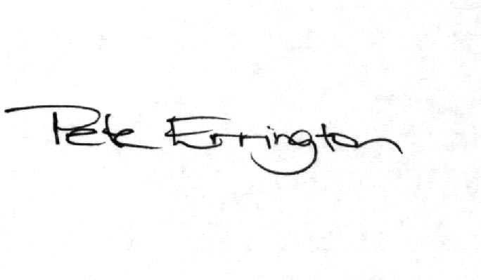

Pete Errington
Home Builders Federation
Regional Policy Manager (South, East & London)

CS/PO1

While HBF accepts the need to focus on brownfield sites as a priority we are concerned that this policy does not address the scenario that there are not sufficient brownfield sites available and that there has to be a release of land in the green belt in order to guarantee delivery of the housing target in a manner compliant with PPS3.

Obviously we are aware that work is currently underway on a SHLAA and this will provide the answer one way or another whether or not Greenfield or green belt releases are necessary. If the SHLAA shows that they are necessary then the core strategy must include a policy mechanism to allow this to take place. Merely putting this off for another day is not sufficient to provide the necessary degree of certainty that the housing target will be met. To be fair, this is mentioned in the housing section of the document where there is a reference to the SHLAA identifying green field sites. However, the point remains that, should these sites need to be identified, even in reserve, then the strategy should set out a process which would facilitate their delivery if required. This matter must be addressed more clearly and definitively in the submitted version of the strategy once the results of the SHLAA are finalised.

CS/PO2

Following on from the above point, it is difficult to make any further substantive comment on the adequacy or otherwise of the housing supply situation set out in this document until the SHLAA is finalised. If the picture painted in figure 6.2 is found to be acceptable by the SHLAA stakeholders, then there is not much of a problem. If it is not, however, then the above comments come in to play. HBF must reserve its position on this until the SHLAA work is finalised.

CS/PO3

PPS3, the regional assembly and the SE Plan Panel all make it clear that it is neither appropriate nor helpful for local planning authorities to dictate the mix of units, size and type of accommodation built on the market element of development sites. They may seek to influence the affordable housing mix where there is evidence to support such prescription in the form of a SHMA and they may seek to negotiate with developers to provide certain types and size of unit but they cannot prescribe this market mix. The final version of this policy will need to reflect this policy context and not seek to prescribe the mix of market units on any given site. It should also reflect the conclusions of the SHMA, as summarised in the core strategy, which recommended that the council encourage, not prescribe, the market mix.

CS/PO4

HBF welcomes the ‘cascade’ type approach to affordable housing set out in this policy which applies a different percentage target and different financial approach to sites of differing size. However we are concerned that the policy is being applied to gross units. The planning system, in so far as meeting housing need and demand is concerned, deals with net additions to the dwelling stock. The council does not meet its housing requirement based on gross completions. It meets it on the basis of net completions and it is only the net addition to the dwelling stock which can actually meet the totality of identified needs. The same principle must apply to affordable housing site thresholds. A site of 15 dwellings net should provide affordable housing but a site of 15 dwellings gross (but with, say, 3 demolitions) is an entirely different prospect as the cost of purchasing the 3 existing dwellings and then demolishing them and so on has to be factored in to the equation. Gross and net are not just interchangeable terms. They are very different things with very different costs and other difficulties associated with them. HBF suggests, therefore, that net figures are used as is commonplace across most of the country.

CS/PO19

HBF objects to point 4 of this policy approach and considers that the council should simply toe the Government policy line on climate change. Namely that there is national policy solution to this through the Code for Sustainable Homes. Developers will be legally obliged to comply with the ever tightening standards set out in the C4SH as they will be implemented through successive tightening of the building regulations. There is no need for any additional standards to be imposed through the planning system or for local authorities to try to ‘out-green’ each other by seeking to impose higher standards still or to advance the timescale by which the various Code levels should be met. Such actions are actually counterproductive as they lead to confusion, uncertainty and an adversarial approach to addressing the problem whereas this is one problem which should be addressed by all parties based on mutual understanding of each others’ positions. Only by approaching it in a consistent and co-ordinated way are the policy objectives of tackling the various elements of climate change likely to be achieved.

