

BY EMAIL ONLY

Karol Jakubczyk

Planning Policy Team Leader

Epsom & Ewell Borough Council

Town Hall

The Parade

Epsom

Surrey KT18 5BY

4th July 2008

Dear Mr Jakubczyk,

STRATEGIC HOUSING LAND AVAILABILITY ASSESSMENT

Introduction

Thank you for inviting the Home Builders Federation (HBF) to join your council’s SHLAA steering group. We are happy to be involved and to facilitate the involvement of our Members, as far as possible, as the study progresses. Looking through the draft methodology we are pleased to see that it generally follows the CLG practice guidance. We do, however, still have a few comments to make on the methodology and in answer to the questions raised and these are set out below in the order in which they appear in the document

Paragraph 1.20

HBF’s view on windfalls is that local authorities should follow the PPS3 approach. While the reference to the Inspector’s report is noted, his comments were hardly a glowing endorsement of a clear, transparent and well evidenced approach to housing supply. They were also made prior to the CLG SHLAA guidance being published and, as noted in SEERA’s planning committee report on windfalls of March this year, should be viewed as a response made at a time in transition between different approaches to housing supply and should not be taken as an automatic justification for future windfall allowances. Therefore we welcome the fact that the council is seeking in this SHLAA to correct this situation and to reduce reliance on windfalls as far as possible.

Question 3

A regular email update should suffice rather than the council having to go to the trouble of producing a newsletter. However, at some point, probably towards the end of the process, a seminar or workshop for stakeholders to discuss the approach and the initial findings of the study would be useful prior to the work being finalised.

Question 5

Most authorities have records of lapsed permissions as well as a database of what are usually termed ‘objection sites’ put forward through various plan-making processes. It may be worth revisiting these sources of information. We would also suggest that, in the Table included under paragraph 5.1 of the methodology, the purpose of looking at allocations and permissions (as set out in the first two lines of this table) is not just to identify sites. Consideration will have to be given to the timing of delivery / phasing and constraints to delivery of those sites, particularly in the current market conditions, in the same way as other categories of site further down this table.

Question 6a

Yes, the exceptional circumstance is the need to provide sufficient certainty that the housing requirement will be delivered. This was considered specifically by the SE Plan EIP Panel in their report and I would refer the council to paragraphs 20.51 and 20.69 of the report where the panel specifically stated that there may be a need to review the MGB in Epsom & Ewell.

Furthermore, in commenting on the first paragraph on page 19 of the methodology, we would argue that it is a self-fulfilling prophecy that, if sufficient sites are not identified, then a high windfall rate (especially in high demand areas such as most of Surrey) is the obvious outcome. Government is trying to move local authorities away from what is essentially a negative wait-and-see approach of letting the market decide which sites to bring forward and towards a more positive and proactive role for councils. This approach is a win-win as it provides certainty and direction for developers as well as putting the council in the driving seat in terms of dictating the location of new development and ensuring that local infrastructure is able (or will be made able) to cope. That is the essence of this new frontloaded, evidence based, proactive and collaborative LDF system compared to the old local plan approach of local authorities producing plans and then leaving the rest up to the market. So, just because windfalls have come forward in the past does not mean they can be relied upon as a mainstay of housing supply in the future. Again, we note and welcome the council’s aspiration to address this but thought the point worth making in order that HBF’s position on the windfalls issue is clear.

Question 9

We have no problem with the principle of mapping development hotspots or town centres but would question the justification and evidence which supports the 800m catchment distance. PPG13 on transport takes 2km as a reasonable walking distance (paragraph 75) so we would like further explanation of why only 800m has been chosen. Even if 2km is taken as a there-and-back trip it would suggest 1,000m would be more appropriate than 800m if not 2km in full. This requires further explanation otherwise the PPG13 figure should be used instead.

Question 12

HBF would be happy with a density yardstick approach but we would request that this is not applied inflexibly but is used sensitively taking into account the specific needs of the site being surveyed and the context and character of the area in which it is located. 40dph may be a reasonable yardstick but is unlikely to be acceptable for each and every site.

Paragraph 9.1 Second Bullet point

HBF is concerned that the council is proposing to depart from national policy guidance in PPS3 and advice in the SHLAA practice guidance by including a windfall allowance from year 6 onwards. PPS3 and the practice guidance is clear that windfalls should not be included in the first 10 years of supply. Therefore, this reference should be amended to refer to years 11-15 rather than 6-15. The council will also have to provide robust evidence of genuine local circumstances which prevent specific sites being identified (paragraph 59 of PPS3) before such an allowance could be justified. A high past rate of windfalls coming forward is not, on its own, sufficient justification as the 3rd bullet point under paragraph 25 of the CLG practice guidance makes clear and as already stated above.

Paragraph 9.11 and 9.12

HBF is concerned at the way the council is proposing to use a matrix and ranking approach to site assessment. There is nothing wrong with this in itself. But it needs to be used with caution, particularly in the later stages of the study and presentation of the results. HBF would warn against the final study presenting the information in the form of a ranking or hierarchy as this can be misconstrued and lead to all sorts of practical difficulties when it comes to releasing sites for development through the LDF. If it is used as a tool to assist in arriving as judgements on whether a site falls within the developable, deliverable or not-developable category, that is fine but there should be no further sub-categorisation or ranking beyond this.

Paragraph 11.7

The methodology should include a definition of what constitutes a small / medium-sized site for these figures to be meaningful. Given comments made earlier in the methodology HBF hopes that the council will be aiming to reduce its reliance on windfall allowances by identifying sites through the SHLAA process which would otherwise have been windfalls. Whilst it may not be possible to identify the categories of very small site development, there has to be some doubt about the appropriateness of a medium-sized site windfall allowance as it should be possible to identify such sites meaning that the PPS3-para 59 “exceptional circumstance” does not apply.

I hope these comments are helpful and that they will be taken on board by the council before it finalises the methodology. Either way I would be happy to continue to be involved in this SHLAA and look forward to receiving updates and further opportunities for input in the coming months.

Yours sincerely,
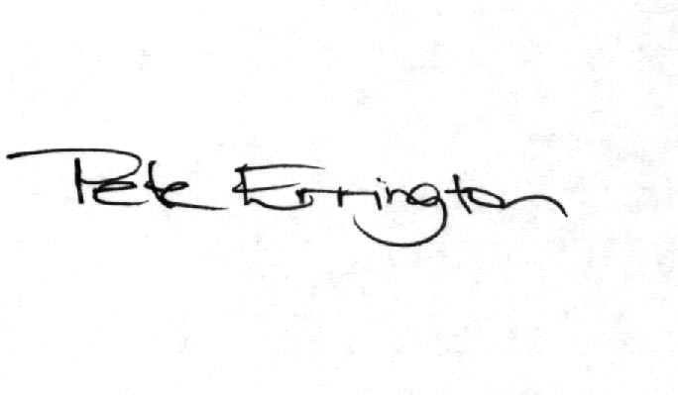

Pete Errington
Home Builders Federation
Regional Policy Manager (South, East & London)

