

BY EMAIL ONLY

Suzannah Parkes

Clerk & Chief Executive’s Department

Mole Valley District Council

Pippbrook

Dorking

Surrey RH4 1SJ

27th June 2008

Dear Suzannah,

ADAMS INTEGRA AFFORDABLE HOUSING VIABILITY STUDY

You will be aware that HBF has submitted representations on your council’s core strategy revised preferred options as well as being involved in work on the SHLAA which is currently underway. Whilst welcoming involvement on the SHLAA (though you will be aware of our concerns regarding windfall allowances) and not objecting to the main thrust of the council’s approach to securing affordable housing we have just had the opportunity of considering the above document which does raise some cause for concern and has implications for both the core strategy and the SHLAA.

Clearly, while the deadline for comments on the revised core strategy preferred options has passed, I thought it helpful to flag up the concerns we have about this document now as this is something we will be raising in due course (if not addressed) in the submission version of the strategy. It also has implications on the deliverability and developability of sites identified in the SHLAA. Raising it now hopefully gives the council time to address this issue prior to the submission stage and so ensure the strategy is sound upon submission.

As we said in our representations on the core strategy we do not object to the principle of a cascade and variable approach to seeking different types and extent of provision of affordable housing on different type and size of site. However, it has been drawn to our attention that the financial viability study on which the percentage targets in criteria 2a, b, & c of policy CS/PO4 are based, uses “notional development scheme types agreed with the council” (para 6 of the executive summary of the viability study) with most of the relevant caveats but without real-world development examples.

This is a worry as there is a great deal of difference between the two and, while the notional development scheme approach is interesting in as far as it goes, it cannot reflect real world considerations, costs, problems and factors which affect development viability. It should not be the developer who has the burden of cost, uncertainty and time delays to prove the norm.

We are particularly concerned that use of this type of approach will not reflect the costs and difficulties associated with real world brownfield redevelopments (which will comprise the vast majority of development in the district) and the full costs e.g. land assembly, demolition, de-contamination, relocation associated with redevelopment of former uses and so on. Similarly it is unlikely to reflect the true costs of bringing forward urban infill on backland sites; in particular the ‘personal factors’ which affect how much a private individual would consider as a fair price to take into account the upheaval of moving or loss of amenity and other legal and taxation costs and dis-benefits of selling garden land or their current property to allow a site to be redeveloped. These less tangible, though no less important, costs are unlikely to come to light based on notional development type examples. So, while the notional scheme approach may have its uses, we consider that, on its own, it is not sufficiently robust or credible (in PPS3 terms) to justify the application of specific and precise policy targets in the core strategy (or in assumptions about deliverability of sites in the SHLAA).

There are also concerns about the extent to which the study has taken on board the need to provide for other planning obligations as now set out in the council’s tariff which would appear to have been included in the figures but not recognised in any real test compared to residual land values on sites submitted before 31st January.

Our suggestion, therefore, is that these notional development scheme examples must be supplemented by some actual examples of land and property transactions which have taken place in the district in recent times and there should be a comparative assessment between the costs and values pertaining to these real world schemes against the more theoretical approach apparently taken in the study. Based on our Members experiences of trying to assemble and bring forward sites in the district in recent times, these costs are likely to be higher than assumed in the study meaning that the percentage targets in the policy may need to be reviewed (or at the very least applied more flexibly – particularly in the short term given current market conditions). This information on land costs and sale prices is readily available in the public domain.

It is also worth drawing attention to the consultants comments on the credit crunch. In particular we would draw attention to the particular need for flexibility in the application of these policy requirements as the situation even only a couple of months further on from when this study was published are far worse than could have been imagined such a short time ago.

If the study is not based on real world costs and considerations then the impact of the policy will be to render sites unviable and prevent them from coming forward which, in terms of the delivery or funding of affordable housing, will be counter-productive.

As we say in opening, we recognise that these may not be considered as formal representations on the core strategy given the deadline. However, hopefully the council will consider the issue of sufficient importance to consider these comments and what action it may take between now and the submission stage in order to ensure that the final policy is as robust and sound as possible and that delivery of much needed housing (including affordable housing) is not unduly and unnecessarily compromised.

Yours sincerely,

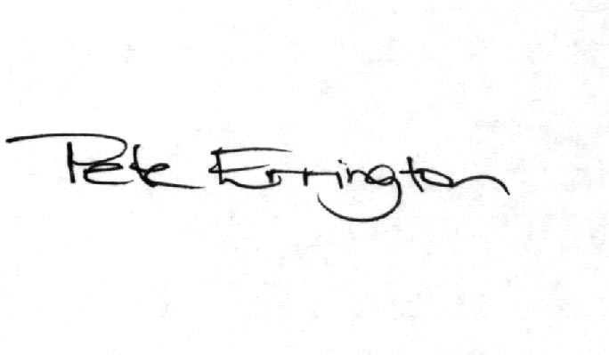

Pete Errington
Home Builders Federation
Regional Policy Manager (South, East & London)

