

BY EMAIL ONLY

Wendy Lane
LDF Team

Medway Council

Gun Wharf
Dock Road
Chatham
Kent ME4 4TR

27th June 2008

Dear Wendy,

KENT & MEDWAY SHLAA PROTOCOL

Introduction

Thank you for allowing the Home Builders Federation (HBF) the opportunity of commenting formally on the draft protocol and apologies for the confusion which arose at the KPOG meeting regarding the pre-circulation of the text.

Overall HBF welcomes the thrust of the approach to carrying out SHLAAs set out in the protocol which, we are pleased to see, follows the general line set out in CLG’s practice guidance. However, there are a couple of suggestions we would like to make for additional pieces of text and clarification of the advice already provided. These are set out below in the order in which they appear in the document.

Paragraph 2.03

While there is no problem with the different land use studies being carried out separately there is some sense in them being carried out at the same time (though to separate methodologies) if resources permit. The example referred to of sites being identified for more than one use highlights the potential problem of not doing these various studies together. While the final use will, as indicated, be a matter for the LDF, clearly if sites are to be considered for a variety of uses then this will impact on the SHLAA in terms of the extent to which a site, say, already in an existing commercial use, should be considered deliverable, certainly in the short term. So identifying sites for a variety of uses can impact on the SHLAA and this impact should be recognised in the SHLAA rather than being solely left to the LDF.

Paragraph 3.11

What we are generally saying on SHLAA methodologies is that it makes sense for authorities to include in the SHLAA assessment all sites put forward by developers regardless of whether they would otherwise be excluded (for example under the criteria listed in paragraph 3.10). Clearly no respectable developer is going to be proposing a site for residential development in an SSSI ! However, some of the lower order constraints (car parks, allotments etc) should not be considered as absolute constraints in the same way as international designations. Certainly, if a developer is putting forward a site for inclusion in the SHLAA which falls foul of one of these lower order designations, then the fact it is being put forward suggests the developer considers it a prospect which they may pursue either through the LDF or via a planning application. On that basis, the evidence base would be more robust if all sites put forward by developers were assessed regardless of the level of constraint identified in this early part of the study. That is not to say any such site will not, later in the study, be found to be unsuitable. But it ensures that there is an audit trail in the decision making process which will make the SHLAA much more robust as an evidence base rather than ruling out sites at the start and not assessing them. We suggests there is provision made for this in the protocol.

We would also question the legitimacy of some of these category two examples in the context that the SHLAA should be seeking to identify as many reasonable sites as possible. It may not be reasonable to develop on a category-1 constrained site. But a car park or allotment should not be considered similarly constrained. We would therefore suggest that there is a caution against over-zealous exclusions included in the protocol.

Paragraph 3.12

Under the heading of “other sources of information” you could add local plan / LDF objection sites as well as lapsed planning permissions as other potential sources of sites.

Paragraph 3.15

If the above point under 3.11 is accepted then the words “except when suggested by developers / landowners” or words to that effect should be added to the last sentence of this paragraph.

Paragraph 3.18

3rd line should be “Practice” rather than “Practical” Guidance.

Paragraph 3.19

Again, following on from 3.11 above, we would consider that this adds weight to our suggestion as, if too many sites were excluded at the start, there will not be much left to revisit.

Paragraph 3.25

3rd line last word should be “and” rather than “ad”.

Paragraph 3.28

Under the heading of achievability it is vital that there is an assessment of the costs of meeting the council’s own planning requirements included. This would include the requirements to deliver affordable housing, deliver increasing levels of the Code for Sustainable Homes and paying any existing tariffs or other planning obligations.

On development costs, the costs associated with relocating existing uses or compensating existing owners for the loss of amenity (if residential infill) or moving house should also be factored in to the assessment. With the latter it is not just about assuming the market value of the house being lost but, on top of that, what an existing owner would wish to realise by way of value in order to make it worth his or her while moving house or selling part of a large garden which must be taken into account.

Paragraph 3.35

We would like to see a disclaimer included at the end of this section of the protocol explaining that these examples are for illustration only and that it should not automatically be assumed that the percentages, distances or general approaches applied in these case studies are replicable or directly relevant to the Kent situation. We have no problem including the information in the protocol by way of example. But we would be concerned if it was assumed that, just because 800m or 50% PDL is referred to in this protocol means it is in some way endorsed by KPOG or necessarily an appropriate way forward in a Kent SHLAA.

Stage 9

On the issue of broad locations I got the impression reading it that this section was a bit confused. I think there needs to be clarification that the concept of broad areas is not just any broad area that the council may wish to consider. Rather, it is clearly defined in the practice guidance as broad locations where housing is feasible and likely “but where specific sites cannot yet be identified” (para 46 of the practice guidance). So, on that basis it would not be appropriate, for example, for a council to identify a whole settlement or part of a settlement as a broad location as it would be possible to identify sites in a complete settlement.
There has to be a reason why it is not possible to identify sites in any given part of a settlement before a broad location would be acceptable.

The sort of example I generally think of is student areas where there is a long history of sub-division of existing properties to flats and bedsits where it would not be possible to identify which property would be converted next but evidence suggests such conversions have consistently come forward in the past and will continue to happen in the future. So an area could be identified where this sort of development would be encouraged by policy and an allowance made accordingly. It is little more than a locationally and/or reason specific windfall allowance. The key to it, though, is that there has to be a robust explanation of why it is not possible to identify sites. The same applies to broad locations on the edge of settlements. If it is possible to identify specific sites put forward by developers then they should be assessed. Broad locations should only be used to indicate a general direction of expansion outwards of a settlement if that is a policy preference but no specific individual sites have yet been put forward or identified.

This section needs to be clarified by explaining the above.

Paragraph 3.44

On to the traditionally thorny issue of windfalls HBF is concerned that the protocol is a bit misleading in this respect. It is not the issue of whether there are particular local circumstances that justify the inclusion of a windfall allowance. Rather, paragraph 59 of PPS3 makes it absolutely clear that there is only one exceptional circumstance which could justify the inclusion of a windfall allowance; namely, that there is robust evidence that it is genuinely not possible to identify specific sites. If it is possible to identify sites then there is no justification for a windfall allowance.

In practical terms what this suggests really is that such an allowance is only really acceptable in those areas or for those categories of development below the threshold at which sites are identified and surveyed in the assessment; in other words, small sites. Larger sites could not be included in a windfall allowance as it is possible to identify them. Obviously there is a degree of overlap between a broad locations approach and a more general windfall allowance. The key is the explanation of why it is not possible to identify sites and the local circumstances, in that regard, must relate to the nature of development which tends to come forward in an area.

Paragraph 3.45

It is worth pointing out, however, that this is not an automatic justification for including a small site windfall allowance. The third bullet under paragraph 25 of the practice guidance makes it clear that authorities, in such cases, should still try to identify as many sites as possible (and this may mean going down to a smaller site threshold for identifying sites than would otherwise be the case).
But, if it really is not and this can be proven via robust evidence, then a windfall allowance may be acceptable. That is the only circumstance. In that regard the reference to the SEERA windfalls report at paragraph 3.45 of the protocol is helpful.

Paragraph 3.46

Following on from that point, the sentence in paragraph 3.46 which begins “However, if a windfall allowance is used….” should be expanded to state that this should only be included as a last resort at the end of the SHLAA process rather than being automatically assumed right from the start.

Appendix 3

Finally, turning to Appendix 3 and the site assessment pro forma under Policy Constraints D, in order to reflect the comment made under paragraph 3.11 above, the heading should be expanded to say “Or has the site been put forward by a landowner / developer”.

Under Suitability B we would question the justification for these walking distances. PPG13 on transport takes 2km as a reasonable walking distance (paragraph 75) so we would like further explanation of why only 800m has been chosen. Even if 2km is taken as a there-and-back trip it would suggest 1,000m would be more appropriate than 800m if not 2km in full. This requires further explanation otherwise the PPG13 figure should be used instead.

Turning finally to the Achievability section, this needs inclusion of a “Policy Factors” heading. While it would not be appropriate to assess the actual costs on a site visit, it would be helpful to record, for example, whether or not a site is likely to be liable to trigger an affordable housing contribution or any similar obligations.

I hope these comments are helpful and can be taken on board prior to the document being finalised.

Yours sincerely,

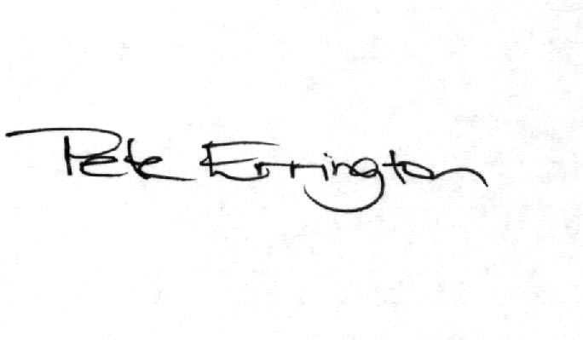

Pete Errington
Home Builders Federation
Regional Policy Manager (South, East & London)

