
Forward Planning and Transport – Major Projects
Basingstoke and Deane Borough Council
Civic Offices
London Road
Basingstoke
Hampshire
RG21 4AH 13 June 2008
BY EMAIL ONLY

Dear Sir/Madam
BASINGSTOKE AND DEANE: RESIDENTIAL PARKING STANDARDS SPD

Thank you for giving the Home Builders Federation an opportunity to comment on the above. The HBF would like to make the following points:

Introduction (paragraph 1.1)

The council states that the parking standards introduced via this SPD provide interim guidance and reflect the change of emphasis in Planning Policy Note 3. The council argues that this is necessary while preparation of the council’s core strategy is underway. Even so, we would remind the council that this is not strictly in accordance with Government planning policy. SPDs may only ‘supplement’ and add clarity to adopted core strategy policies. They cannot introduce new policy as entailed by a change of parking space allocations. As the new PPS12 states (paragraph 6.1) SPDs may be prepared “to provide greater detail on policies in its DPDs. SPDs should not be prepared with the aim of avoiding the need for the examination of policy which should be examined.”

Given that the allocation of parking space in developments is an important consideration for housing developers, because it will have a significant impact upon marketability and sales, we would expect the policies in this SPD to be tested in a DPD (probably the core strategy) in due course. Strictly speaking this SPD should not be adopted until the relevant DPD has been adopted. However, even though the SPD will carry little weight until it is rooted in adopted DPD policy, we recognise the benefit of the council issuing updated interim guidance reflecting PPS3 and the Manual for Streets. In the meantime we urge the council to listen carefully to the concerns of housebuilders and apply these standards flexibly where necessary to ensure that new developments are attractive to purchasers by allocating sufficient parking space.

Paragraph 1.3

We are not sure what is meant by the sentence ‘indiscriminate on-street parking to the front of the (their) property for either convenience or security reasons’. Is it more discriminating to choose not park in front of one’s home? This is an irrational statement. Surely it is rational to wish to park in front of one’s home (even if one might be frustrated in practice)? We are unclear what problem the council is articulating here. Clarity is required.

Car ownership in the Borough

We welcome the realistic stance adopted by the council with regard to planning for parking. Paragraph 17 of PPS13, elaborating on PPS3, states that parking space allocations should not be expressed as minimum standards and that the need for parking space will need to reflect the income, age, household type and location of the housing.

Paragraph 2.5 considers the circumstances where local authorities might revise the general standard downwards. While this would be in keeping with paragraph 17 of PPS13 which states that councils "should revise their parking standards to allow for significantly lower levels of off-street parking provision, particularly for developments in locations, such as town centres, where services are readily accessible by walking, cycling or public transport" we would urge the council to acknowledge that although usage might decline, it is not necessarily true that ownership will and we would emphasise that the provision of adequate parking must remain a priority. Demand for parking should be mitigated as far as possible by good design as the council’s document and the Manual for Streets suggests.

Therefore, the levels of car parking provision permitted within the core/inner urban zone should be kept under review to ensure that provision is adequate to meet the needs of occupiers.

Proposed parking standards

Paragraph 4.4

Surely it is better to plan to ‘over-provide’ car-parking space - to a reasonable degree - than to under-provide with the problems that attend this? Adequate car parking is likely to be a very important consideration for prospective purchasers in a town such as Basingstoke where the nature of its local economy and employment is heavily car-dependent. Under-utilised car-parking space can always be converted to other uses (gardens? allotments?) and re-converted back if necessary.

We are therefore concerned that the amount of car-parking space provided for one bedroom dwellings - 0.75 per dwelling - in the core/inner zone may be inadequate for residents’ needs. We recommend that this is raised to 1 space per one-bed unit.

Paragraph 6.3

In accordance with Circular 5/2005 any planning obligation levied must meet the five tests outlined in paragraph B5. Contributions to transport must be in proportion to the additional demand generated by the development in question or the collective impact of a series of developments in a specified (Action Plan) area.

I hope these comments are useful and that the SPD will be revised accordingly and to reflect future changes to core strategy policies.

Yours faithfully
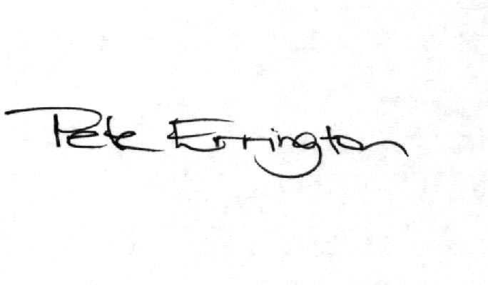
Pete Errington
Homes Builders Federation
Regional Policy Manager (South, East and London)

